*Florida International University*

*School of Computing and Information Sciences*

Software Engineering Focus

Final Deliverable

Project Title: Academic Success Initiative - ASI PantherCentric 1.0

**Team Member(s):** Alfredo Santoyo, Jake Lopez, Priscila Cordova**,** Rolando Moreno

**Project:** Academic Success Initiative - ASI PantherCentric 1.0

**Product Owner(s)**: Myrian Herlle

**Mentor(s)**: Myrian Herlle

**Instructor**: Masoud Sadjadi

The MIT License (MIT)

Copyright (c) *2016 Florida International University*

Permission is hereby granted, free of charge, to any person obtaining a copy of this software and associated documentation files (the "Software"), to deal in the Software without restriction, including without limitation the rights to use, copy, modify, merge, publish, distribute, sublicense, and/or sell copies of the Software, and to permit persons to whom the Software is furnished to do so, subject to the following conditions:

The above copyright notice and this permission notice shall be included in all copies or substantial portions of the Software.

THE SOFTWARE IS PROVIDED "AS IS", WITHOUT WARRANTY OF ANY KIND, EXPRESS OR IMPLIED, INCLUDING BUT NOT LIMITED TO THE WARRANTIES OF MERCHANTABILITY, FITNESS FOR A PARTICULAR PURPOSE AND NONINFRINGEMENT. IN NO EVENT SHALL THE AUTHORS OR COPYRIGHT HOLDERS BE LIABLE FOR ANY CLAIM, DAMAGES OR OTHER LIABILITY, WHETHER IN AN ACTION OF CONTRACT, TORT OR OTHERWISE, ARISING FROM, OUT OF OR IN CONNECTION WITH THE SOFTWARE OR THE USE OR OTHER DEALINGS IN THE SOFTWARE.

***Abstract***

*Academic Success Initiative PantherCentric Web Application was tested on its usability for its target audience: students requesting tutoring for courses required in computer science and information technology. The usability surveys were targeted to find ease of use of the current system. After analysis of the data, this paper supported changes that were necessary to improve the overall experience when interactive with ASI PantherCentric.*

**Table of Contents**

**Introduction** ……………………………………………………………………………………………. 5

Current System ……….……………………………………….……………………………………… 5

Purpose of New System …………………………………………………..……...…………………... 5

**User Stories**

Implemented User Stories ………………………………………….………………….……………..7

Pending User Stories …………………………………………………………………...…..…..….. 10

**Project Plan**

Hardware and Software Resources ……………………………………………………...…….… 12

Sprints Plan …………………………………...……………………………………………………. 13

*Sprint 1*  ……………………………………………………………………………………………. 13

*Sprint 2*  ……………………………………………………………………………………………. 13

*Sprint 3*  …………………………………………………………………..………………………... 14

*Sprint 4*  ………………………………………………………..…………………………………... 15

*Sprint 5*  …………………………………………………………..………………………………... 16

**System Design**

Architectural Patterns …………………………………….…………………………………….. 20

System and Subsystem Decomposition ………………………………………………………….… 21

Deployment Diagram ………………………………………………………………………….…... 22

Design Patterns ……………………………………………………………………………….….... 22

**System Validation**  …………………………………………………………………………………….23

**Glossary**  ……………………………………………………………………………………………….37

**Appendix**  ……………………………………………………………………………………………….38

Appendix A - UML Diagrams ………………………………………………………………………. 38

*Static UML Diagrams*  ……………………………………………………………..……………….38

*Dynamic UML Diagrams*  …………………………………………………………………………..40

Appendix B - User Interface Design ………………………………………………………………. 52

Appendix C - Sprint Review Reports ……………………………………………………………… 69

Appendix D - User Manuals, Installation/Maintenance Document, Shortcomings/Wishlist Document and other documents …………………………………………………………………….…………… 74

**References** …………………………………………………………………………………...………...80

# 

# Introduction

ASI PantherCentric is a user friendly platform that offers students at Florida International University access to tutoring services. Usability is a plague to those intending to actually implement useful software. Because the user is all knowing, we must take precautions to appease them, after all the user is always right. In order to facilitate a more user-friendly web service, we have issued a survey of usability for the website asiportal.cis.fiu.edu in order to improve end-user experiences. We tested various ways on how students interact with the application through basic functions required to use the application. We discovered from our experiments methods and systems that required change in order to meet the end-user’s needs.

Subsection One of the Introduction will cover the current system. The current system will include definitions and conclude with the actual current state and system of ASI PantherCentric. Subsection Two will cover the purpose of the new system.

Section Two, User Stories, will cover two subsections, implemented stories and pending user stories. Section Three, Project Plan, goes over the following subsections: Hardware and Software Resources and Sprint Plans.

Section Three, The System Design, will talk about Architectural Patterns, System and Subsystem Decomposition, Deployment Diagram and Design Patterns in ASI PantherCentric.

Finally, the section on System Validation will cover the testing done on the ASI PantherCentric 1.0. An accompanying glossary and appendix will follow after that. The last section of this document will be references to all materials and data.

## Current System

The current version of the ASI PantherCentric 1.0 software is a Django web application that is running on a Ubuntu 16.04 LTS server using Nginx as the HTTP server, PostgreSQL as the relational database, and Redis for in memory caching.

The current system has several features which are distinct to specific user groups. Those user groups are:

* Tutees - Users who are seeking tutoring service from the ASI organization.
* Ambassadors - Users who are members of the ASI organization.
* Team Leaders - Users who are members of the ASI organization and administrate a team of Ambassadors for a specific course.
* Logistic Director - User who is responsible for scheduling tutoring sessions.
* Project Lead - User who is the overseer of the entire ASI organization.

It is helpful to note that all abilities of the previous user group in the list are inherited by the preceding user group.

The feature set of the current system for Tutees includes:

* Creating accounts.
* Requesting tutoring sessions
* Completing surveys.
* Viewing scheduled tutoring sessions.

The feature set of the current system for Ambassadors includes:

* Scheduling availability for tutoring.
* Logging tutoring hours.
* Logging special project hours.
* Requesting tutoring session cancellations.

The feature set of the current system for Team Leaders includes:

* Viewing statistics for individual team members.
* Manually creating tutoring session requests.
* Approving logged tutoring hours for their team members.

The feature set of the current system for the Logistic Director includes:

* Approving / Denying tutoring requests.
* Approving / Denying session cancellation requests.

The feature set of the current system for the Project Lead includes:

* Approving Ambassador logged hours in the form of a timesheet.
* Downloading Excel versions of approved Ambassador timesheets.

## 

## 

## Purpose of New System

The purpose of the new system is to facilitate and expedite certain responsibilities of the Project Lead. By creating a system that can easily display information about the operations of the Academic Success Initiative program the Project Lead can spend less time completing tasks at the end of the semester.

The new system shall allow the Project Lead to do the following:

* View list of current Tutees
* View detailed Tutee information
* Sort and filter list of Tutees
* View overall survey statistics for a Tutee’s sessions
* View average rating of Tutee and Ambassador per session in course
* View detailed survey responses per session in course
* Write notes on a Tutee’s profile
* View a semester report including statistics on:
* Tutoring Sessions
* Courses
* Tutees
* Ambassadors
* Record status of students that have been reviewed
* Download an Excel file of the report

The system will also have new features to improve user experience such as:

* Login Page UI redesign
* Signup Page UI redesign
* Register for Courses UI redesign
* Administrator UI redesign
* Admin Header UI redesign
* Admin Footer UI redesign
* User Header redesign
* User Footer redesign
* User Profiles
* Notify Tutees of upcoming sessions via email
* Notify Ambassadors of upcoming sessions via email

# User Stories

The following section provides the detailed user stories that were implemented in this iteration of the ASI PantherCentric 1.0 project. These user stories served as the basis for the implementation of the project’s features. This section also shows the user stories that are to be considered for future development.

## Implemented User Stories

#666 View Of Current Tutees

#668 Sort list of Tutees by name

#669 Sort list of Tutees by major

#670 Filter list of Tutees by name

#678 Create user profile

#711 View overall survey statistics for a student's session

#712 View detailed survey by clicking on survey located in Surveys by Course View

#717 View Average Rating of Tutees and Ambassadors per Session in Surveys by Course View

#731 Write Notes on the Student Profile about the Student

#733 View Information about all courses in the Semester Report View

#734 View Information about Tutees in the Semester Report View

#736 Record the status of Tutees that have been reviewed

#737 Change Login Page User Interface

#739 Download an excel file of the report

#740 Notify Tutee of upcoming sessions

#741 Notify Ambassador of upcoming sessions

#777 Change Signup Page User Interface

#779 Change Administrator User Interface

## Pending User Stories

* System should notify administrator every time a new student registers to the ASI portal
* System should be ADA compliant
* System should notify tutee of completing survey
* System should notify ambassador to completing survey
* System should notify ambassador to complete timesheet
* System should deny access to unauthorized users
* Make Tutee names in semester report table provide link to tutee view

# 

# Project Plan

This section describes the planning that went into the realization of this project. This project incorporated the agile development techniques and as such required the sprints to be planned. These sprint plannings are detailed in the section. This section also describes the components, both software and hardware, chosen for this project.

## 

## Hardware and Software Resources

The following is a list of all hardware and software resources that were used in this project:

Surface Pro 3

Windows 10

4th generation Intel® Core™ i7

256 GB storage with 8 GB RAM

Mac Pro

MacOS 10.12.5

256 GB storage with 8 GB RAM

XCode

FIU Servers

Django 1.11.2

**Sprints Plan**

### Sprint 0

Sprint 0 was used to familiarize ourselves with the objectives of the product owner with the existing software. It involved formulating the entire product backlog and breaking them down into user stories. The team went on to understand the domain of the system. Eventually we all participated in understanding the technologies currently being used in the system. We came to the conclusion and brevity of the semester, that we would keep the existing framework to continue enhancing the application with new features. Regarding significant changes to the existing application came only through the use of Docker and developing and deploying via containerization.

### Sprint 1

**User Story #666 View of current tutees**

### Description:

* As an administrator I would like to see a list of students that are being tutored so I know who is receiving tutoring services

### Acceptance Criteria:

1. Student’s first and last name will be displayed
2. Student’s major will be displayed
3. Student’s sex will be displayed
4. Student’s courses they are receiving tutoring for will be displayed

**User Story #667 View detailed student information**

### Description:

* As an administrator I would like to select a student in order to see more detailed information of that student so that I can contact them and differentiate similar students

### Acceptance Criteria:

1. Student’s first and last name will be displayed
2. Student’s major will be displayed
3. Student’s sex will be displayed
4. Student’s contact information, phone number and email.
5. Student’s courses they are receiving tutoring for will be displayed

**User Story #668 Sort list of students by name**

### Description:

* As an administrator, I would like to sort the list of students by name so I can quickly search for a student

### Acceptance Criteria:

1. The list of students can be sorted in ascending alphabetical order
2. The list of students can be sorted in descending alphabetical order

**User Story #669 Sort list of students by major**

### Description:

* As an administrator, I would like to sort the list of students by major so that I can easily see the students of a particular major

### Acceptance Criteria:

1. The list of students can be sorted in descending alphabetical order based on their major
2. The list of students can be sorted in ascending alphabetical order based on their major

**User Story # 670 Filter list of students by name**

### Description:

* As an administrator, I would like to filter the list of students by name in order to easily find a specific student

### Acceptance Criteria:

1. A text box will allow user input to be used for filtering
2. The list of students can be filtered based on an entered string

**User Story # 678 Create user profile**

### Description:

* As a user, I would like to store my extra information, so that an administrator can easily access that information.

### Acceptance Criteria:

1. User should be able to store their sex
2. User should be able to store their phone number
3. User should be able to store their major

### Sprint 2

**User Story #711 View overall average rating of tutee and ambassador per sessions located at bottom of surveys by course view**

### Description:

* As an administrator, I would like to view overall survey statistics for a students sessions, so that at a glance I can determine a students progress

### Acceptance Criteria:

1. For both ambassador and tutee surveys an overall average must be shown.
2. There must be an overall average for each question.
3. The average must be with 2 decimal places of precision.
4. View ratio of student absences to total sessions occurred.

**User Story # 712 View detailed survey by clicking on survey located in surveys by course view**

### Description:

* As an administrator, I would like to click on a survey summary in order to view the details of the surveys so that I can see the answers to each question

### Acceptance Criteria:

1. A modal will pop up containing the detailed information
2. Questions of the survey will be displayed
3. Answers to the questions of the survey will be displayed

**User Story #717 View average rating of tutee and ambassador per session in surveys by course view**

### Description:

* As an administrator, I would like to view the average rating for both ambassador and tutee surveys for a session, so that at a glance I can determine if the student is making progress and if our tutors are performing well.

### Acceptance Criteria:

1. Each table row shows the date of the session.
2. Each table row shows the the rating, in floating point with precision .2, of the aggregate of 10 questions answered in the tutee survey about the ambassador.
3. Each table row shows the the rating, in floating point with precision .2, of the aggregate of 10 questions answered in the ambassador survey about the tutee.
4. The surveys are a subset of all surveys by student and course.
5. Ratings below 2.5 are highlighted in their respective table cell in a red color.

**User Story # 718 View the drop down menu for survey by course in the student view**

### Description:

* As an administrator, I would like to see a list of courses that a student is being tutored in, so that I can select which course information I want to see

### Acceptance Criteria:

1. Clearly visible at the bottom of the page
2. Drop down style
3. Different course as options

***Sprint 3***

**User Story # 731 - System should allow the administrator to write notes on the student profile**

### Description:

* As an Administrator I would like to add notes to a student view so I can review said notes later.

### Acceptance Criteria:

1. Each note is shown in one unordered list
2. Each note contains a timestamp
3. Each note cannot exceed 140 characters
4. Each new note is added at the bottom

**User Story # 732 - Show number of actual tutoring sessions vs scheduled sessions**

### Description:

* As an administrator I would like to view a report information about the actual number of sessions that took place and the scheduled sessions from the semester so that I can compare these numbers when I create a report.

### Acceptance Criteria:

1. Display a table on the top of the page
2. Display actual sessions on the left
3. Display scheduled sessions on the right

**User Story # 733 - Show information about courses for the semester**

### Description:

* As an administrator I would like to view a report that among other things, contains information about courses for the semester

### Acceptance Criteria:

1. Each table row shows the course number.
2. Each table row shows the number of sessions for that course
3. Each table row shows the percentage of sessions for that course out of all sessions

**User Story # 734 - Show information for tutees from the semester**

### Description:

* Description: As an administrator, I would like to view a list of tutees information for the current semester to review their progress

### Acceptance Criteria:

1. Each table row shows the tutee’s name.
2. Each table row shows the number of actual sessions the tutee attended
3. Each table row shows the number of scheduled sessions for the tutee
4. Each table row shows the courses the tutee received tutoring for
5. Each table row shows the tutee’s survey completion

**User Story # 735 - Show information about ambassadors from the semester**

### Description:

* As an administrator I would like to view detailed information about ambassadors from the semester so that I can compare these numbers when I create a report.

### Acceptance Criteria:

1. Display the information as a table
2. Ambassadors column must be there and the far right
3. Sessions column next
4. Survey column in the middle
5. Tutoring hours as a column
6. Project hours in the last column

**User Story # 736 - Record the status of students that have been reviewed**

**Description:**

* As an administrator, I would like to mark students as reviewed so that I can identify them

**Acceptance Criteria:**

1. A checkbox to mark or unmark the reviewed status
2. A symbol to denote a student as reviewed in the student list

**User Story # 739 - System should allow administrator to download an excel file from the report**

### Description:

* As an Administrator, I would like to download an excel version of the report, so I can easily generate scaleable graphs and share the file with.

### Acceptance Criteria:

1. An excel file containing the same information as the reports page should be available for download.

### 

### 

### Sprint 4

**User Story # 737 - Change Login Page UI**

### Description:

* As a user I want the Login Page User Interface changed so that it closely resembles the referring website, [https://asi.cs.fiu.edu](https://asi.cs.fiu.edu/).

### Acceptance Criteria:

1. CSS Library used is Bootstrap.
2. Body background color is #ffffff.
3. Font Color is [#666666](https://fiu-scis-seniorproject.mingle.thoughtworks.com/projects/academic_success_initiative___/cards/666666).
4. Button background color is #43A8D3.

**User Story # 740 - System should notify tutee of upcoming session**

### Description:

* As a user, I would like to receive an email with my upcoming scheduled sessions so I am reminded of them

### Acceptance Criteria:

1. Email is sent to the tutee with a list of their upcoming sessions

**User Story # 741 - System should notify ambassador of upcoming session**

### Description:

* As a user, I would like to receive an email with my upcoming scheduled sessions so I am reminded of them

### Acceptance Criteria:

1. Email is sent to the tutee with a list of their upcoming sessions

**User Story # 777 - Change Signup Page UI**

### Description:

* As a user I want the Signup Page User Interface changed so that it closely resembles the referring website, [https://asi.cs.fiu.edu](https://asi.cs.fiu.edu/). The reason for the similarity stems from the AB testing that was done in where new students thought they had gone to a different site.

### Acceptance Criteria:

1. CSS Library used is Bootstrap.
2. The background color for body should be exactly #ffffff.
3. Font Color should be [#666666](https://fiu-scis-seniorproject.mingle.thoughtworks.com/projects/academic_success_initiative___/cards/666666).
4. The button's background color should be exactly #43A8D3.
5. FontFamily: Lato

**User Story # 778 - Change registering for courses UI and accompanying pages**

### Description:

* As a user, I want users to clearly see as the options on the course tables, so that users can distinguish which courses are being offered.

### Acceptance Criteria:

1. The labels are clear for each course
2. Font should be readable.
3. Rows in tables should be two colors.

**User Story # 779 - Change Administrator UI**

### Description:

* As an administrator, I want all administrator UI to be clearly marked, so that authorized users and unauthorized users can distinguish between the two.

### Acceptance Criteria:

1. CSS Library used is Bootstrap.
2. Labeled clearly as an administrator view
3. Background color different from user views to distinguish administrator view.
4. Font Color should be [#666666](https://fiu-scis-seniorproject.mingle.thoughtworks.com/projects/academic_success_initiative___/cards/666666).
5. The button's background color should be exactly #43A8D3.
6. FontFamily: Lato

**User Story # 780 - Change Header for Admin UI**

### Description:

* As an administrator, I want the administrator header UI to be clearly marked, and contain the administrator menu, so that I can access other administrator views easily.

### Acceptance Criteria:

1. Administrator Menu in Header
2. CSS Library used is Bootstrap.
3. Labeled clearly as an administrator view
4. Background color different from user views to distinguish administrator view.
5. Font Color should be [#666666](https://fiu-scis-seniorproject.mingle.thoughtworks.com/projects/academic_success_initiative___/cards/666666).
6. The button's background color should be exactly #43A8D3.
7. FontFamily: Lato

**User Story # 781 - Change Footer for UI**

### Description:

* As an administrator, I want the administrator header UI to be clearly marked, and contain the user menu, so that I can access other user views easily.

### Acceptance Criteria:

1. User Menu in Footer
2. CSS Library used is Bootstrap.
3. Labeled clearly as an administrator view
4. Background color different from user views to distinguish administrator view.
5. Font Color should be [#666666](https://fiu-scis-seniorproject.mingle.thoughtworks.com/projects/academic_success_initiative___/cards/666666).
6. The button's background color should be exactly #43A8D3.
7. FontFamily: Lato

**User Story #782 - Change header for user UI**

### Description:

* As an user, I want the user footer UI to be clearly marked, and contain the administrator menu, so that I can access other administrator views easily.

### Acceptance Criteria:

1. Administrator Menu in Footer
2. CSS Library used is Bootstrap.
3. Labeled clearly as an administrator view
4. Background color different from user views to distinguish administrator view.
5. Font Color should be [#666666](https://fiu-scis-seniorproject.mingle.thoughtworks.com/projects/academic_success_initiative___/cards/666666).
6. The button's background color should be exactly #43A8D3.
7. FontFamily: Lato

**User Story #783 - Change footer for user UI**

### Description:

* As an administrator, I want the administrator footer UI to be clearly marked, and contain the administrator menu, so that I can access other administrator views easily.

### Acceptance Criteria:

1. Administrator Menu in Footer
2. CSS Library used is Bootstrap.
3. Labeled clearly as an administrator view
4. Background color different from user views to distinguish administrator view.
5. Font Color should be [#666666](https://fiu-scis-seniorproject.mingle.thoughtworks.com/projects/academic_success_initiative___/cards/666666).
6. The buttons background color should be exactly #43A8D3.
7. FontFamily: Lato

### Sprint 5

Sprint 5 consisted mostly of finishing up the individual poster, the team slide presentation and this document.

# 

# System Design

This section contains information on the design decisions that went into this project. The architecture patterns are outlined and explained. The entire system is shown in a package diagram and the subsystems are explained. Finally, the design patterns used in the project are discussed.

## Architectural Patterns

This system was created using Django web framework. This framework uses the Model View Controller architecture pattern. Model represents the interface to the data stored. View represents any output of information that is displayed on the browser as well as an interface to collect user input. Controller represents the the control between the model and view.

## System and Subsystem Decomposition

This section contains information on the minimal class diagram which can be found in Appendix A. In Django, with respect to model view controller architectural pattern, Django’s templates are views and Django’s views are controllers. Listed below is a brief explanation of the functionality of each subsystem:

Admin Dashboard - Contains Template and View. Responsible for User Stories in Sprint 2.

ASI App - Contains Template and View. Use extensively in Sprint 4.

Reports - Contains Template and View. Responsible for User Stories in Sprint 3.

Tutoring Sessions - Contains Template and View for tutoring sessions. Used extensively in Sprints 2 and 3.

## 

## 

## 

## 

## 

## Deployment Diagram

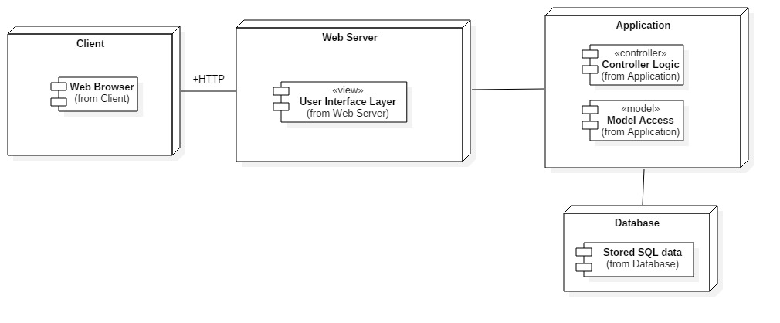

## 

## 

## Design Patterns

Django implemented the Active Record design pattern which is basically an object that wraps a row in a database table or view, encapsulates the database access, and adds domain logic on that data.

The object carries both data and behavior. The data is persistent and needs to be stored in a database. Active Records approach, is putting data access logic in the domain object. This way all people know how to read and write their data to and from the database [9].

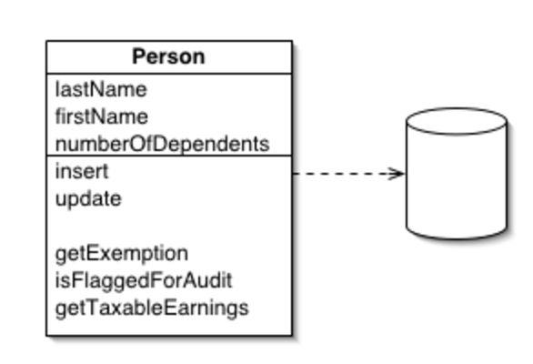

# System Validation

Test Case # 666 Unit Test

Test case ID: Get Admin Dashboard Context Data

Description/Summary of Test: return array of objects containing tutees currently in sessions.

Pre-condition:

Administrator must be logged in.

Administrator must navigate to /admindashboard.

Expected Results:

Array of Objects of current tutees in sessions.

Actual Result:

Array of Objects of current tutees in sessions.

Status (Fail/Pass): **Pass**

Test Case # 666 Selenium

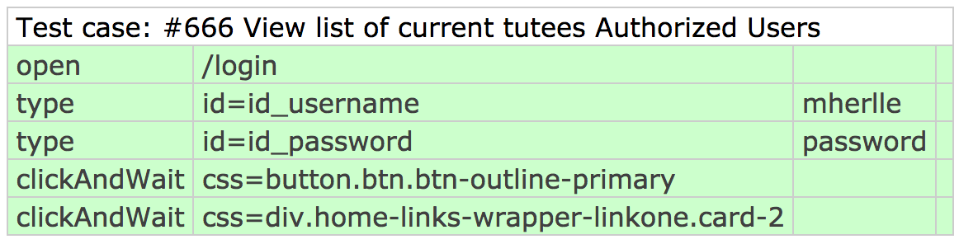

Figure n. Integration test case for authorized users with Selenium

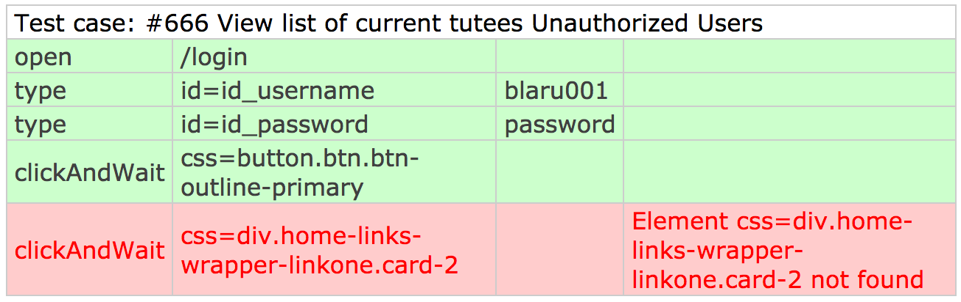

Figure n. Integration test case for authorized users with Selenium

Test Case #711 Python UnitTest

* Test case ID:
* Test overall average calculates correctly with one survey
* Description/Summary of Test:
* Given a single survey, ensure that the averages are what we expect
* Pre-condition:
* 1 ambassador survey with every rating set to 5 is submitted.
* Function is called with survey and asked to average ratings 1 - 3.
* Expected Results:
* A dictionary is returned with the ratings mapped to the average which should equal 5.
* Actual Result:
* A dictionary is returned with the ratings mapped to the averages which all equal 5.
* Status (Fail/Pass):
* Pass
* Test case ID:
* Test overall average calculates correctly with multiple surveys
* Description/Summary of Test:
* Given more than one survey, ensure that the averages are what we expect
* Pre-condition:
* 2 ambassador surveys are submitted.
  + One survey has all ratings set to 5.
  + The other has all ratings set to 3.
* Function is called with survey and asked to average ratings 1 - 3.
* Expected Results:
* A dictionary is returned with the ratings mapped to the average which should equal 4.
* Actual Result:
* A dictionary is returned with the ratings mapped to the averages which all equal 4.
* Status (Fail/Pass):
* Pass
* Test case ID:
* Test overall average does not calculate the averages of an empty list
* Description/Summary of Test:
* Given no surveys, ensure we get an error message and are notified there are no surveys to average.
* Pre-condition:
* Function is called with no surveys and asked to average ratings 1 - 3.
* Expected Results:
* A dictionary is returned with the ratings mapped to the average which should equal 0.
* There is a dictionary entry named errors which is mapped to the boolean value true
* There is a dictionary entry named message which is mapped to the string “No surveys to average”
* Actual Result:
* A dictionary is returned with the ratings mapped to the average which all equal 0.
* There is a dictionary entry named errors which is mapped to the boolean value true
* There is a dictionary entry named message which is mapped to the string “No surveys to average”
* Status (Fail/Pass):
* Pass

Test Case # 717 Selenium

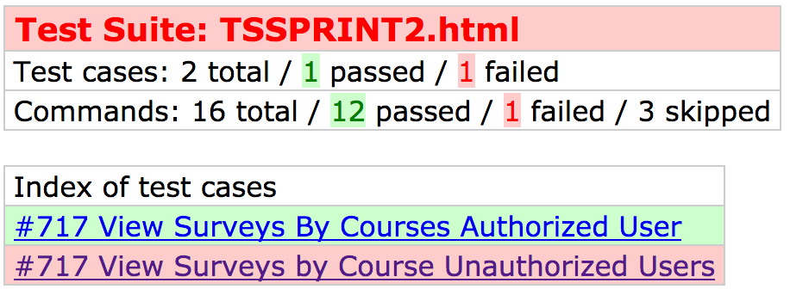

Figure 4. Test cases performed.

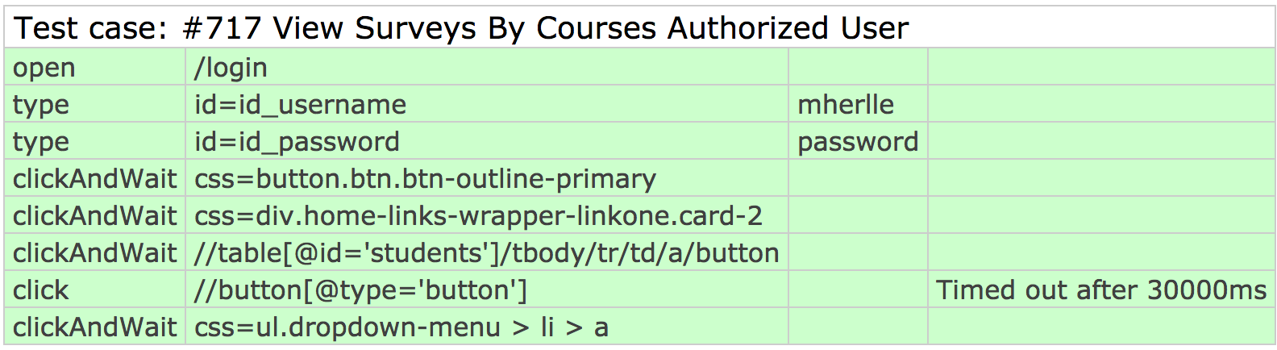

Figure 5. Test case for authorized users with Selenium

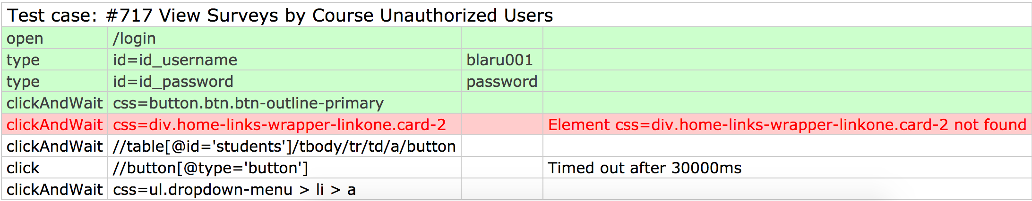

Figure 6. Test case for unauthorized users with Selenium

Test Case # 678 Python Unittest

* Test case ID: Test authorized users can view page
* Description/Summary of Test:
  + An authenticated user is logged in and then directed to page. The HTTP response code should be 200. If it is 302 then they were redirected away because they were not authorized.
* Pre-condition:
  + A user must be logged in.
* Expected Results:
  + HTTP Response Code 200.
* Actual Result:
  + HTTP Response Code 200.
* Status (Fail/Pass):
  + Pass
* Test case ID: Test profiles can be created
* Description/Summary of Test:
  + An authenticated user is logged in and then directed to page. They make a POST request with their desired profile information.
* Pre-condition:
  + A user must be logged in.
  + The user must not already have a profile.
* Expected Results:
  + The new user profile is created.
  + An HTTP Response code of 302 is returned.
* Actual Result:
  + The new user profile is created.
  + An HTTP Response code of 302 is returned.
* Status (Fail/Pass):
  + Pass

Test case ID: Test users can view their own profile.

* Description/Summary of Test:
  + An authenticated user is logged in and then directed to page. The page should display their user profile.
* Pre-condition:
  + A user must be logged in.
  + A user must have a profile.
* Expected Results:
  + HTTP Response Code 200.
  + The user profile is shown on the page.
* Actual Result:
  + HTTP Response Code 200.
  + The user profile is shown on the page.
* Status (Fail/Pass):
  + Pass
* Test case ID: Test authorized users with no profile are instructed to create one.
* Description/Summary of Test:
  + An authenticated user is logged in and then directed to page. The page should display a link to create a new profile.
* Pre-condition:
  + A user must be logged in.
  + The user must not have a profile.
* Expected Results:
  + HTTP Response Code 200.
  + A link to create a new profile is shown on the page.
* Actual Result:
  + HTTP Response Code 200.
  + A link to create a new profile is shown on the page.
* Status (Fail/Pass):
  + Pass

Test Case # 731 Selenium

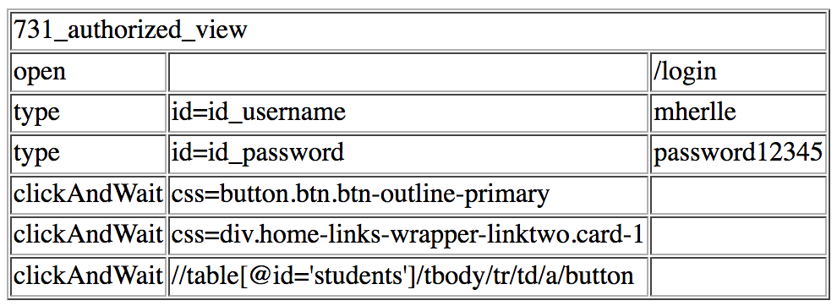

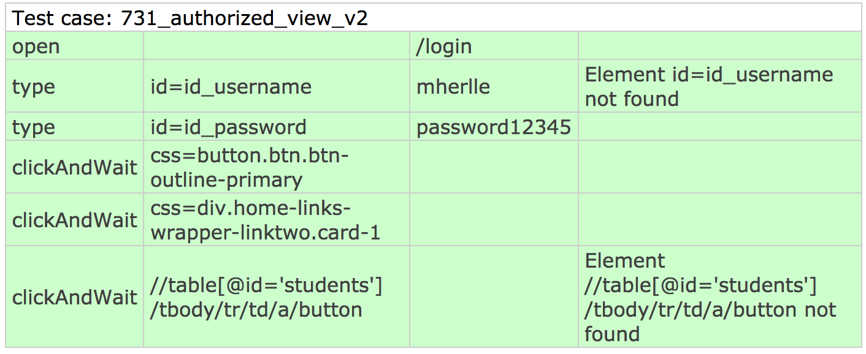

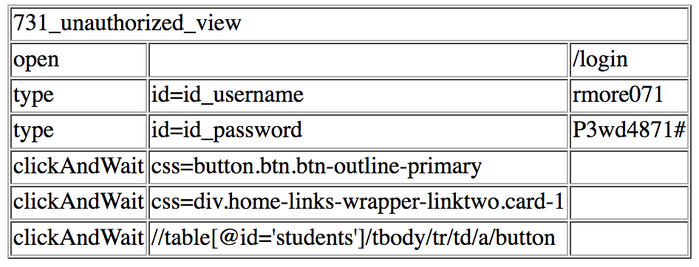

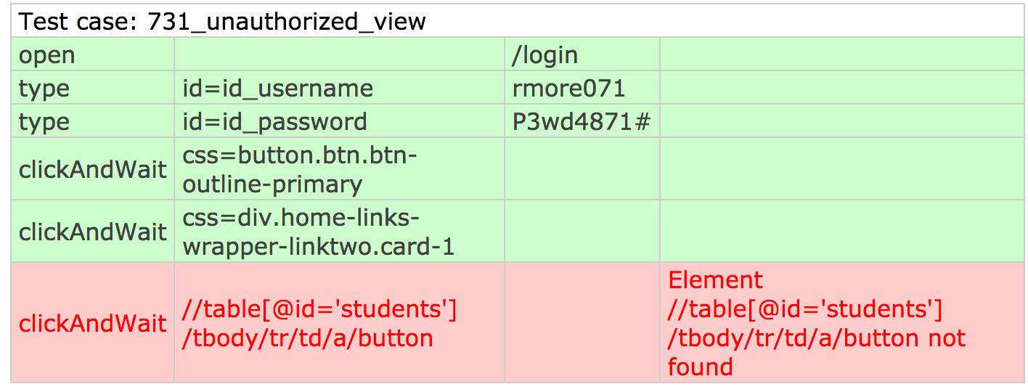

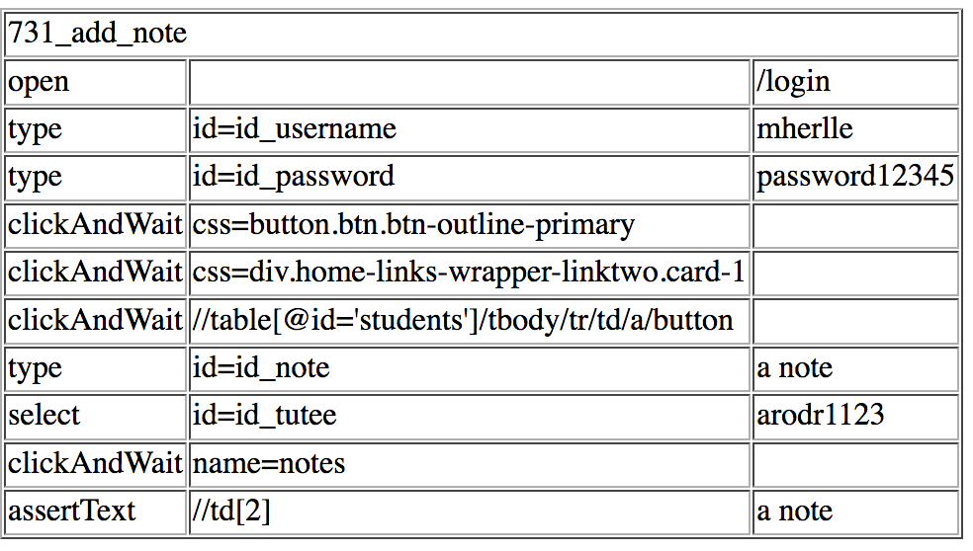

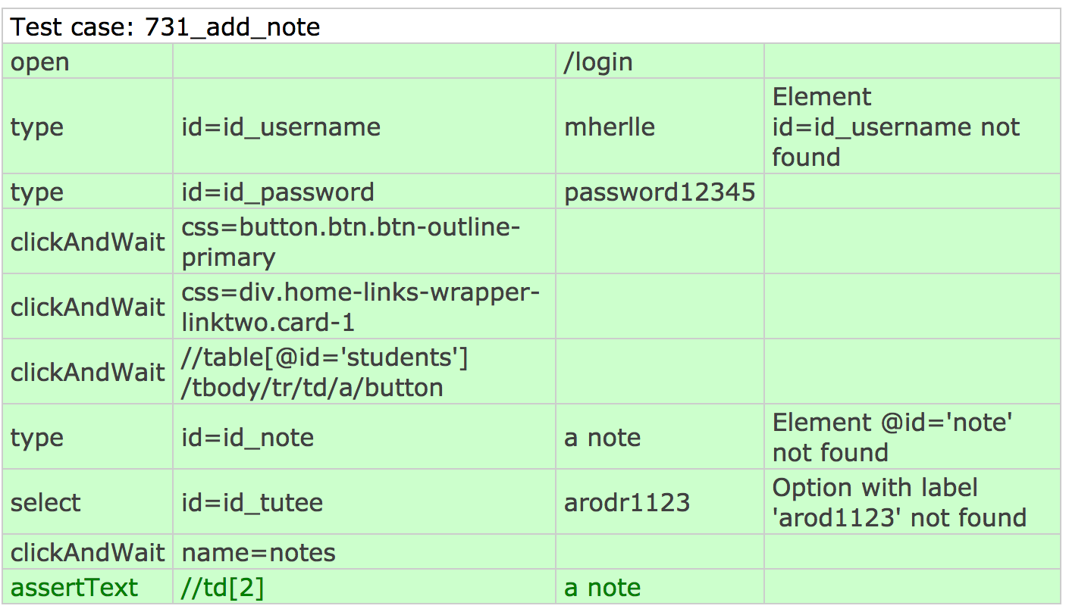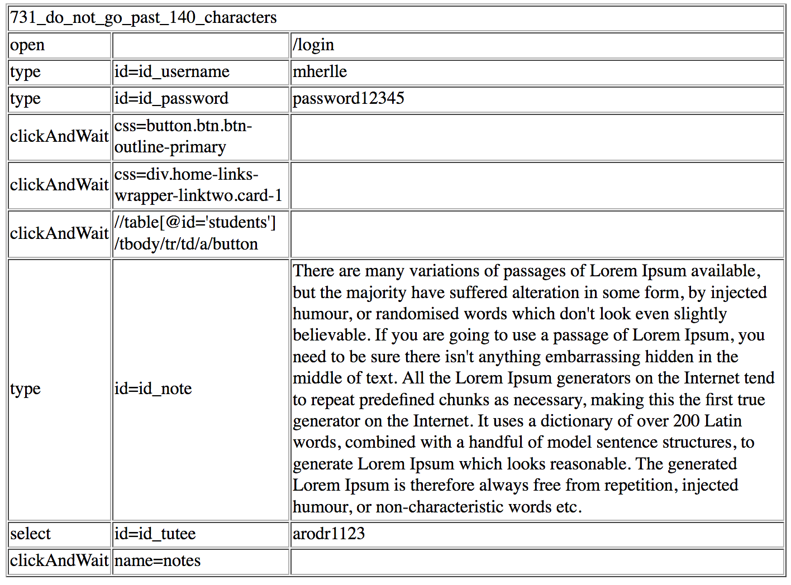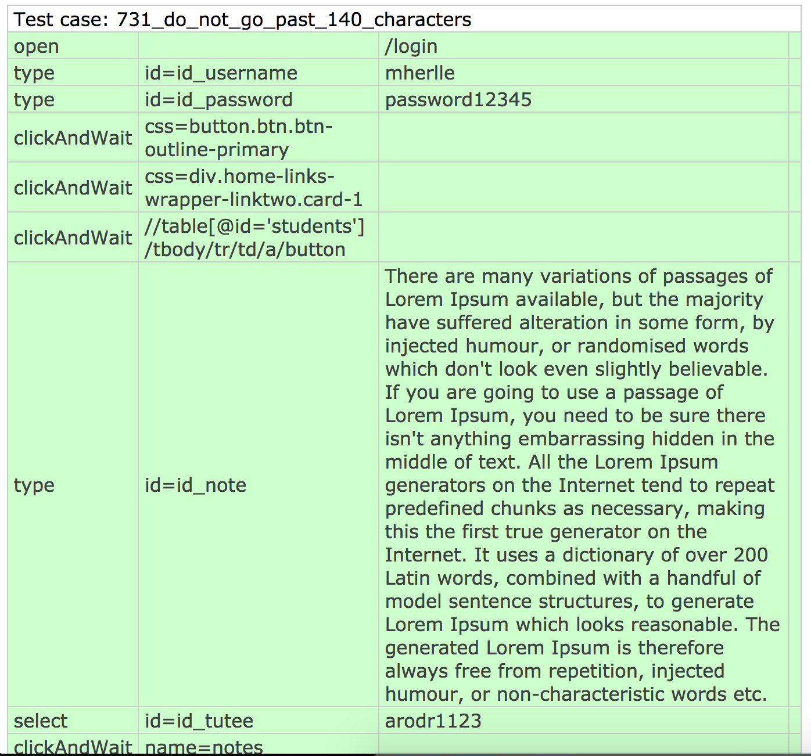

Test Case # 733 Selenium

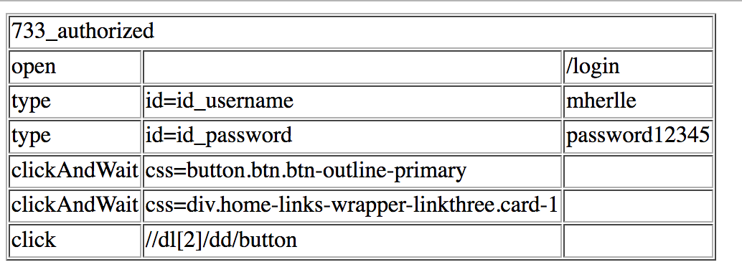

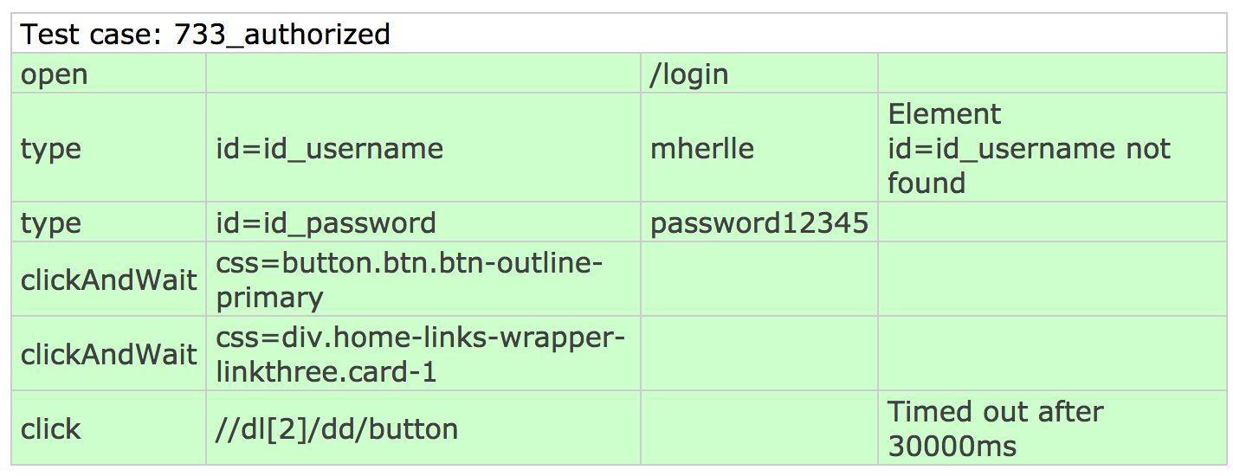

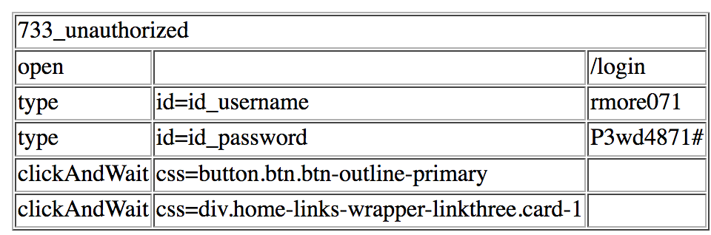

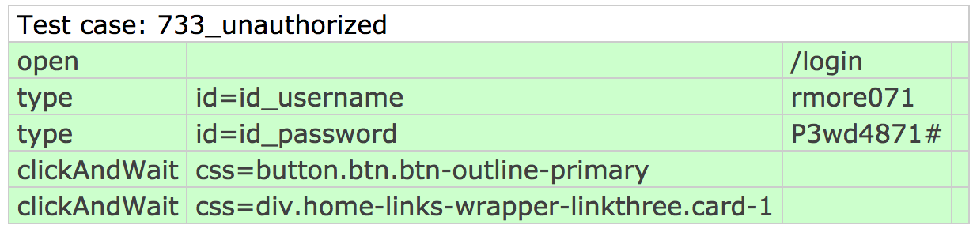

Test Case # 737 Selenium

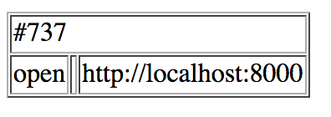

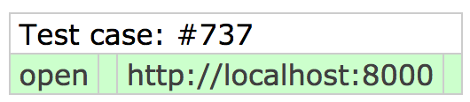

Test Case # 777 Selenium

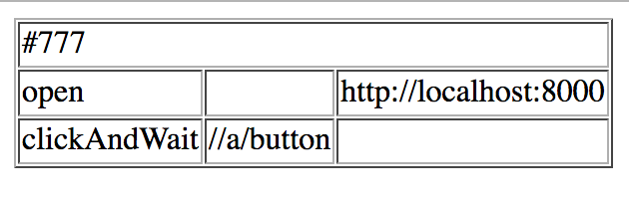

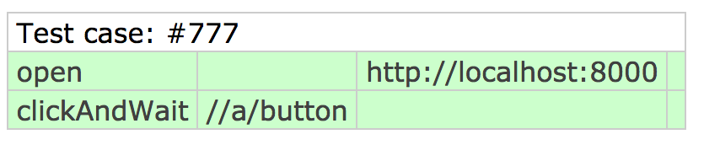

Test Case # 779 Selenium

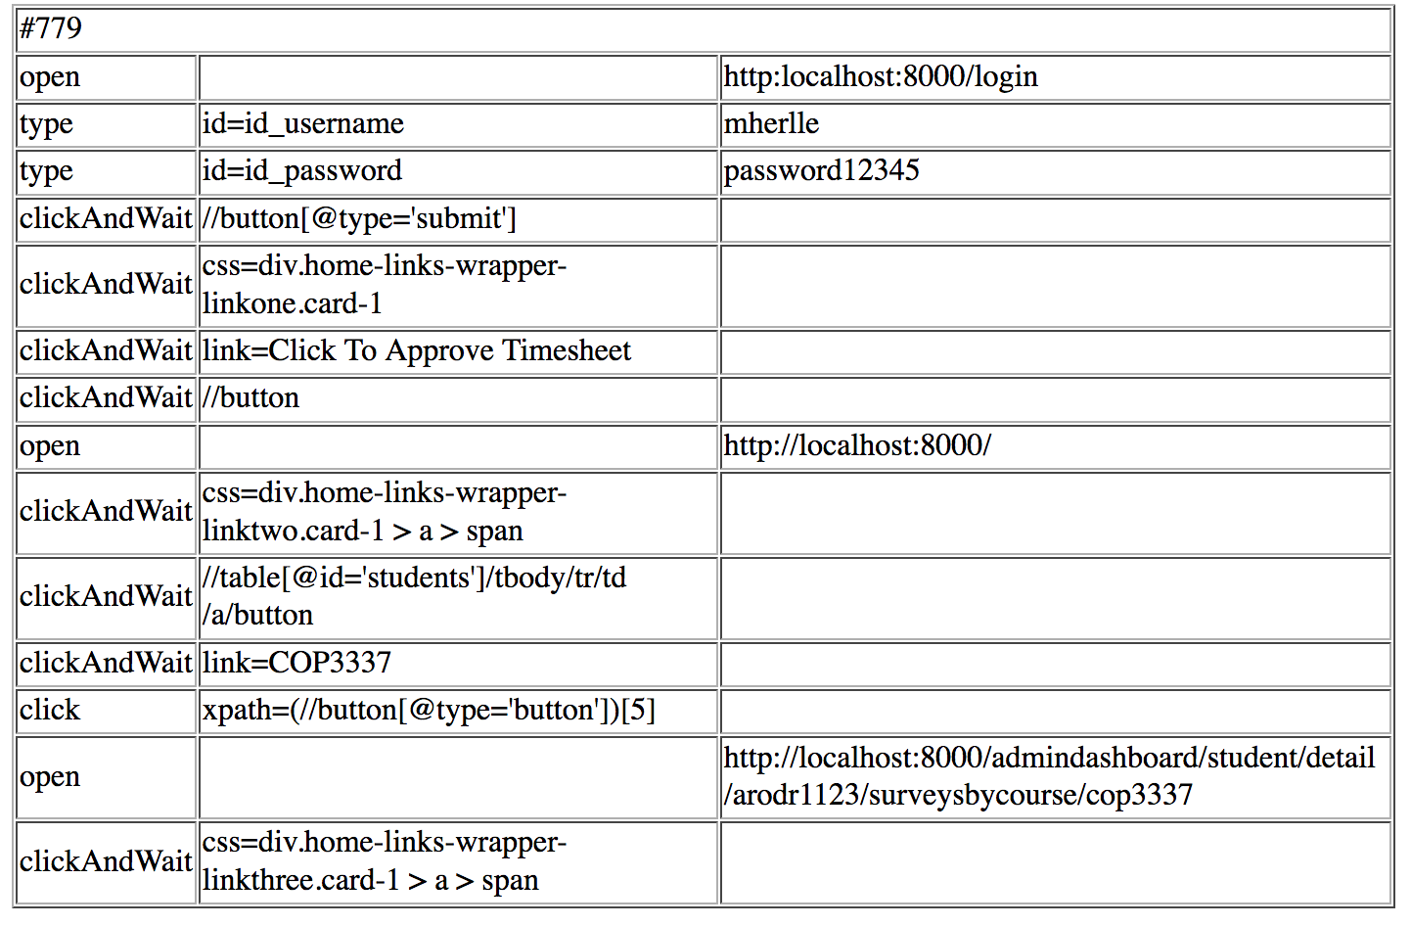

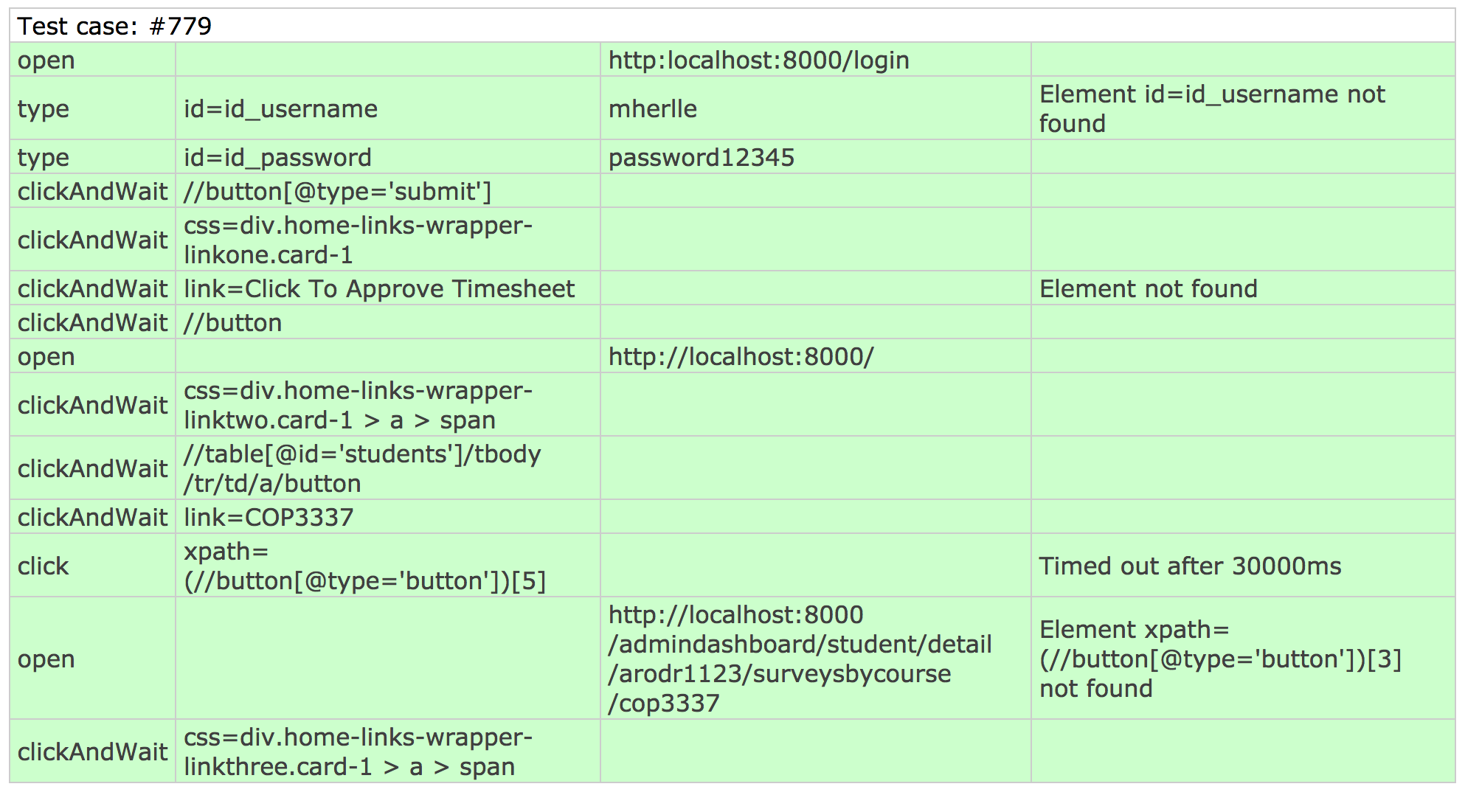

Test Case # 780 Selenium

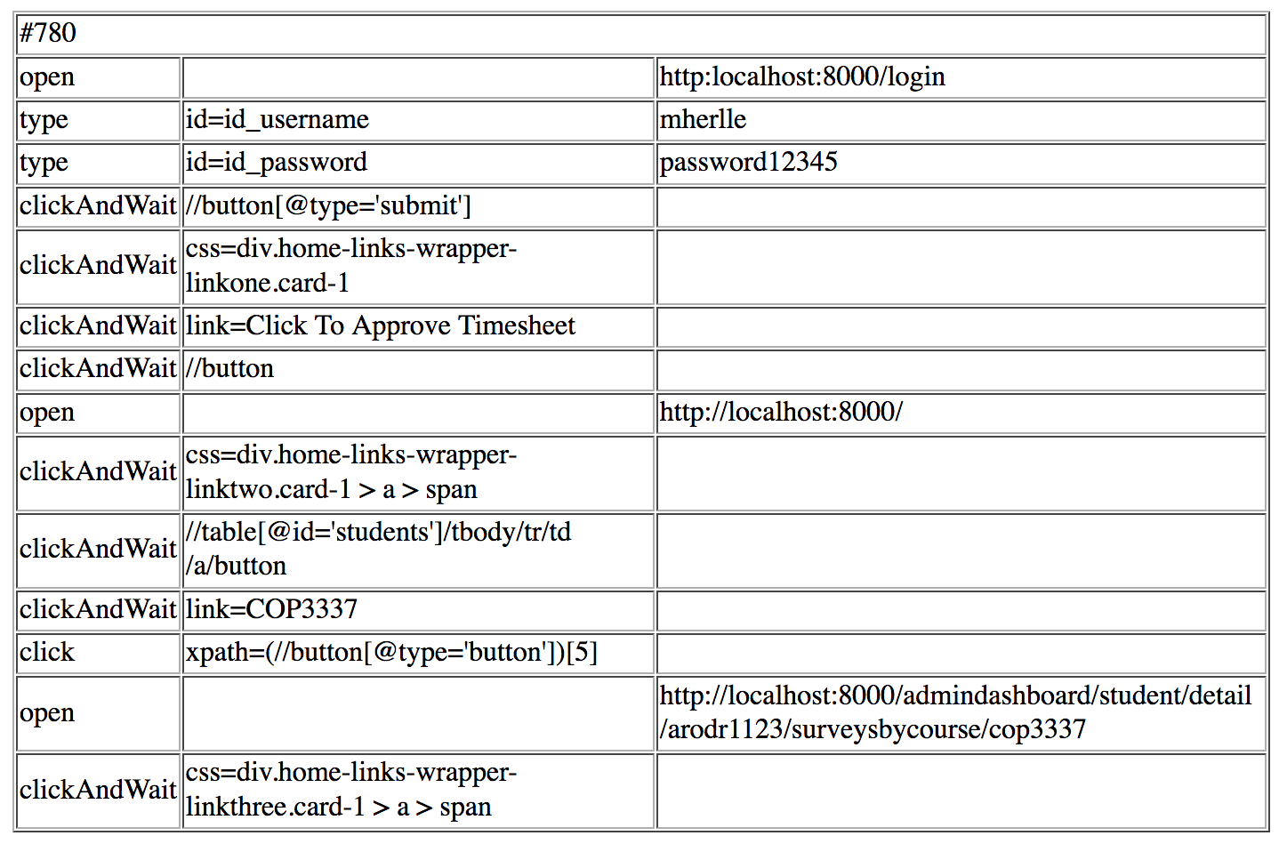

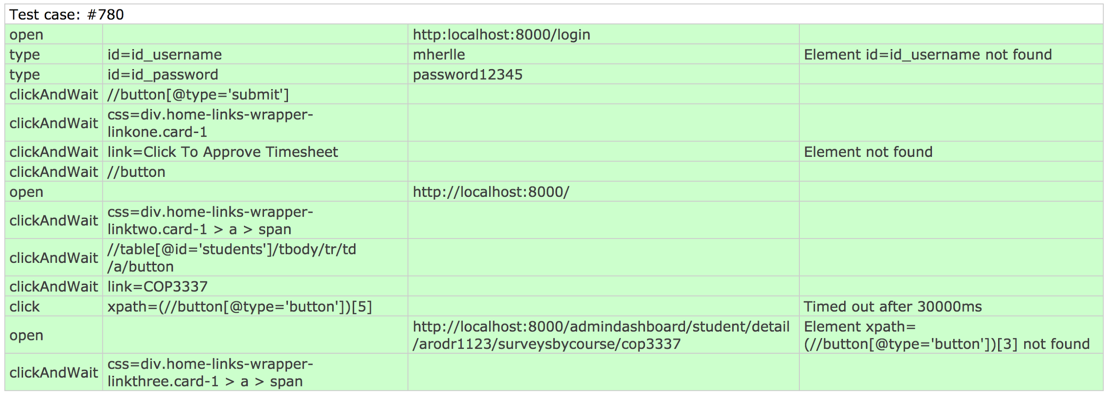

Test Case # 781 Selenium

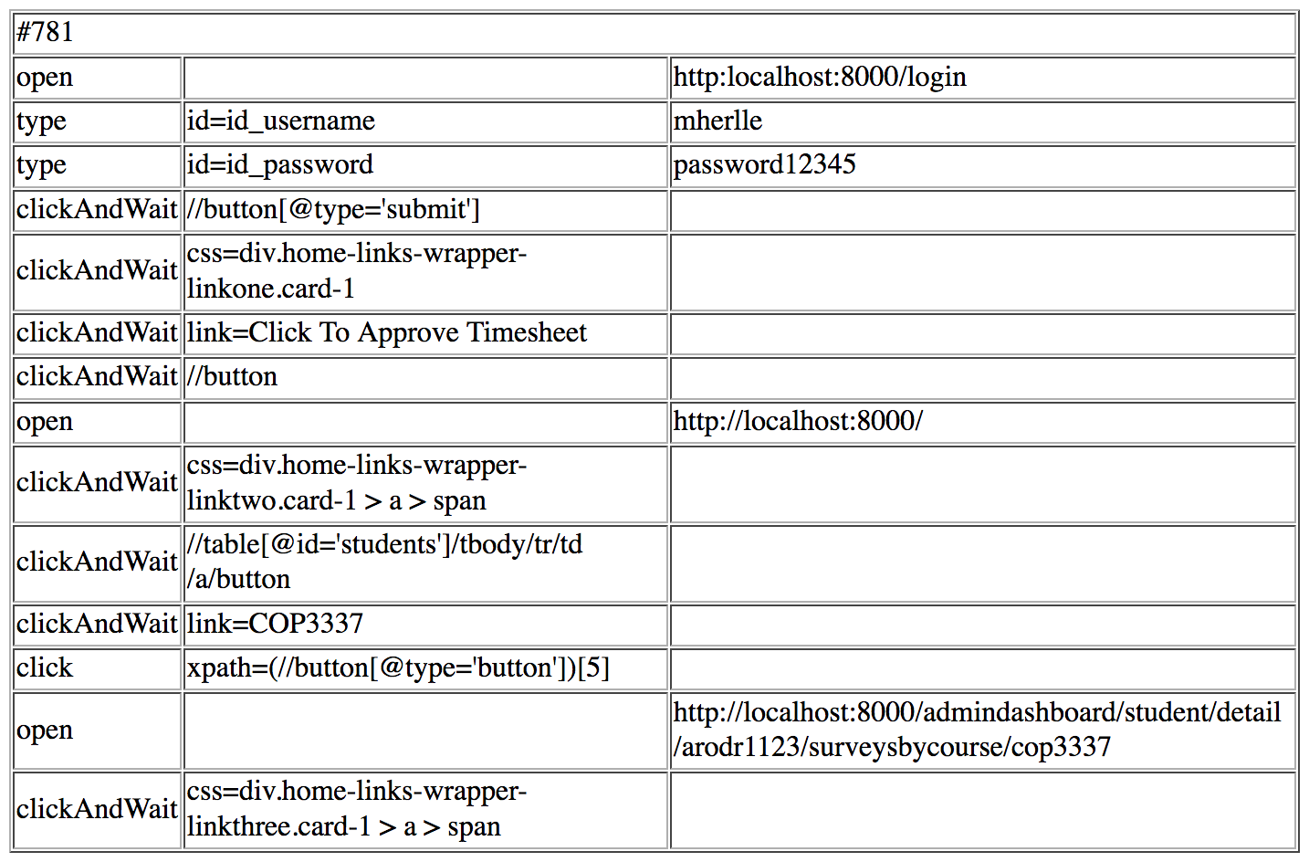

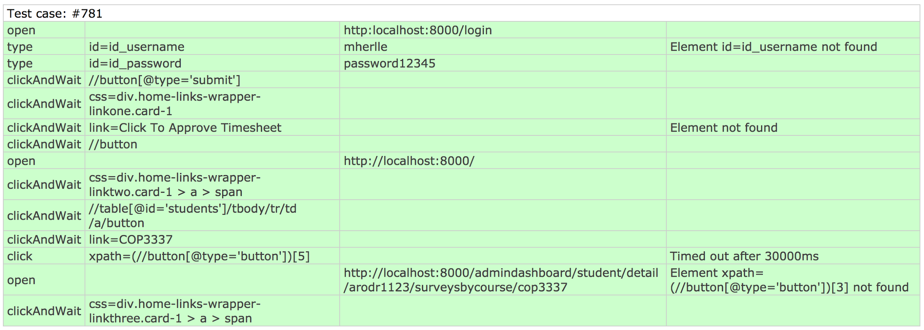

# Glossary

Ambassadors: tutors that are in the ASI organization

ASI: Academic Success Initiative

Tutee: Student that is receiving the tutoring service

# 

# Appendix

## Appendix A - UML Diagrams

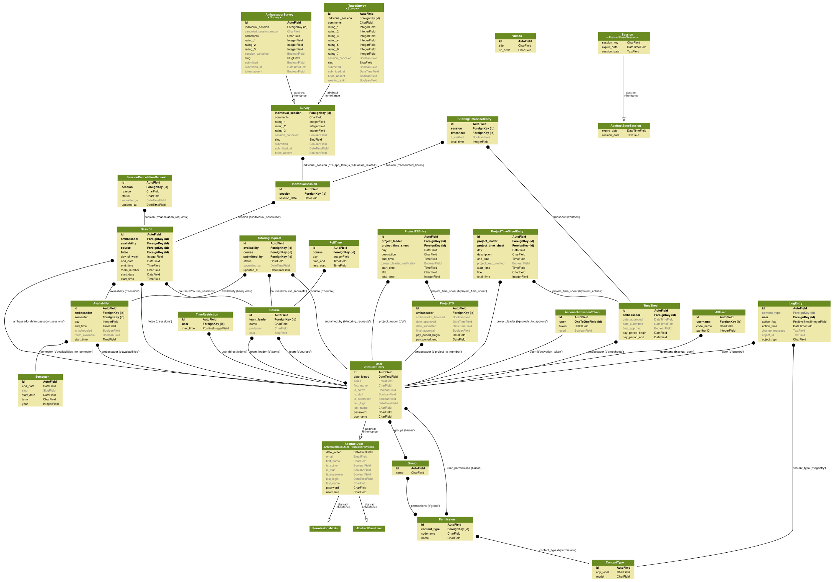

Full Size png available upon request

***Static UML Diagrams***

User Story # 666 Class Diagram: View Current Tutees

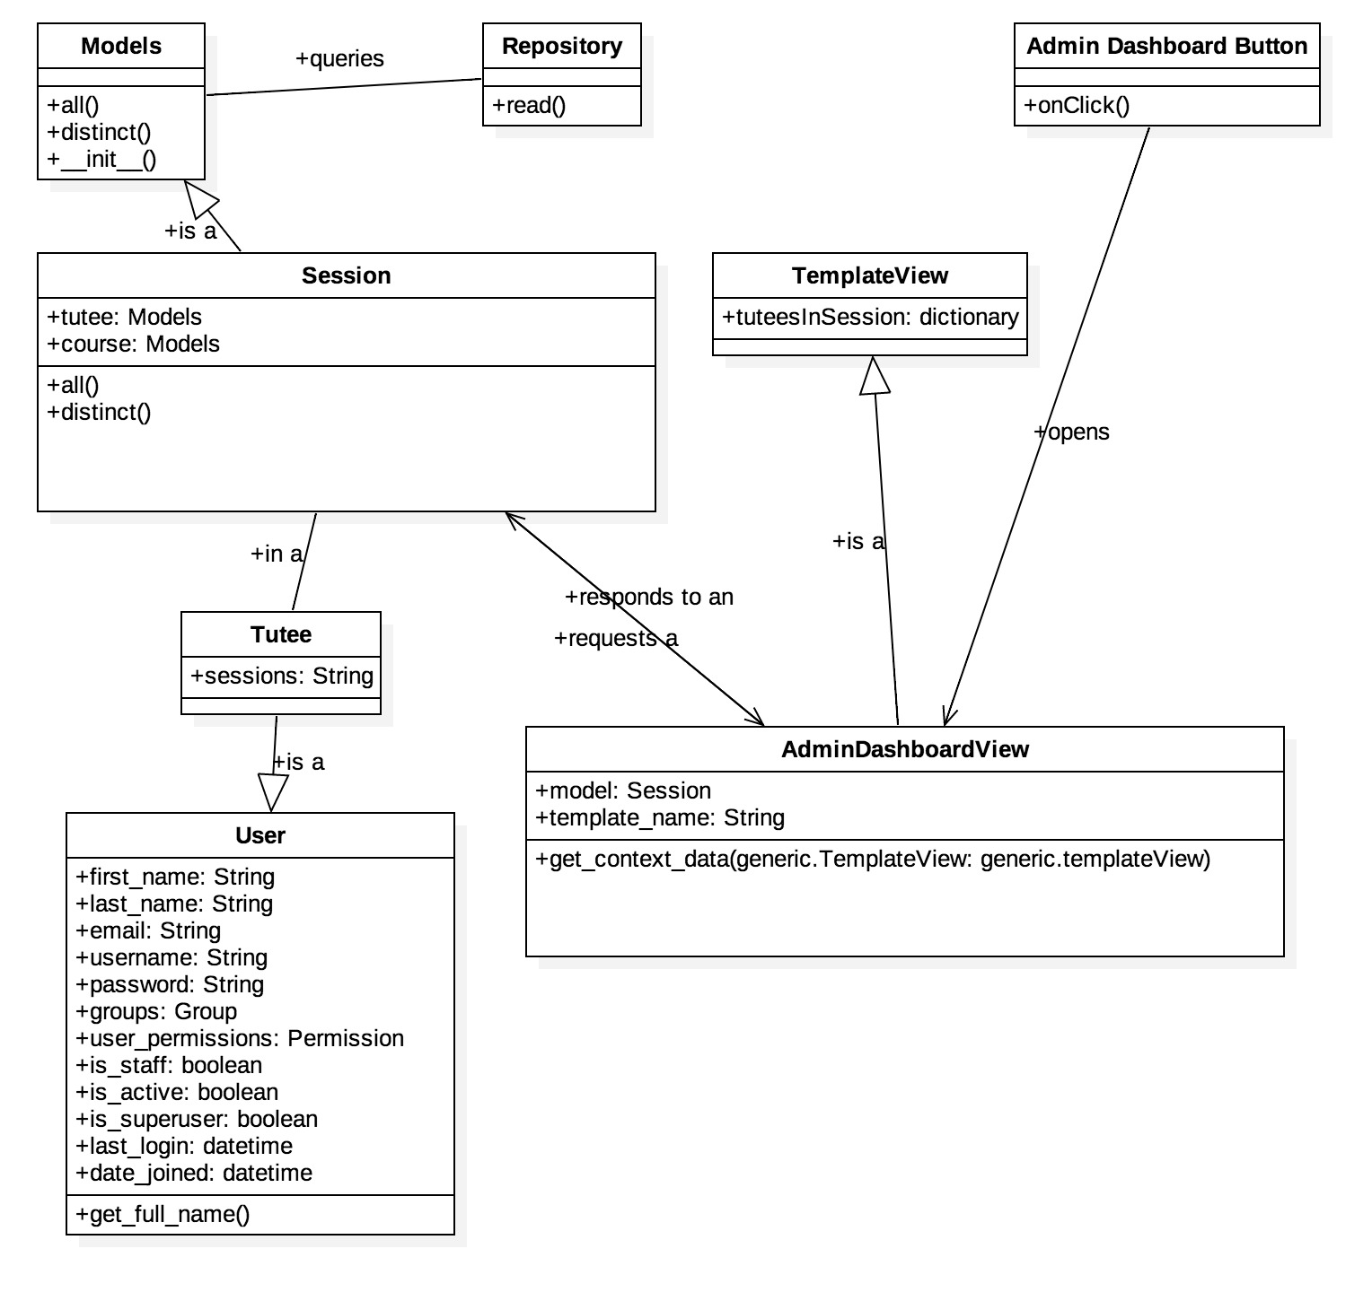

User Story # 667 Class Diagram: View Current Tutees

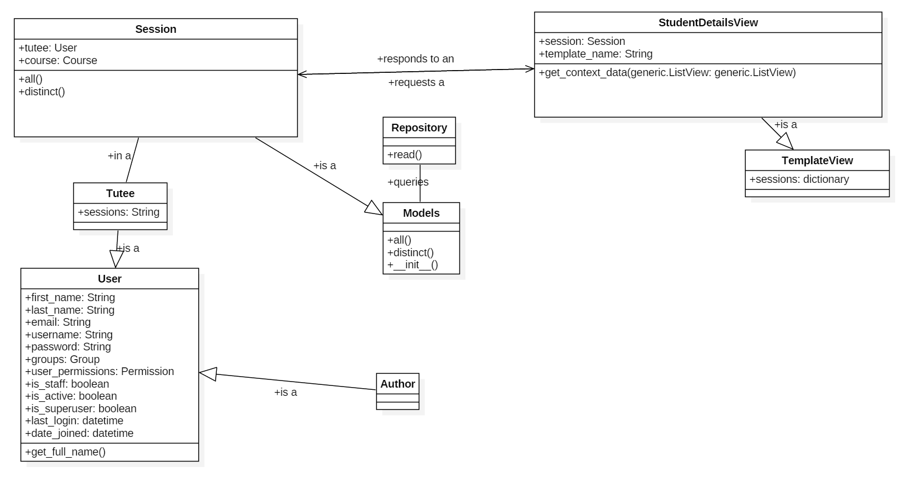

User Story # 678 Class Diagram: Create user profile

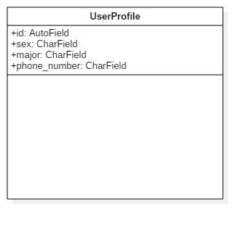

User Story # 717 Class Diagram: View average rating of tutee and ambassador per session in surveys by course

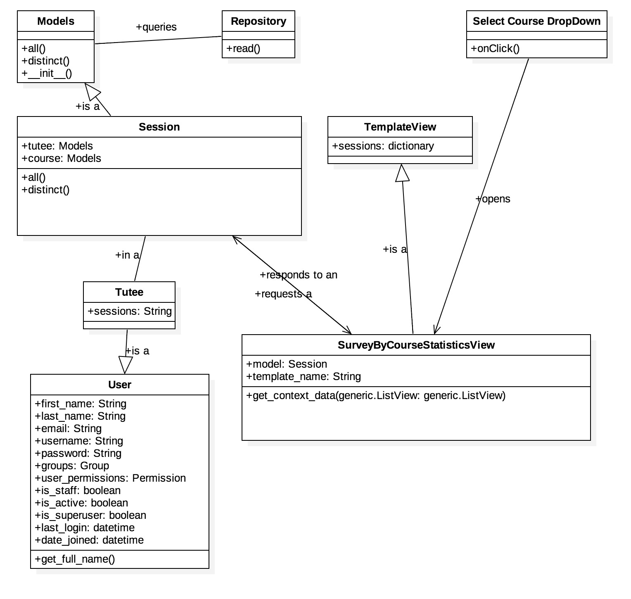

User Story # 718 Class Diagram: View the drop down menu for survey by course in the student view

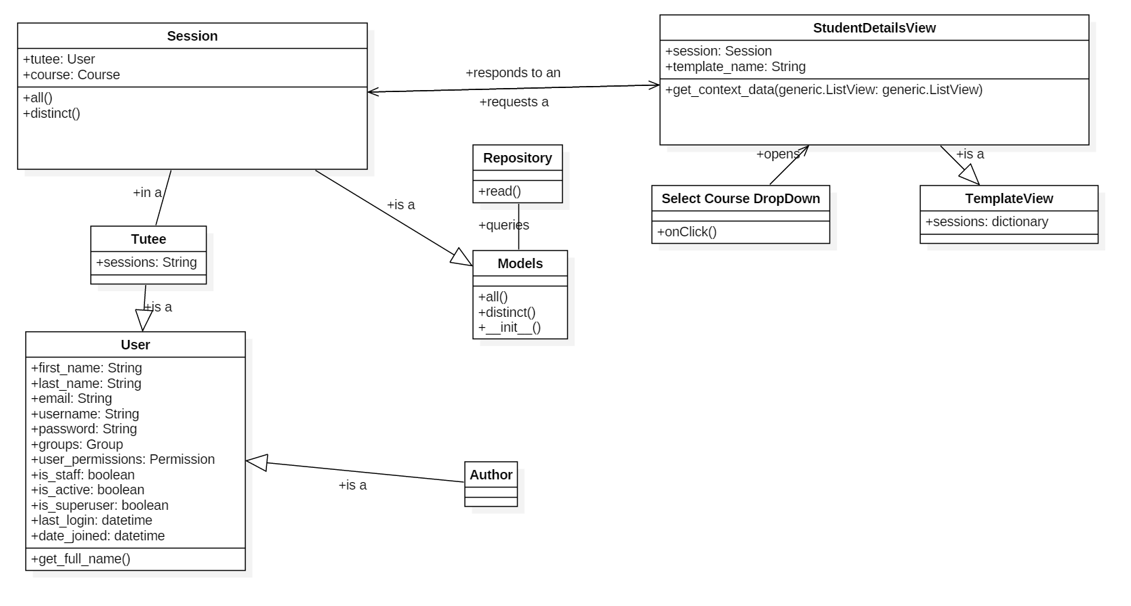

User Story # 731 Class Diagram: Write notes on the student profile

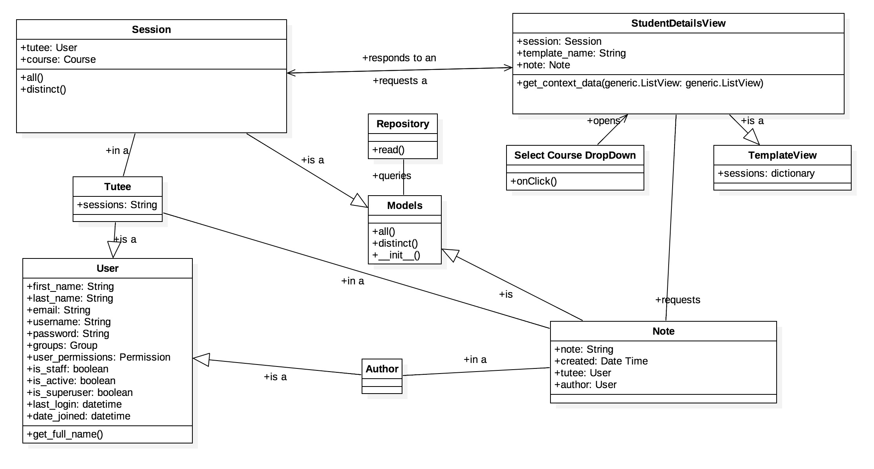

User Story # 732 Class Diagram: Display number of actual tutoring sessions vs scheduled sessions

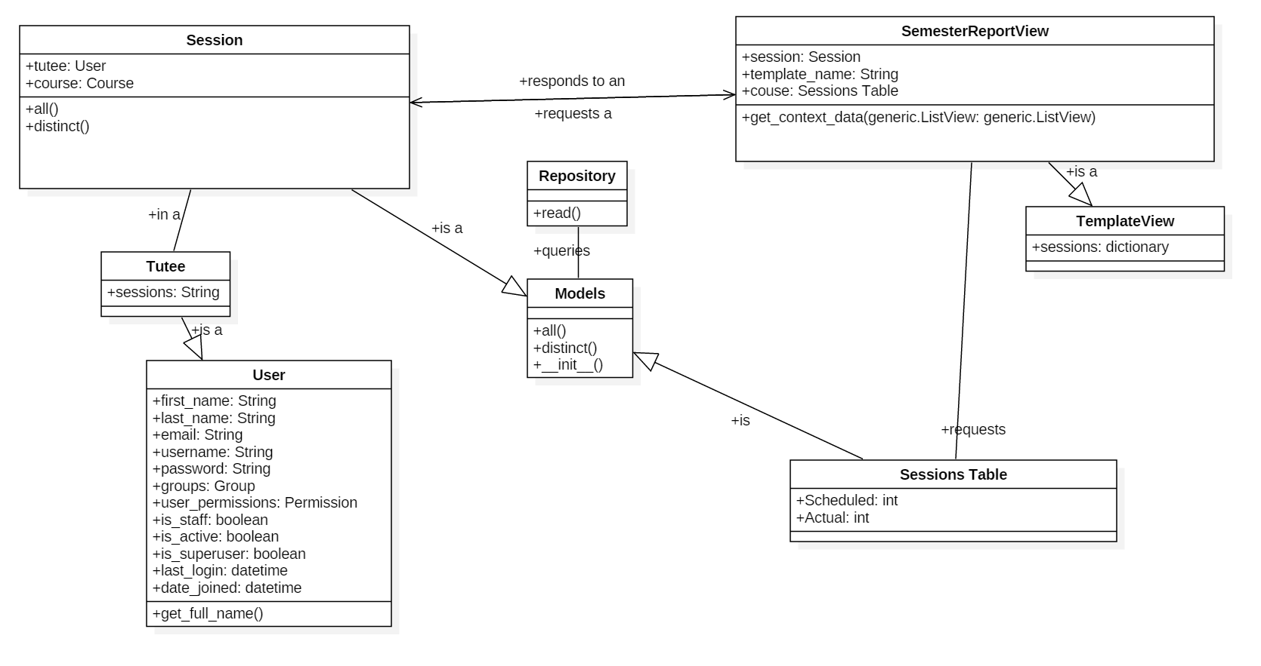

User Story # 733 Class Diagram: Show information about courses for the semester

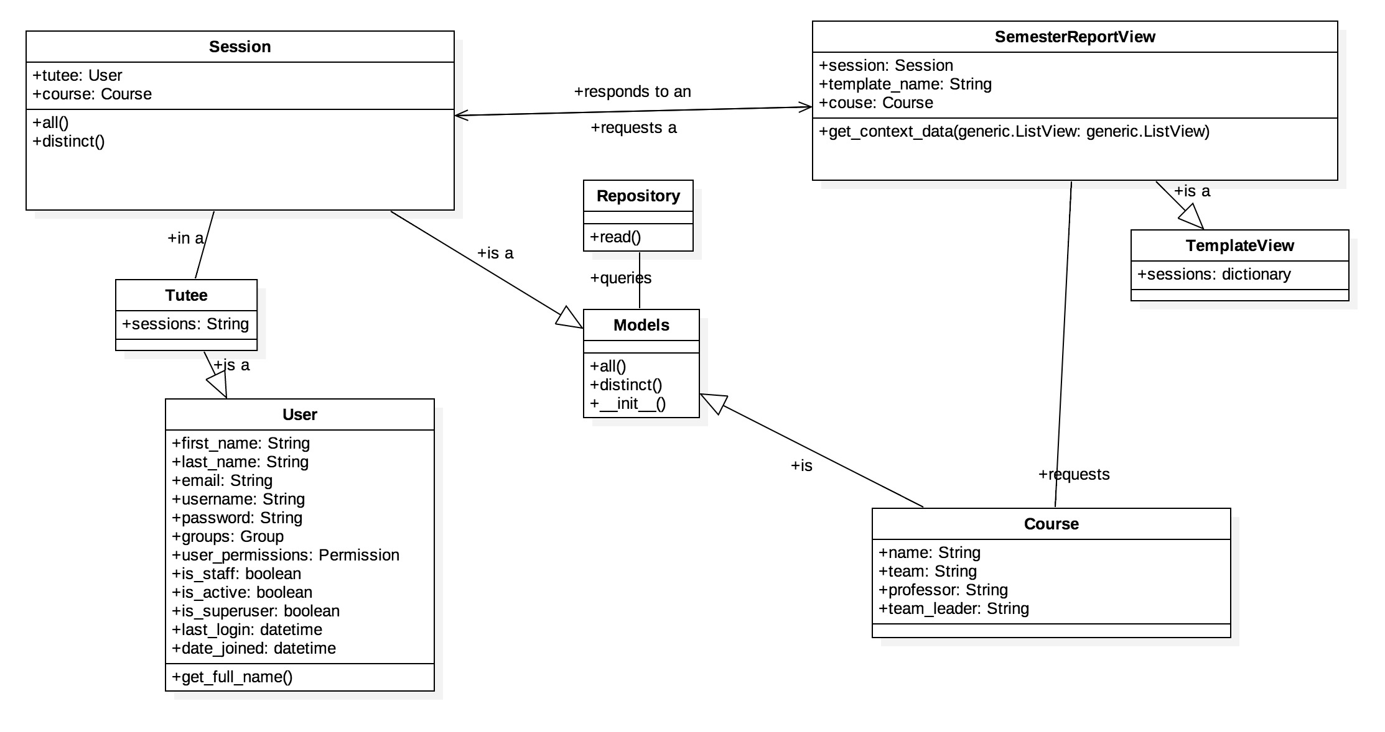

User Story # 735 Class Diagram: Show information about ambassadors from the semester

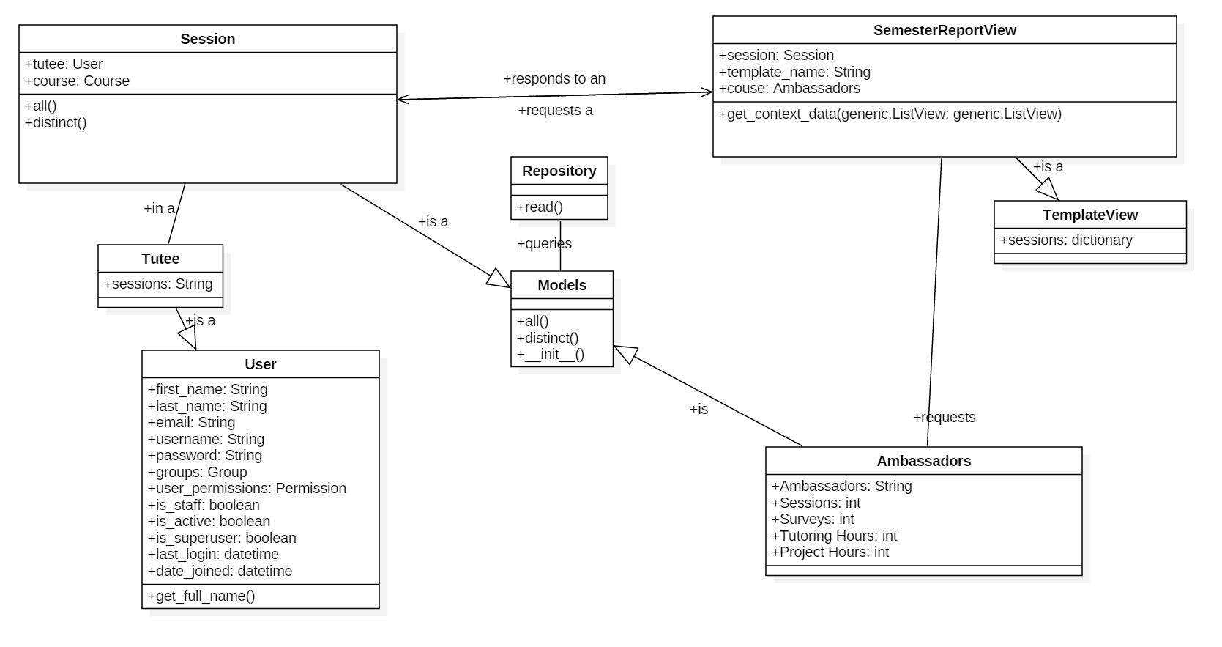

User Story #739 Class Diagram: Download an Excel file of the report  
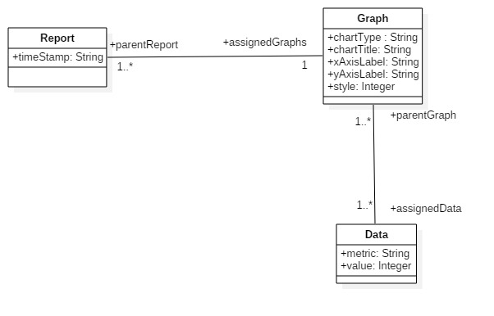

***Dynamic UML Diagrams***

User Story # 666 Sequence Diagram: View Current Tutees

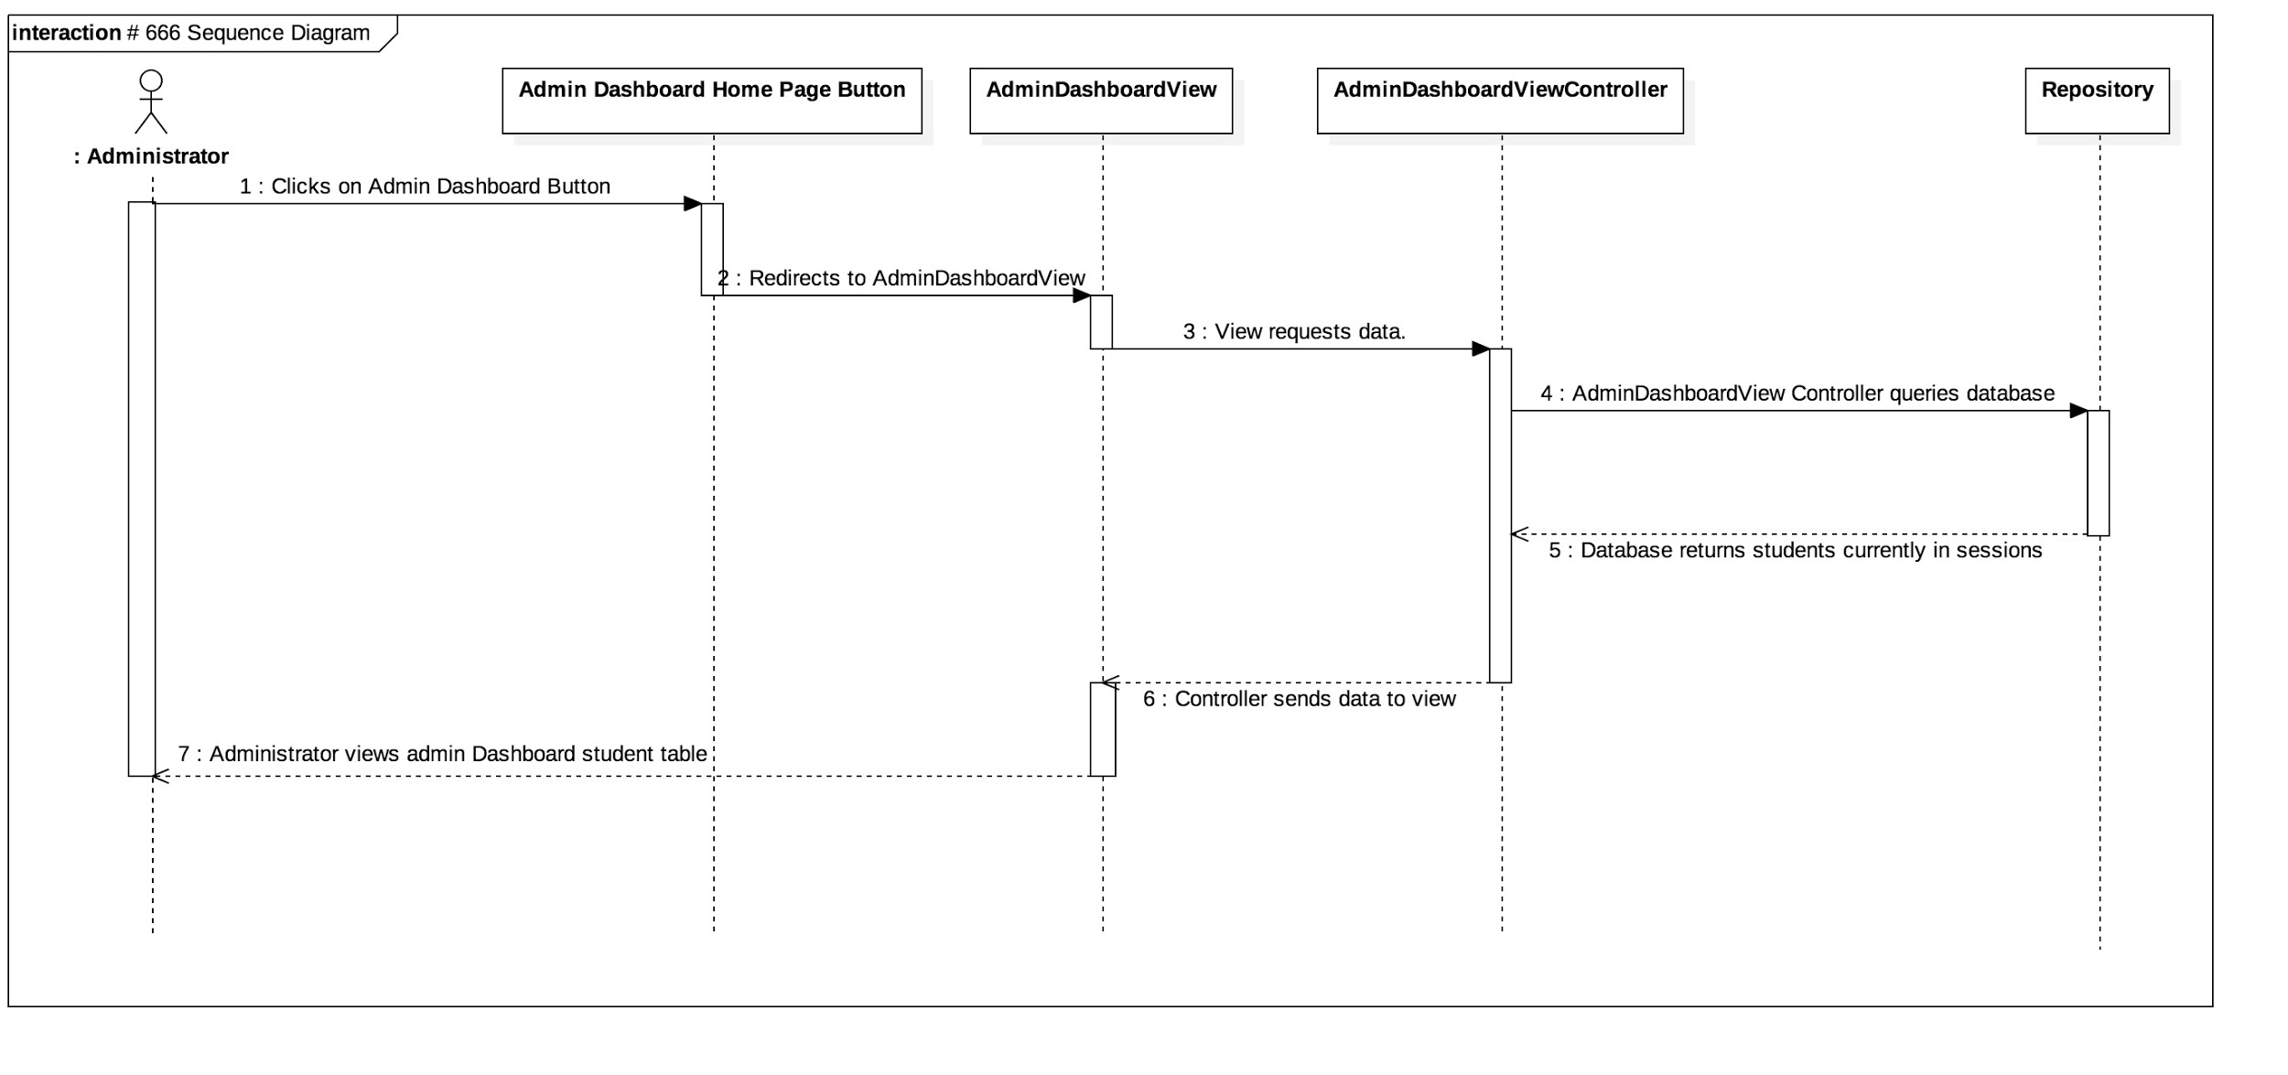

User Story # 668 Sequence Diagram: Sort list of students by name

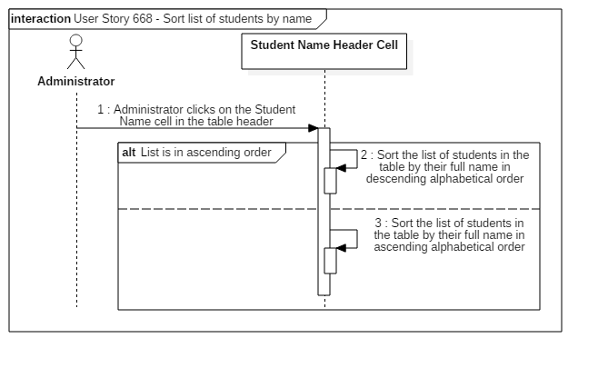

User Story # 669 Sequence Diagram: Sort list of students by major

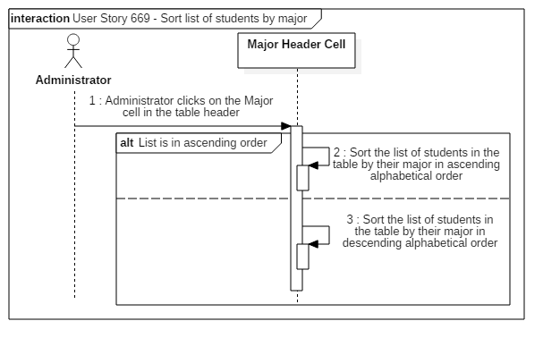

User Story # 670 Sequence Diagram: Filter list of students by name

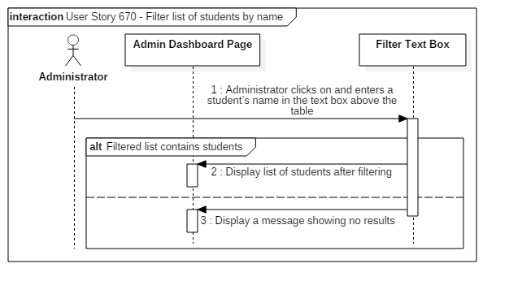

User Story # 678 Sequence Diagram: Create user profile

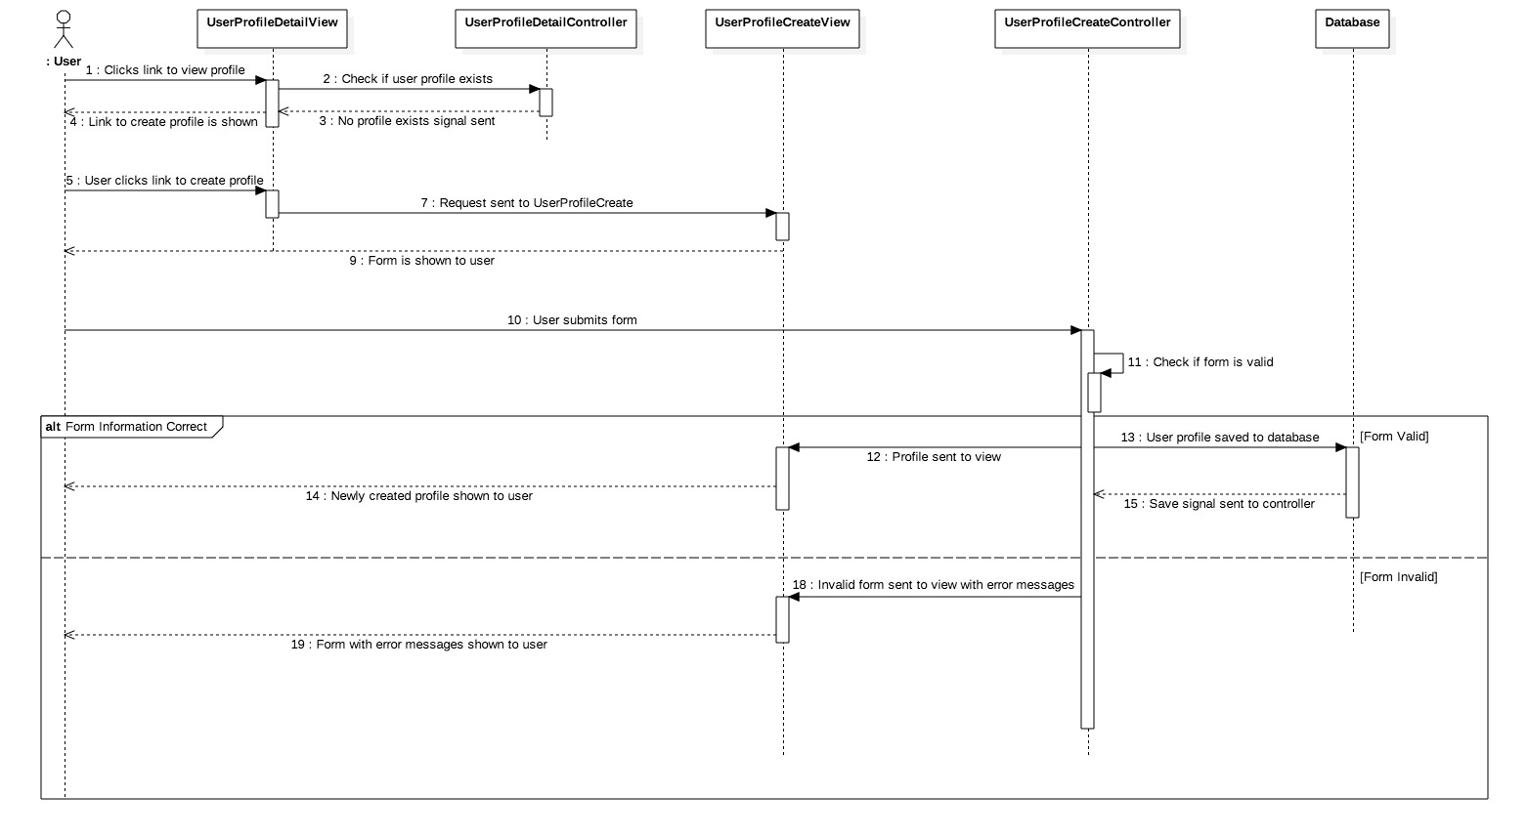

User Story # 711 Sequence Diagram: View overall statistics

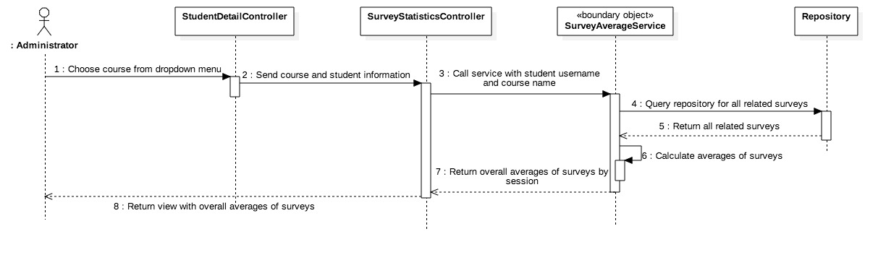

User Story # 712 Sequence Diagram: View detailed survey information

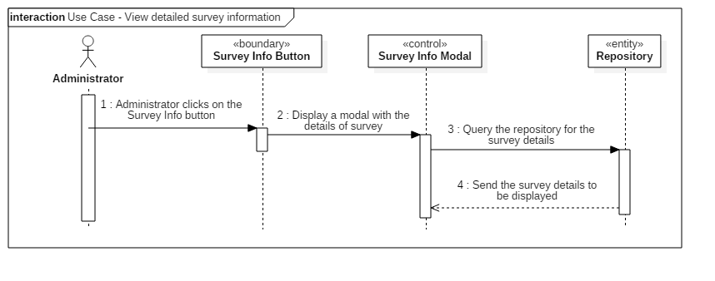

User Story # 717 Sequence Diagram: View average rating of tutee and ambassador per session in surveys by course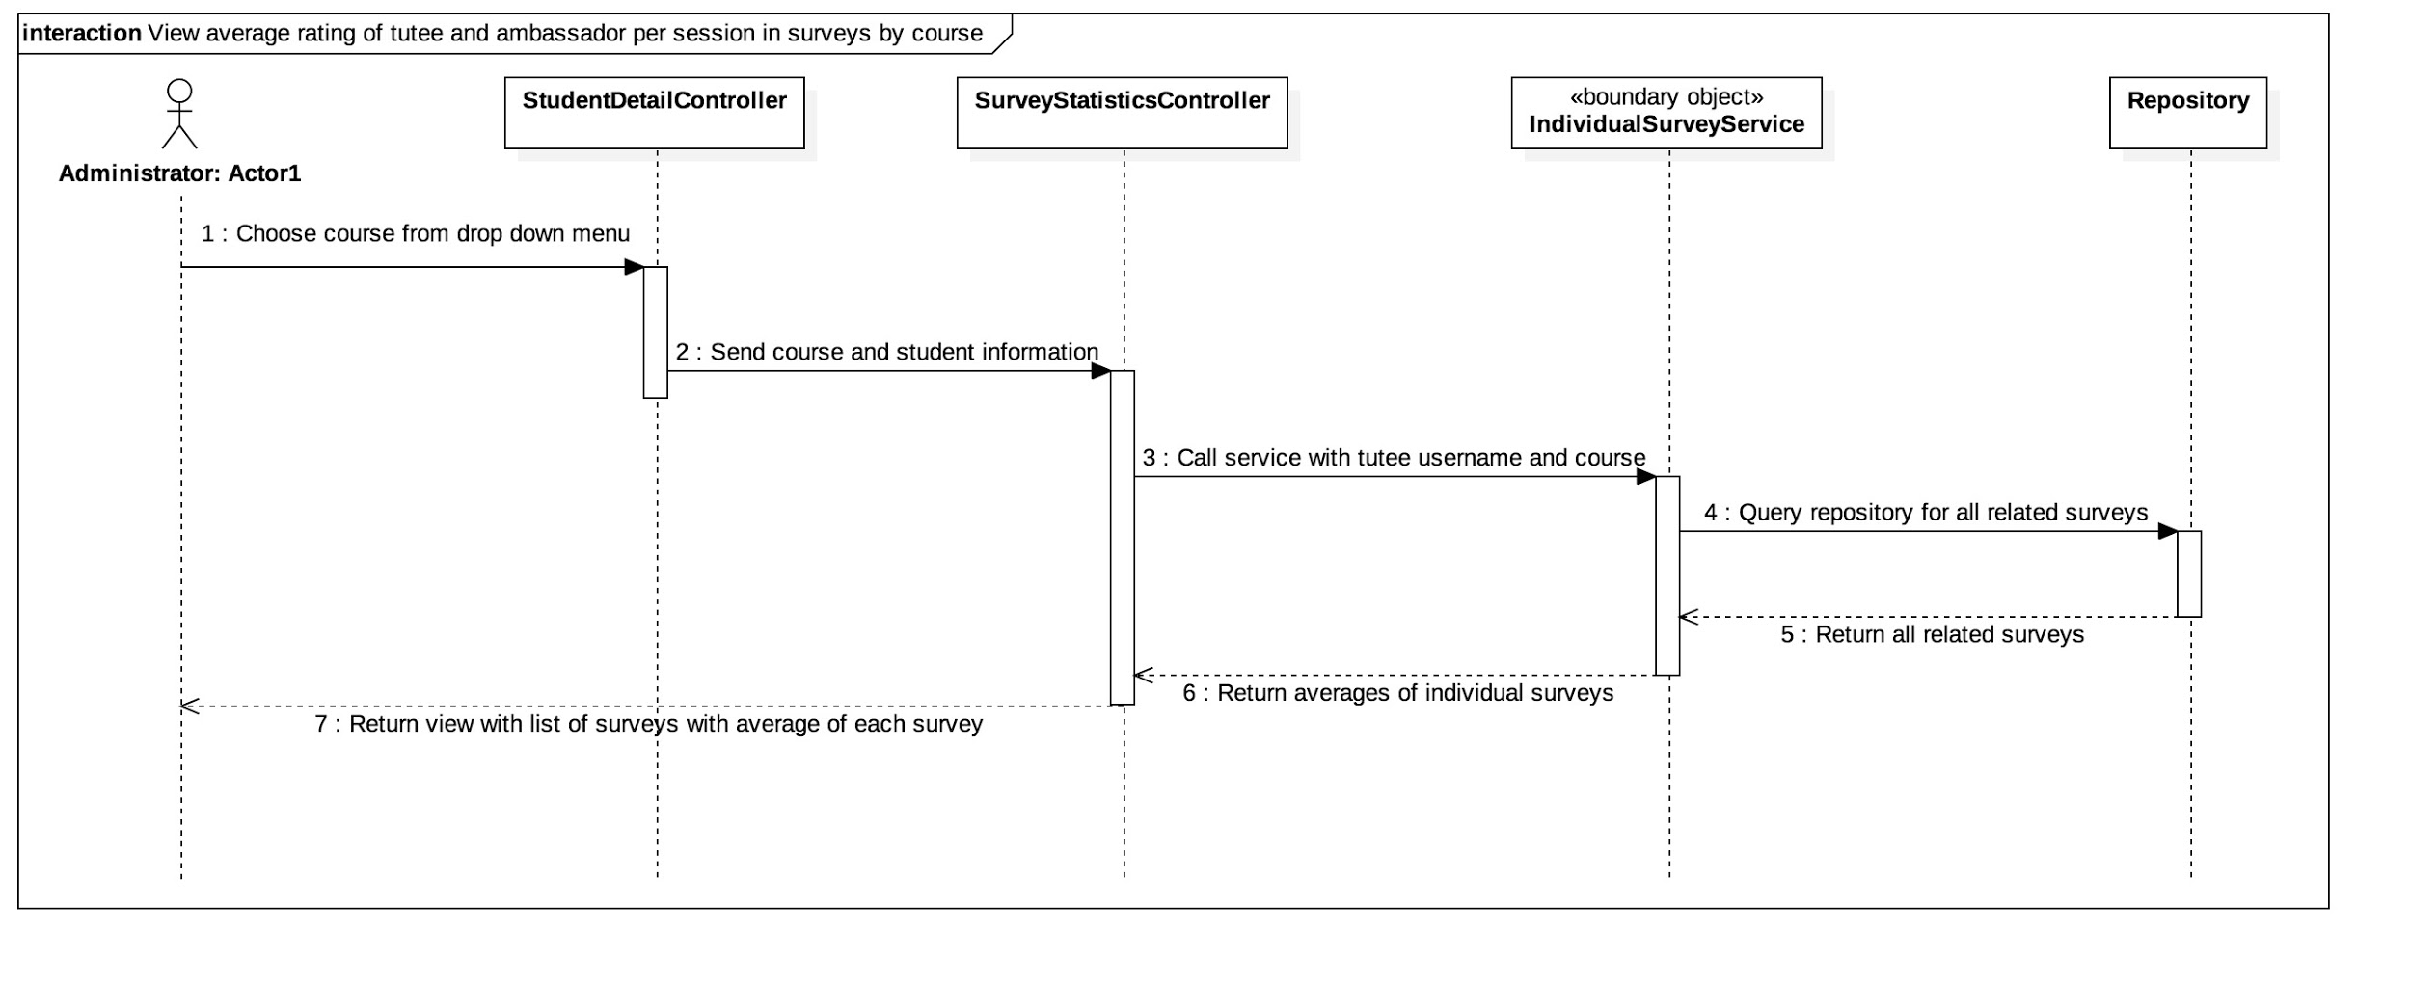

User Story # 731 Sequence Diagram: Write notes on the student profile

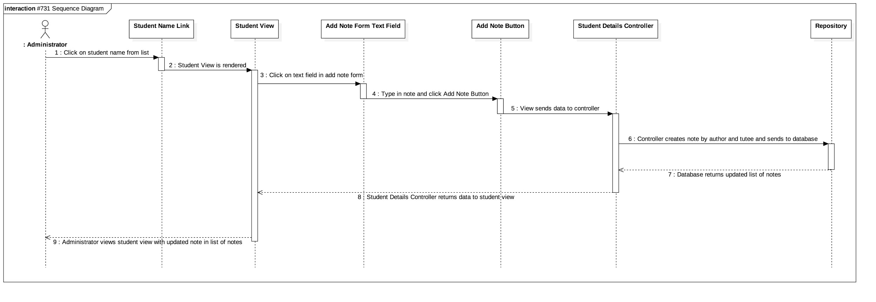

User Story # 733 Sequence Diagram: Show information about courses for the semester

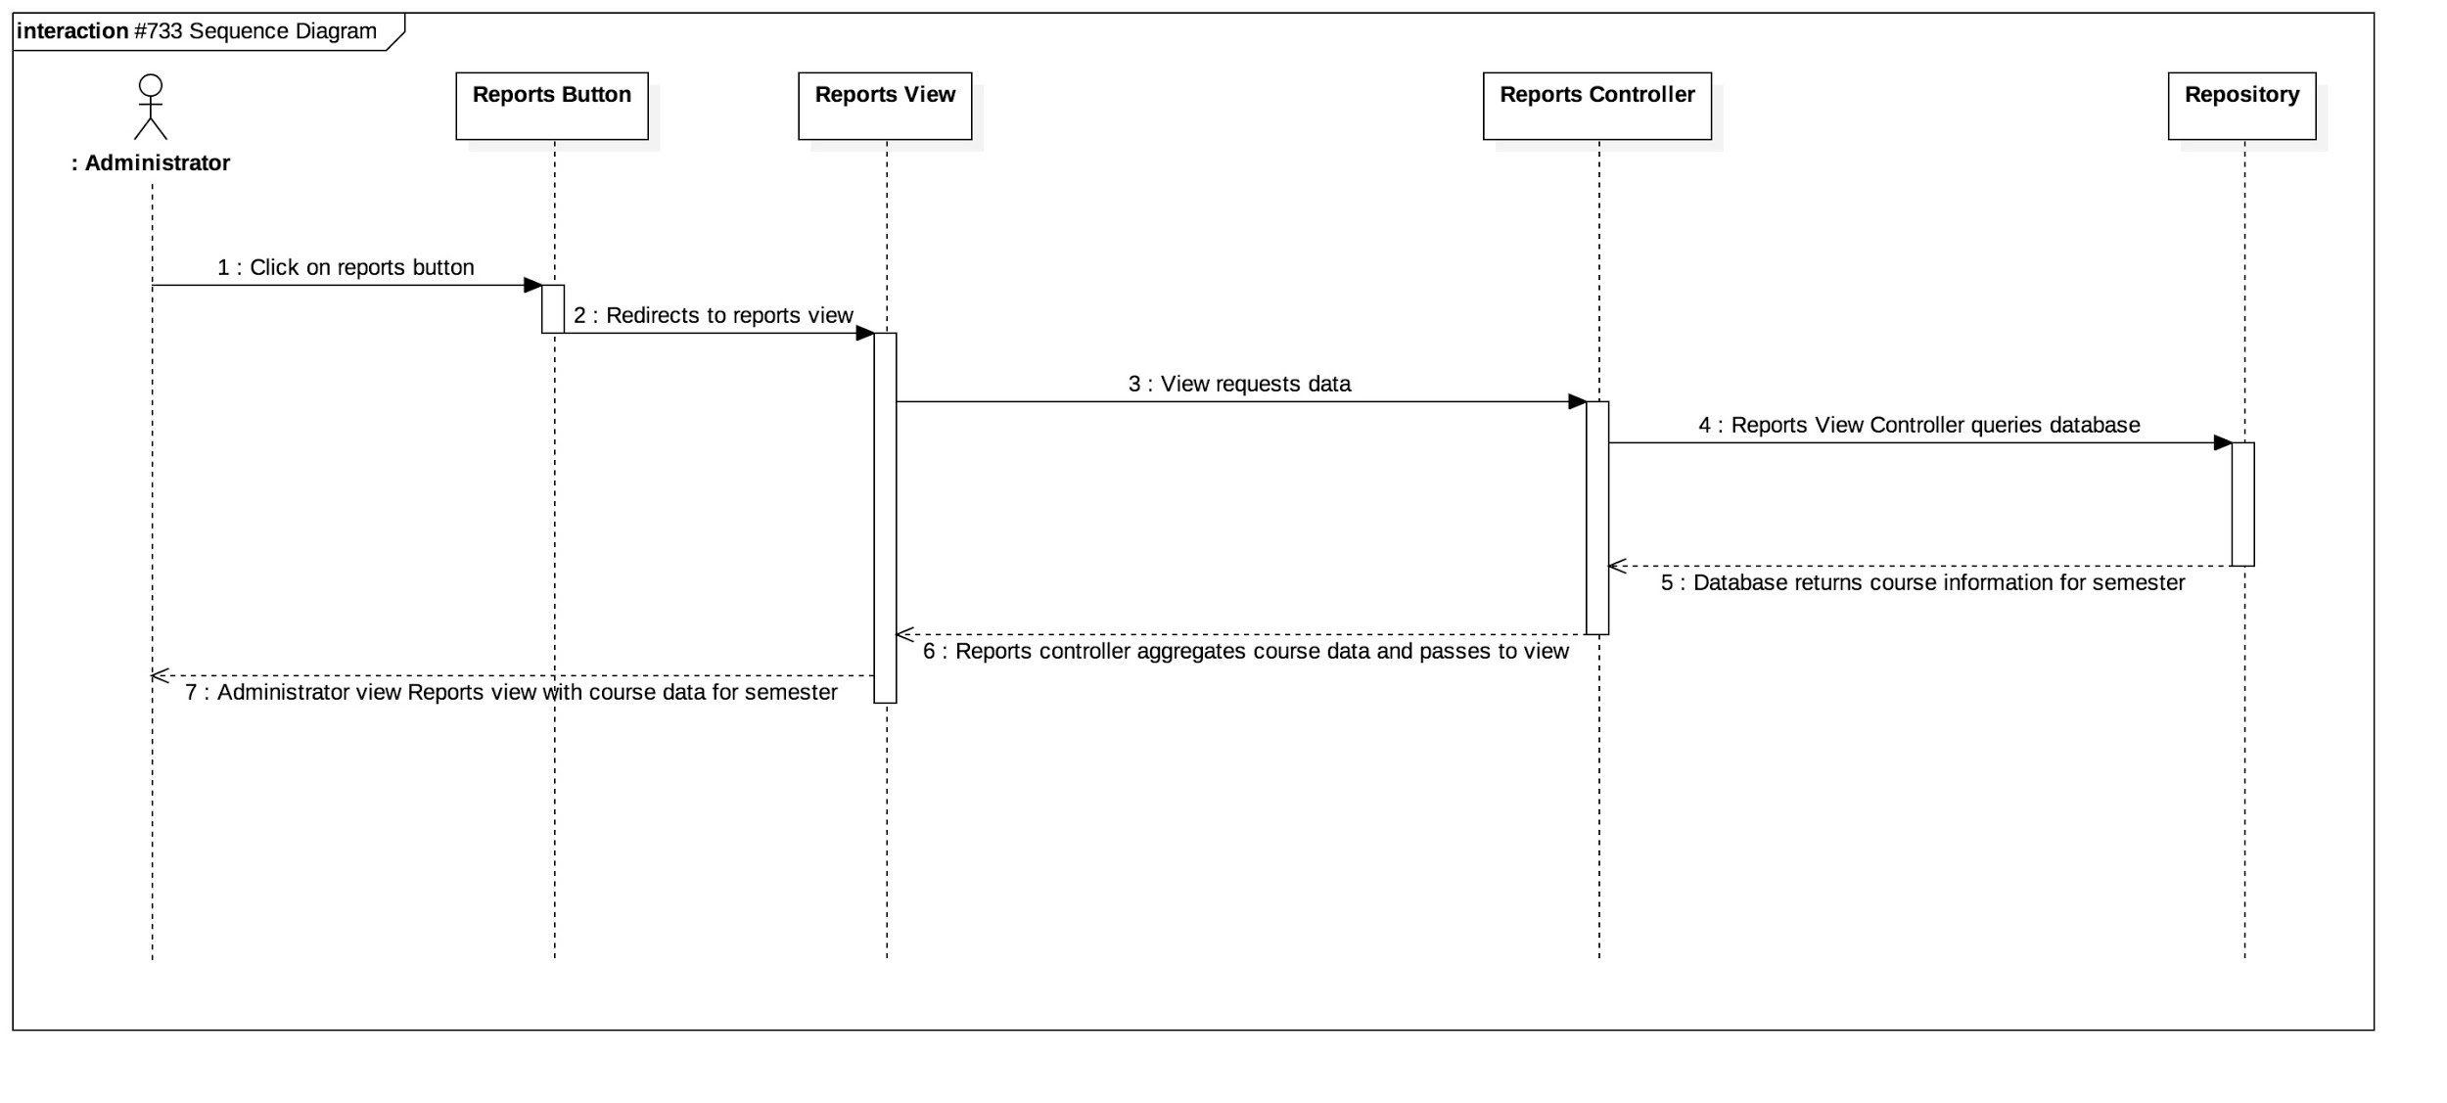

User Story # 734 Sequence Diagram: View information for tutees from the semester

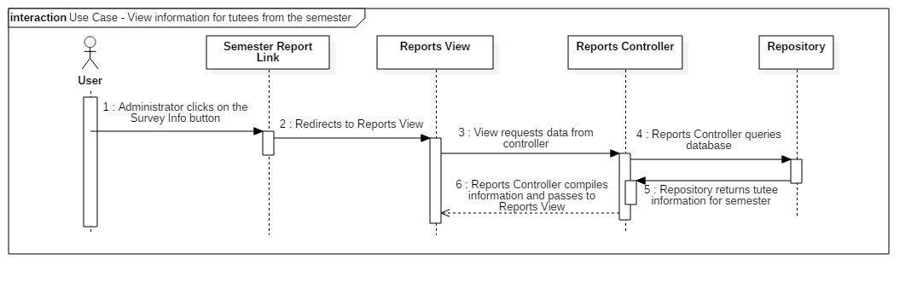

User Story # 737 Sequence Diagram : Change Login Page User Interface

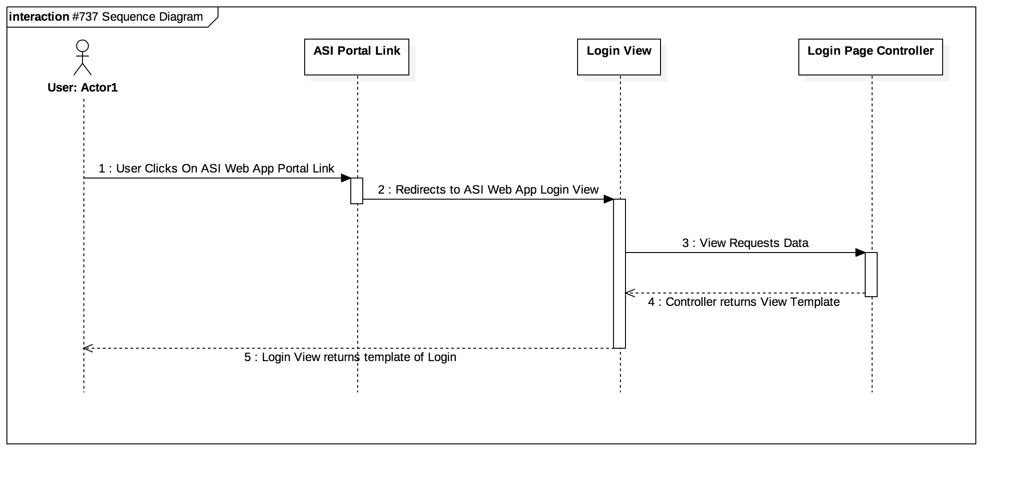

User Story #739 Sequence Diagram: Download an Excel file of the report

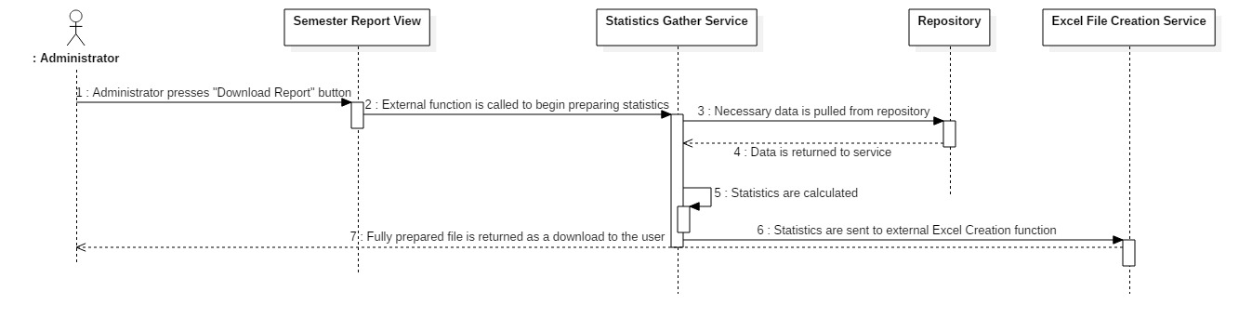

User Story # 740 Sequence Diagram: System should notify tutee of upcoming session

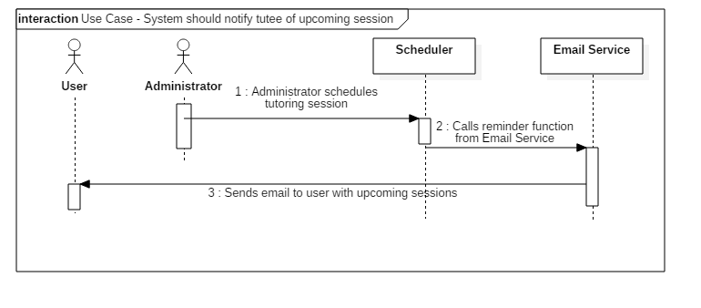

User Story # 741 Sequence Diagram: System should notify ambassador of upcoming session

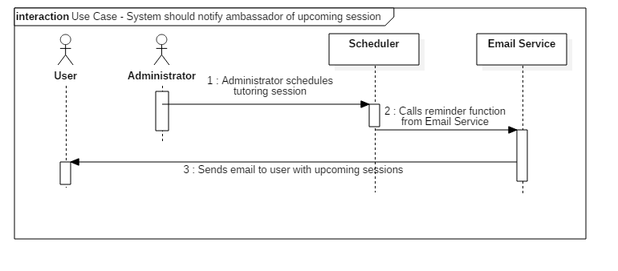

User Story # 777 Sequence Diagram : Change Sign Up Page User Interface

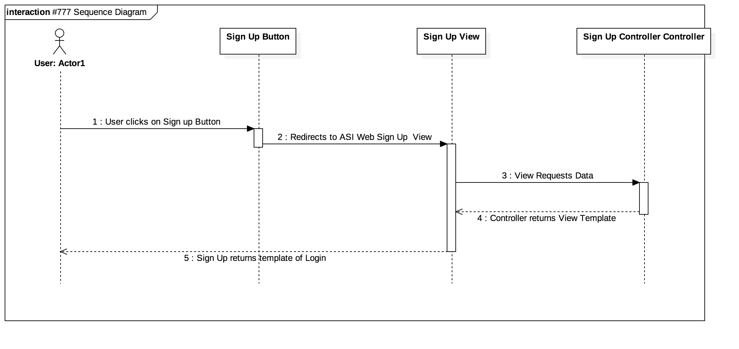

## User Story # 779 Sequence Diagram: Change Administrator UI

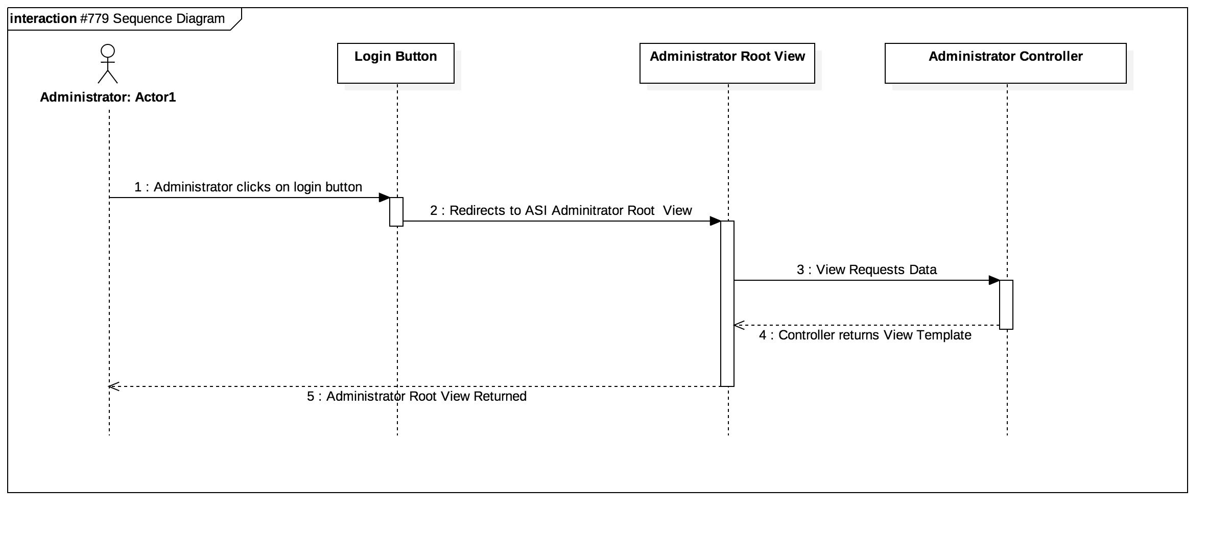

## User Story # 780 Sequence Diagram: Change Administrator Header UI

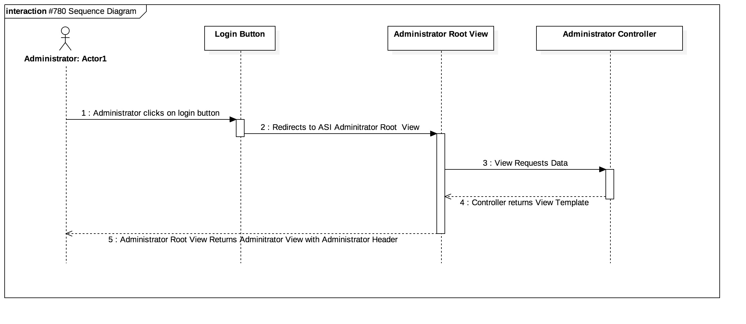

## User Story # 781 Sequence Diagram: Change Administrator Footer UI

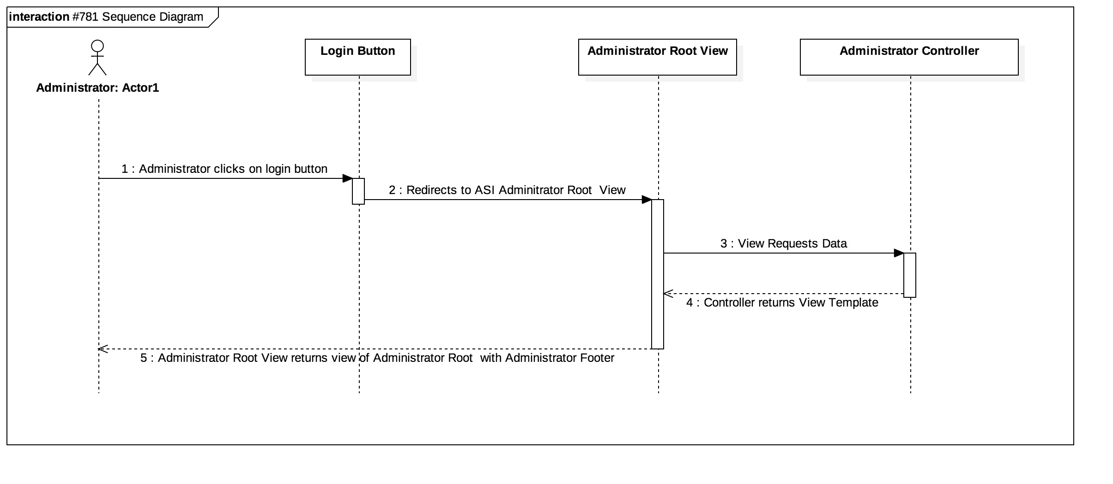

## Appendix B - User Interface Design

User Story # 666 View Current Tutees

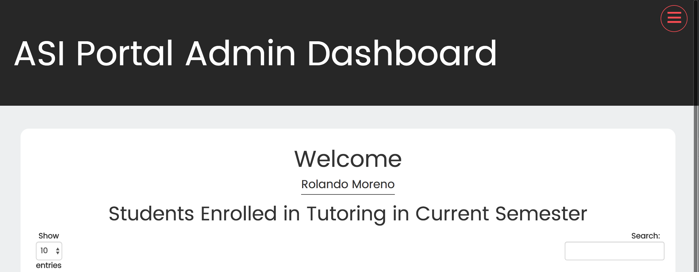

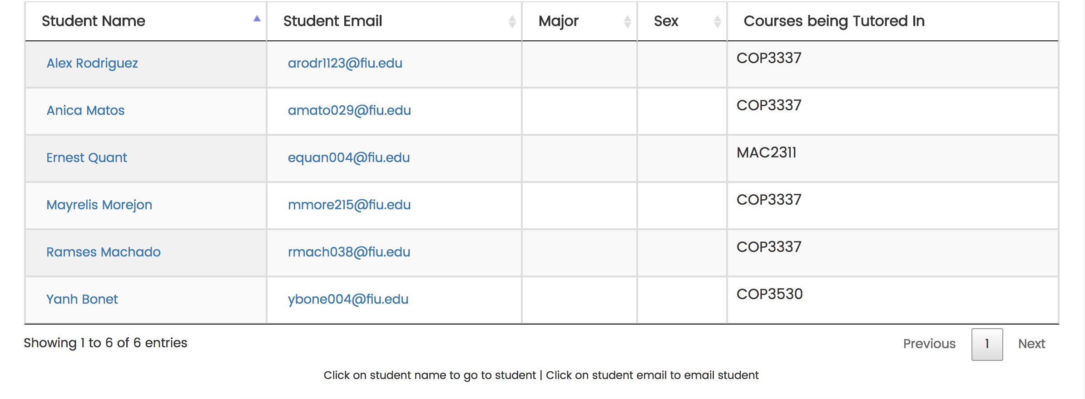

User Story # 667 View detailed student information

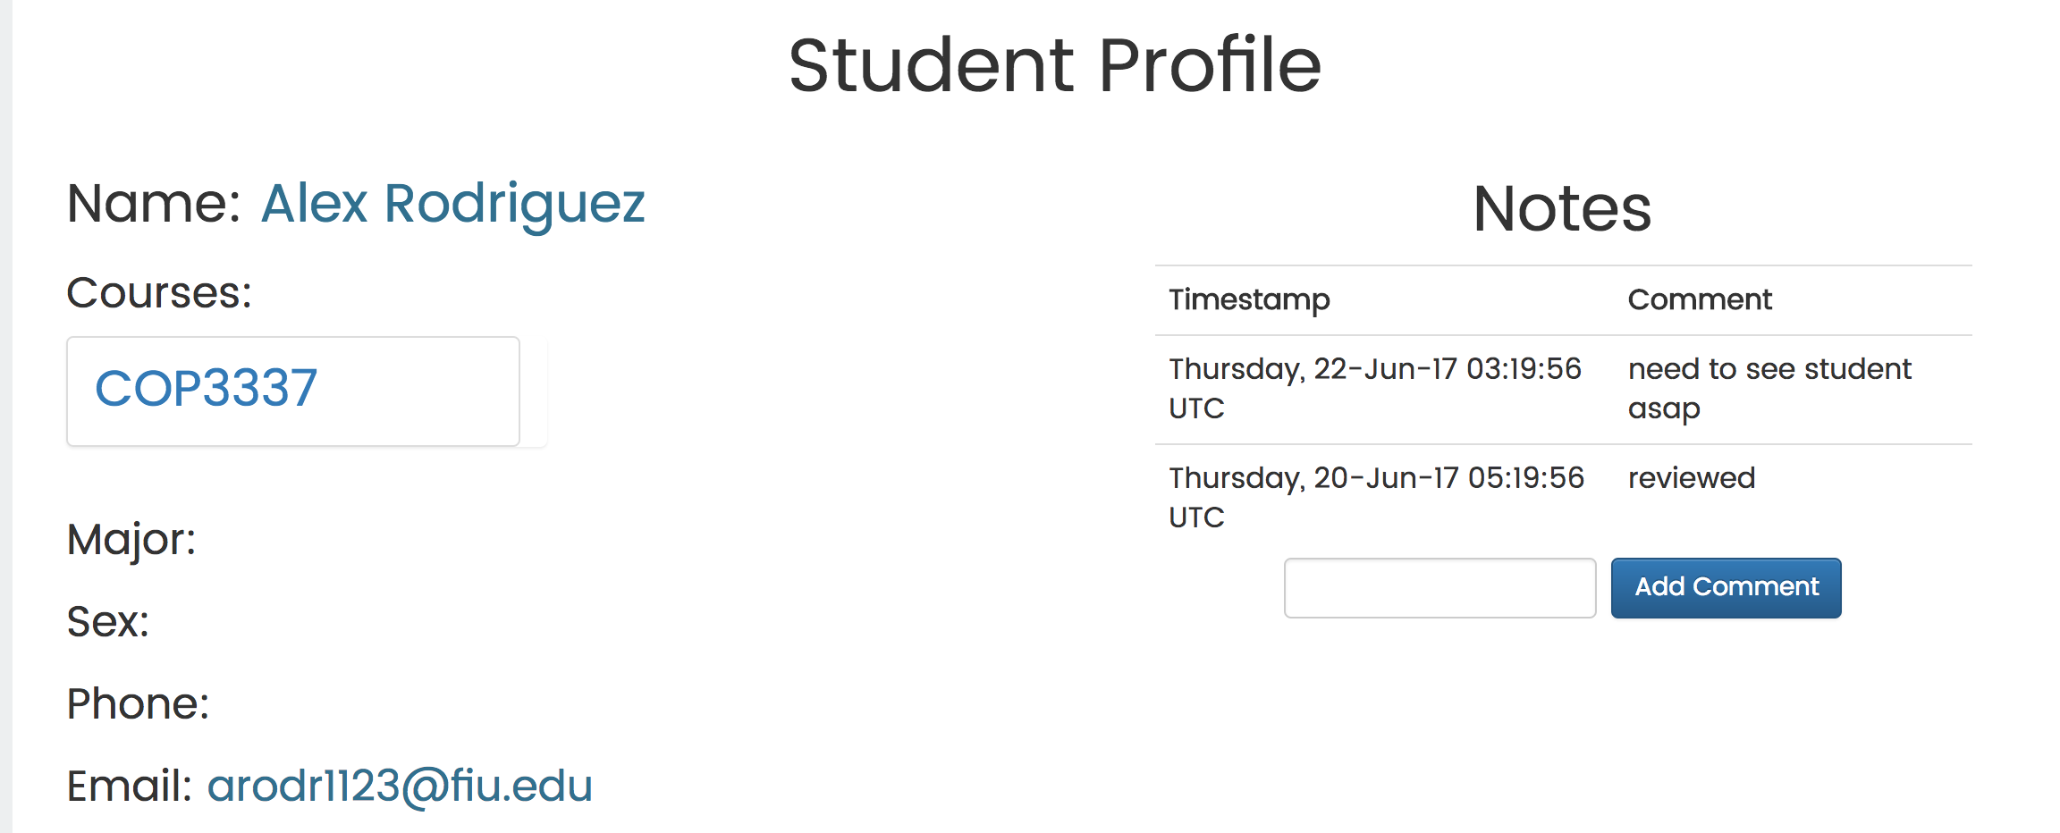

User Story # 668 Sort list of students by name

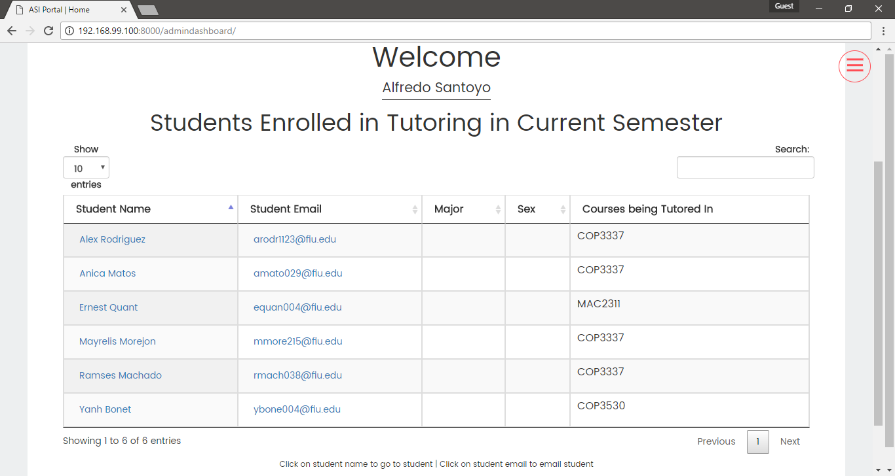

User Story # 669 Sort list of students by major

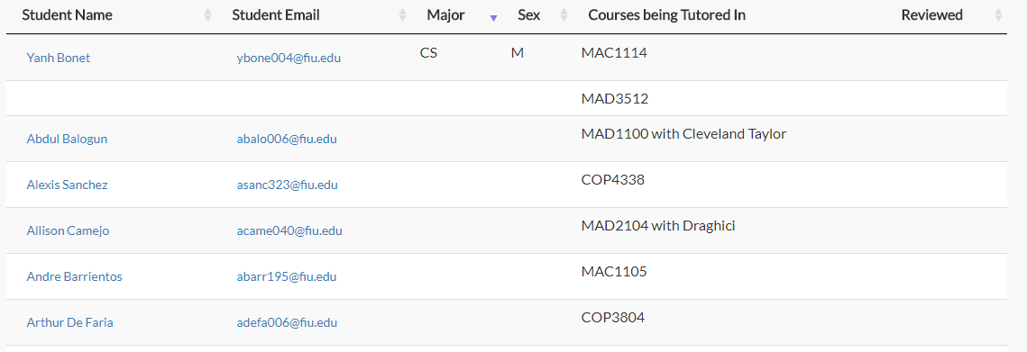

User Story # 670 Filter list of students by name

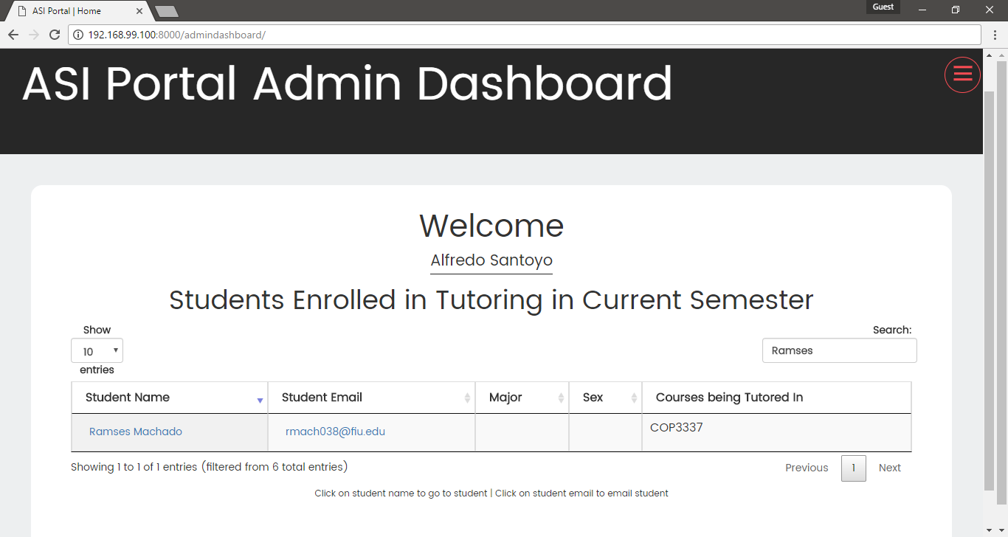

User Story # 678 Create user profile

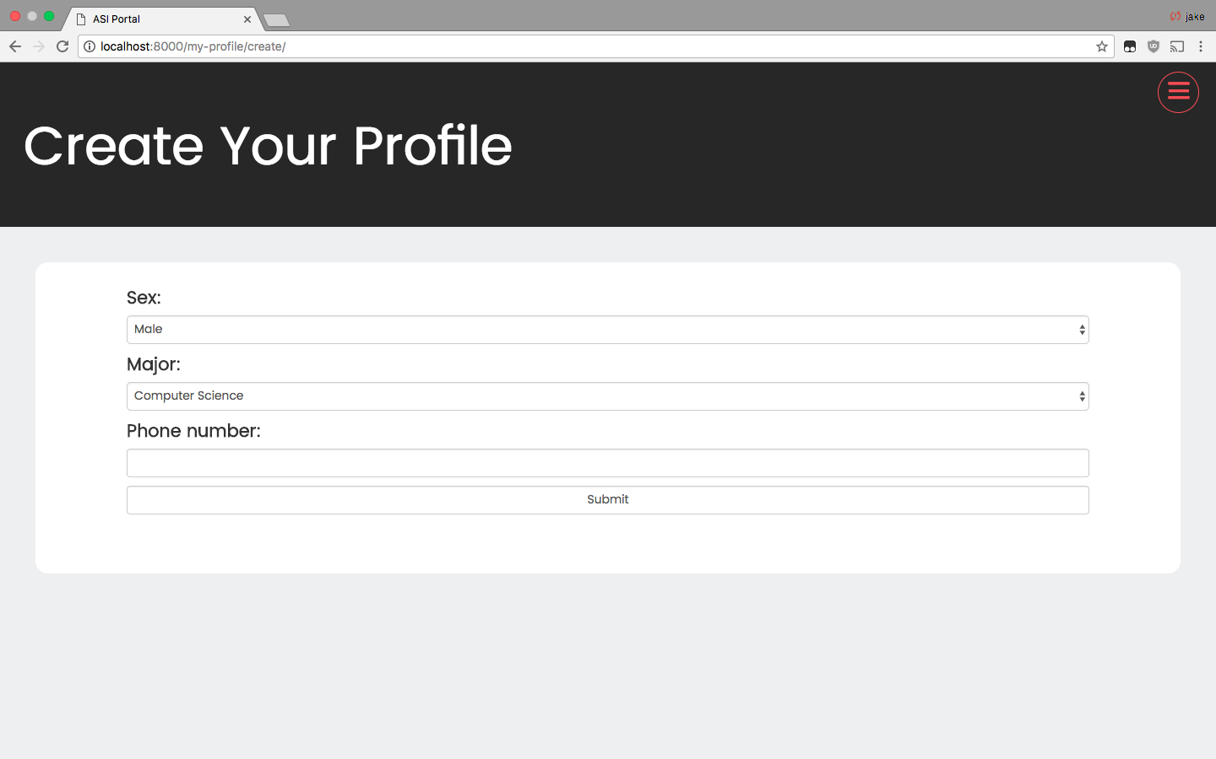

User Story #711 View Overall statistics

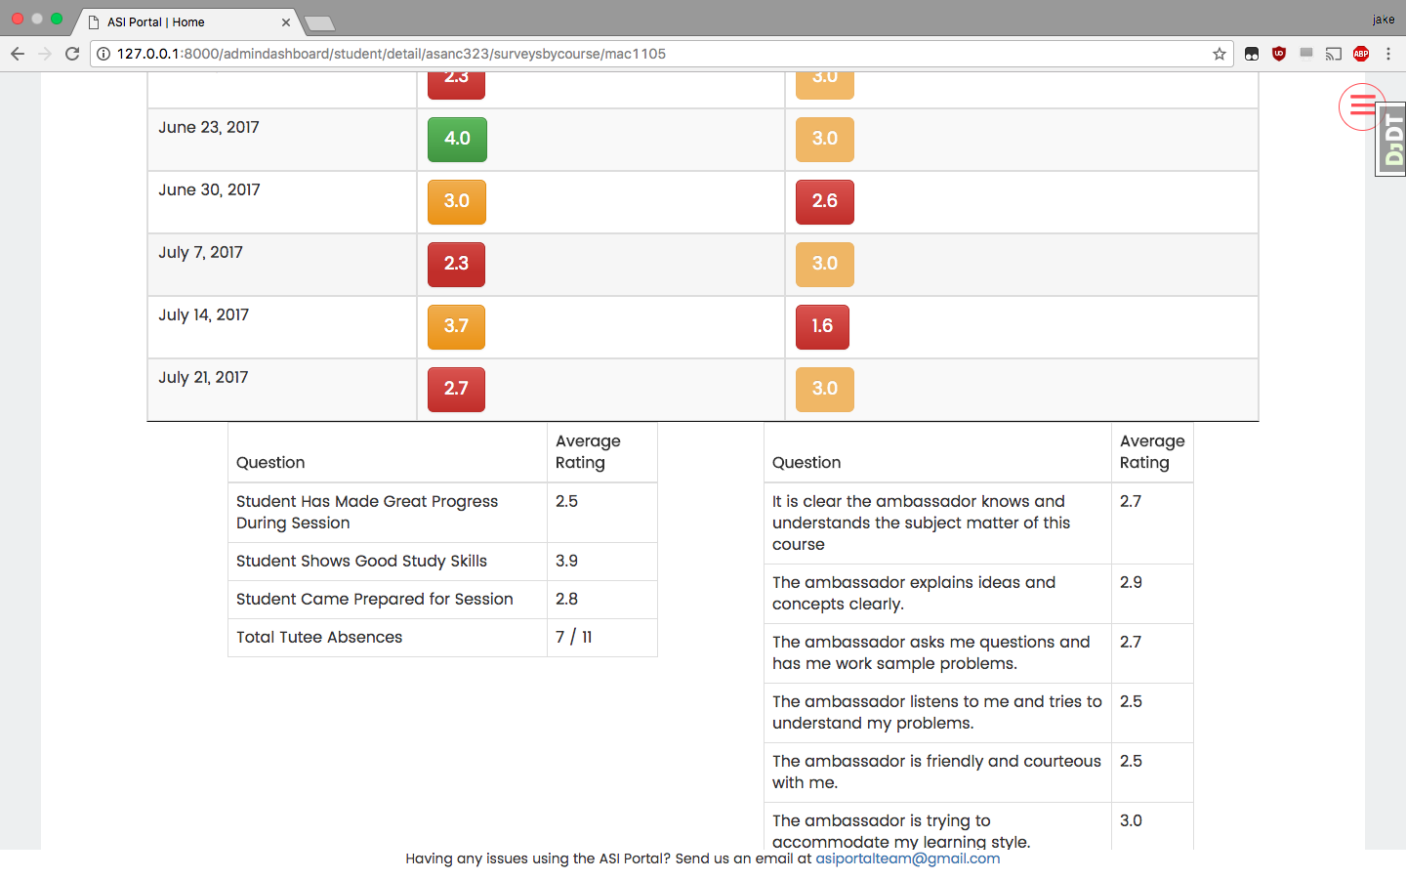

User Story # 712 View detailed survey by clicking on survey located in Surveys by Course view

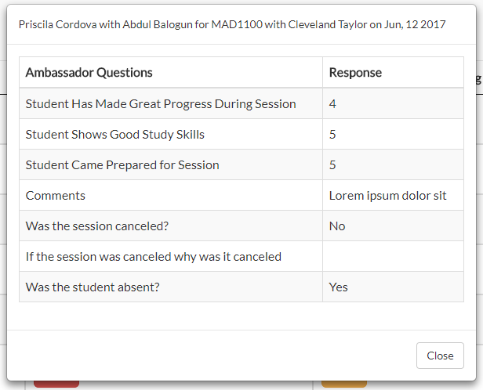

User Story # 717 View Current Tutees

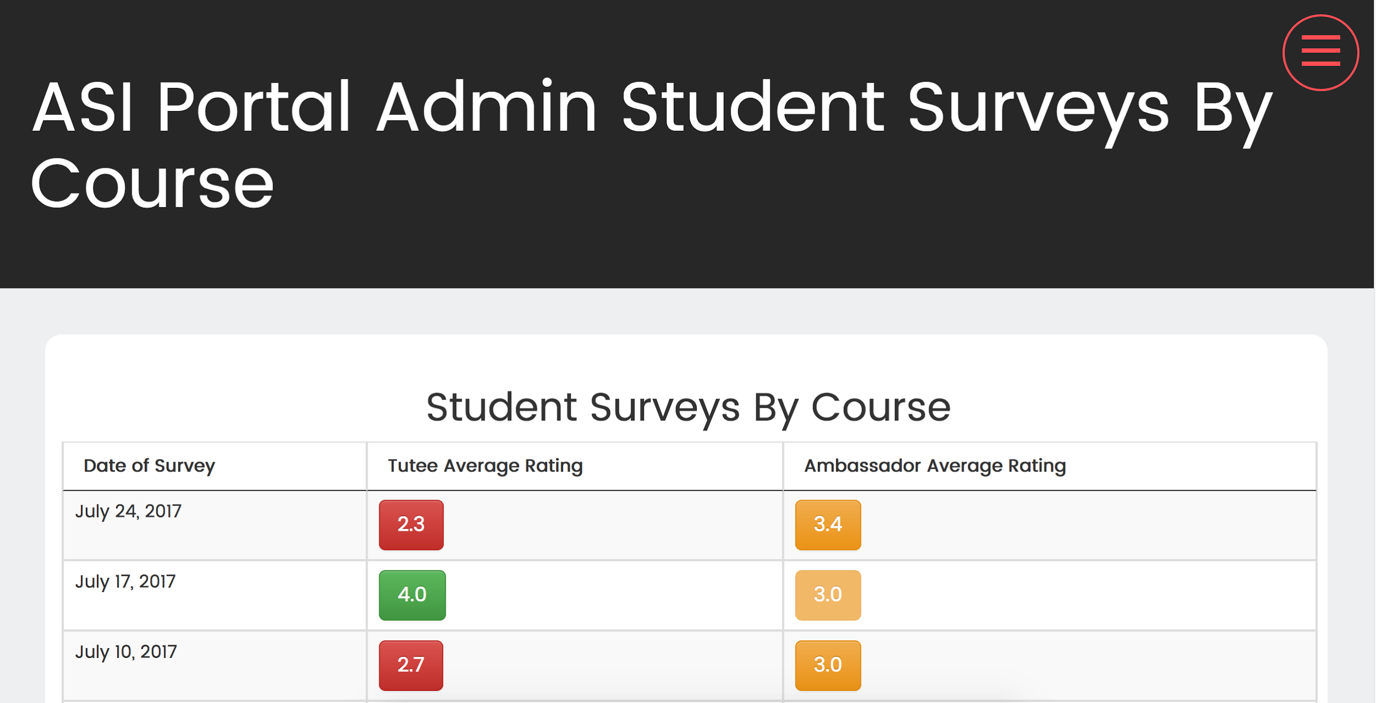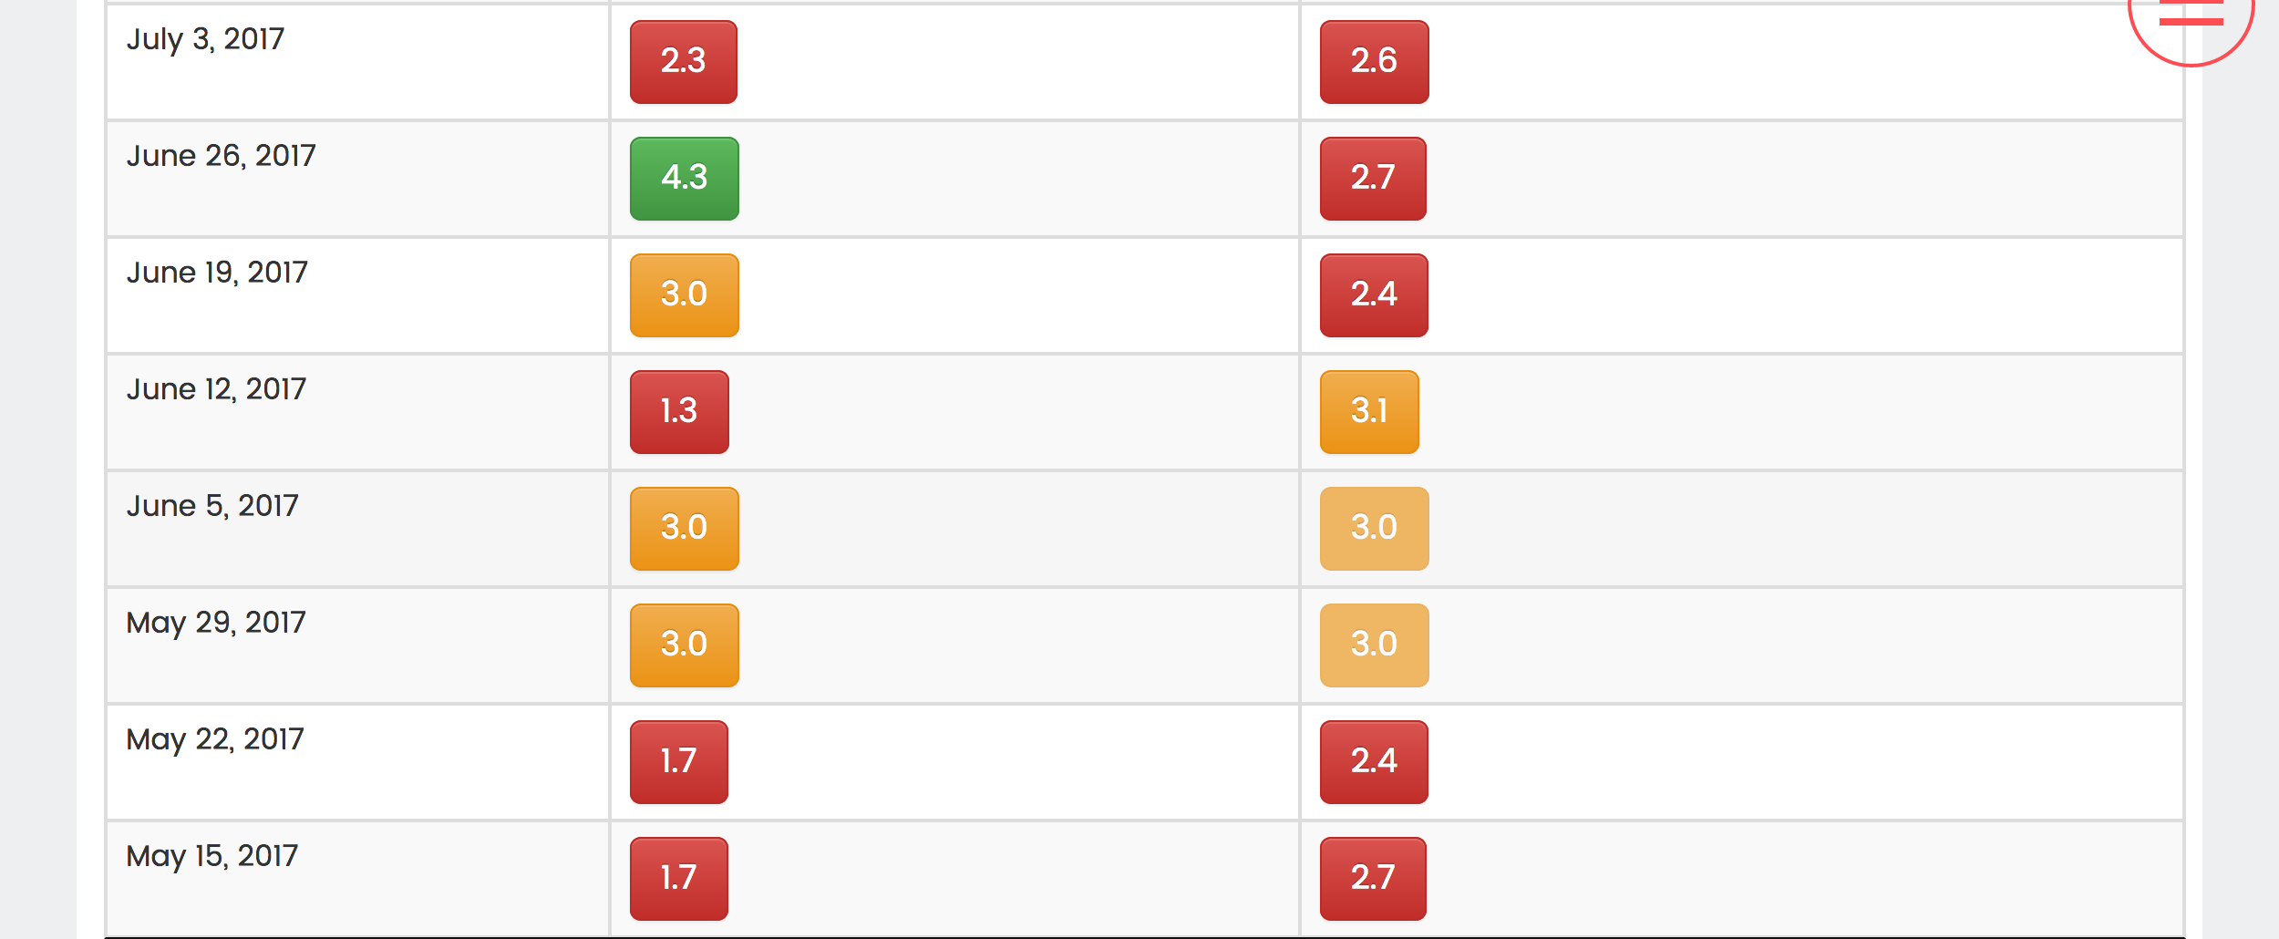

User Story # 718 View the drop down menu for survey by course in the student view

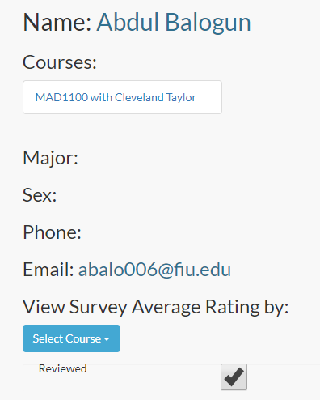

User Story # 731 Write notes on the student profile



User Story # 732 Show number of actual tutoring sessions vs scheduled sessions

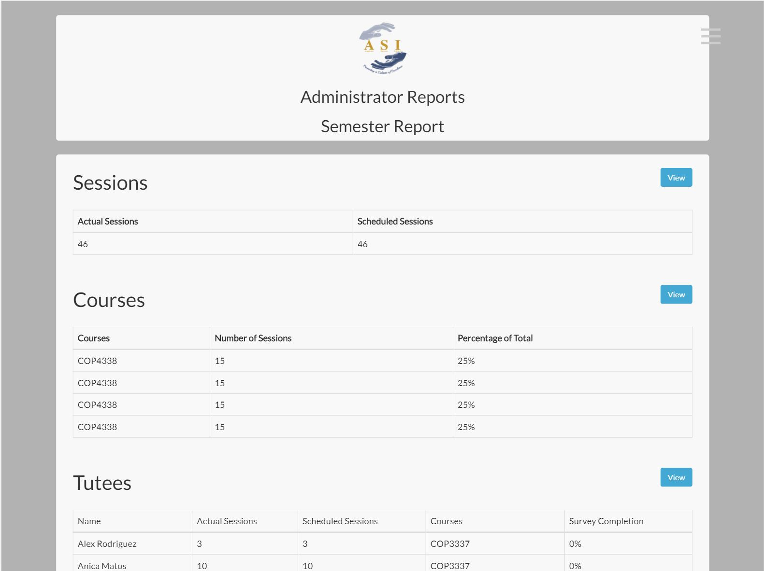

User Story # 733 Show information about courses for the semester

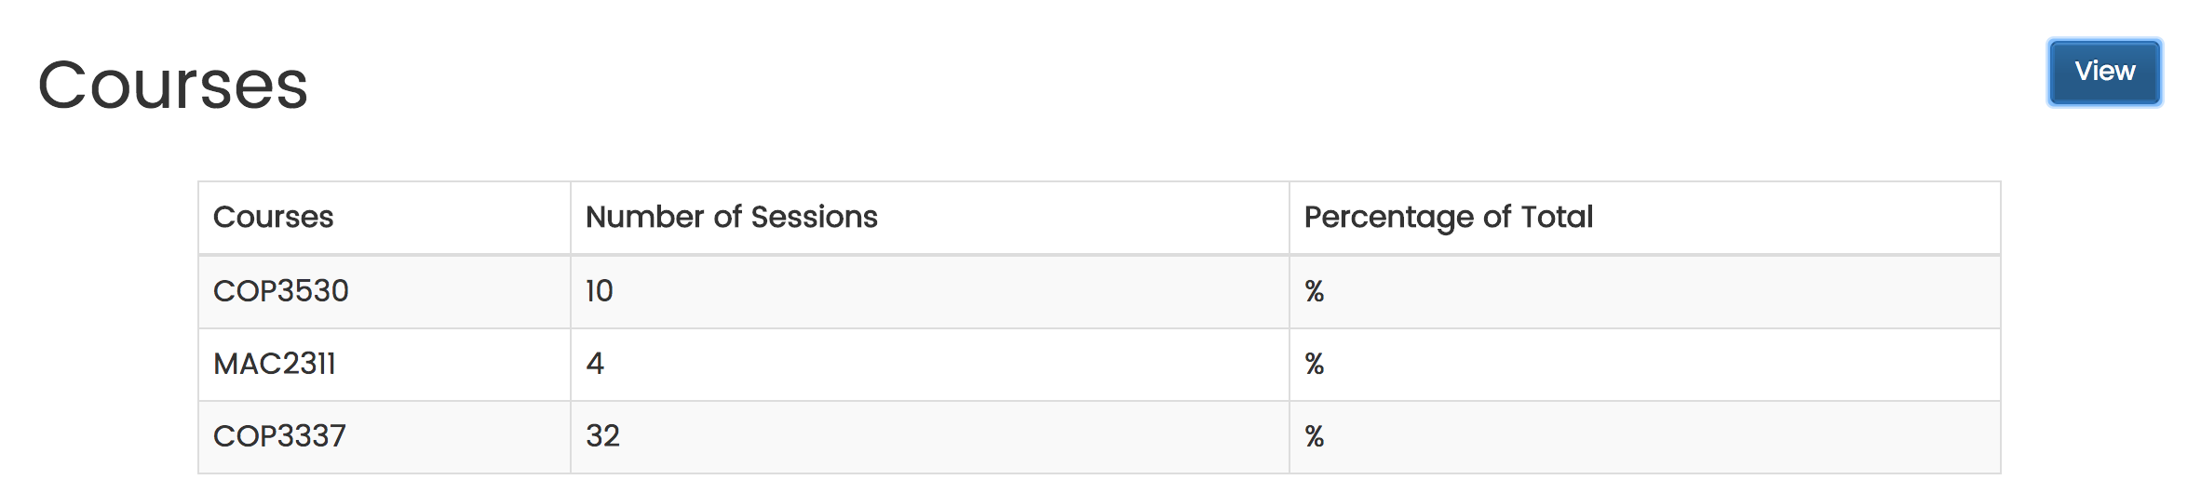

User Story # 734 Show information about tutees from the semester

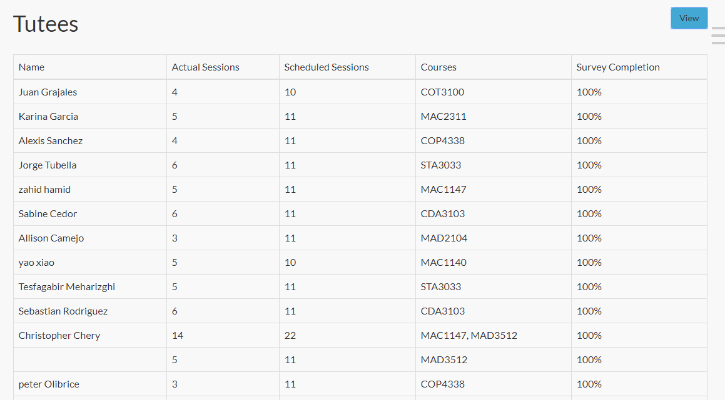

User Story # 736 Record the status of students that have been reviewed



User Story # 737 Change Login Page User Interface

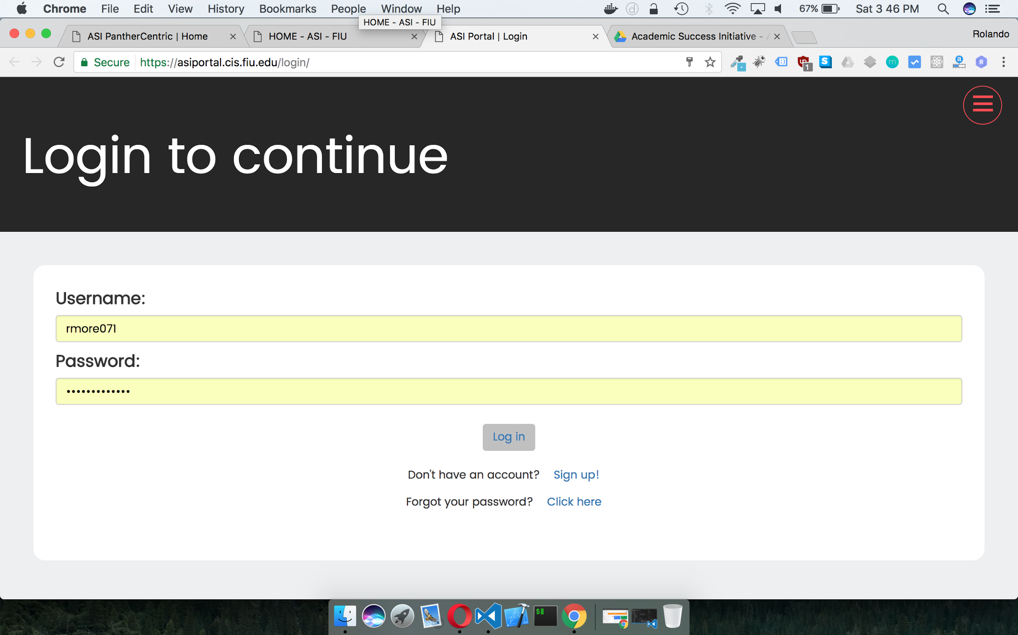

Before

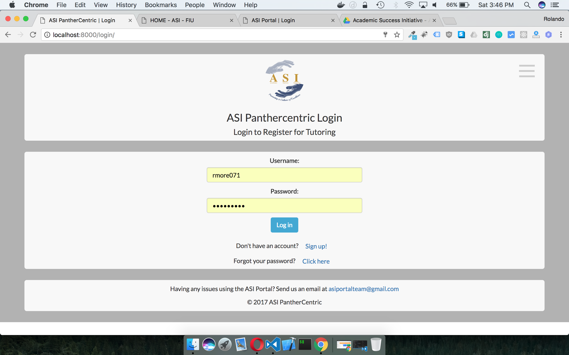

After

User Story # 739 Download an Excel file of the report

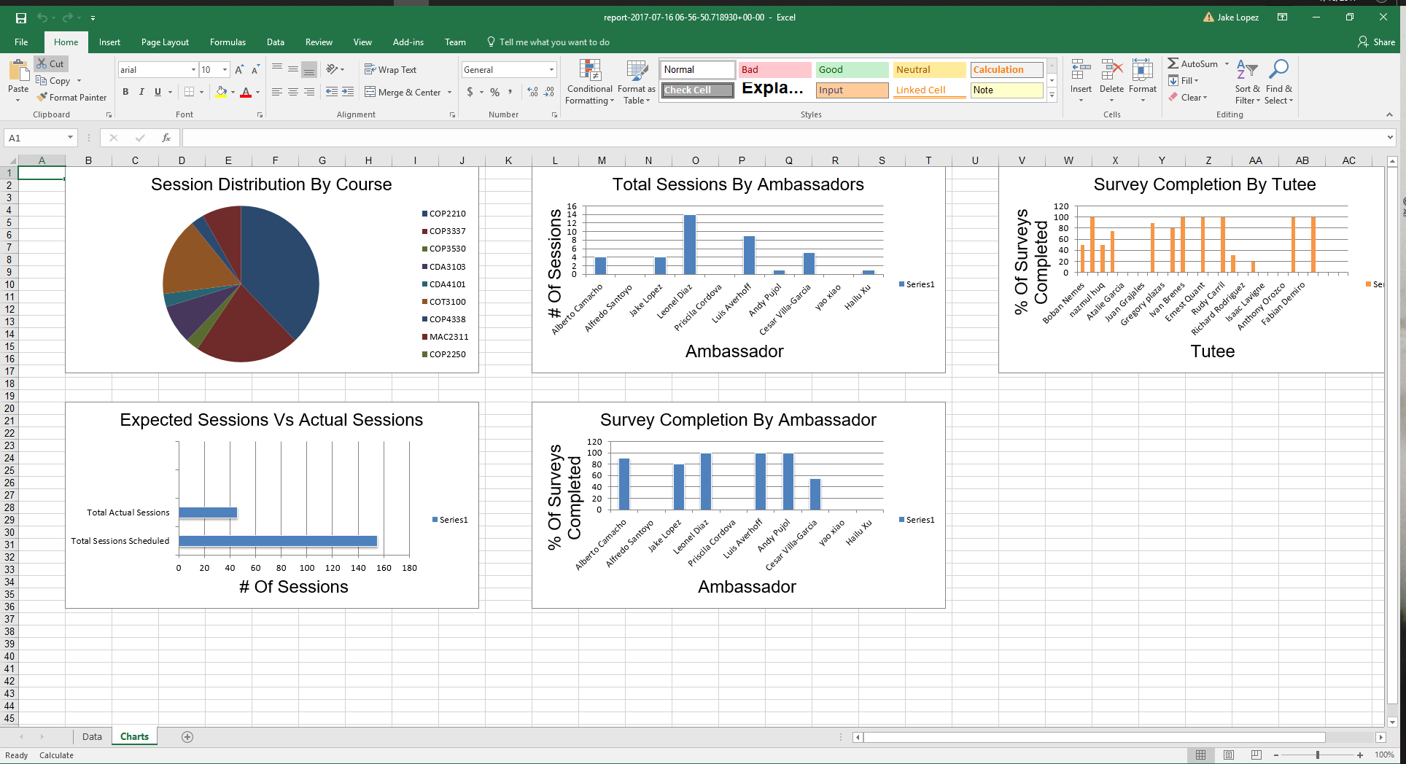

User Story # 740 System should notify tutee of upcoming sessions

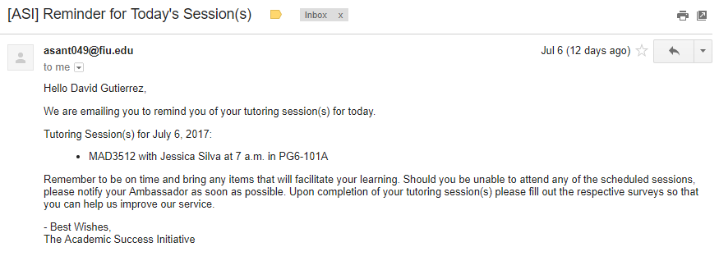

User Story # 741 System should notify ambassador of upcoming sessions

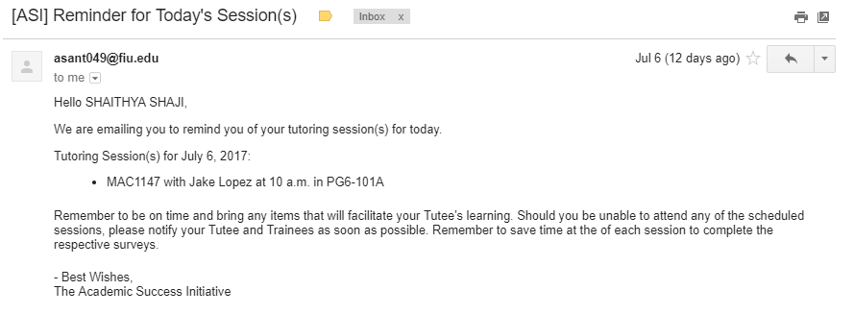

User Story # 777 Change Signup Page User Interface

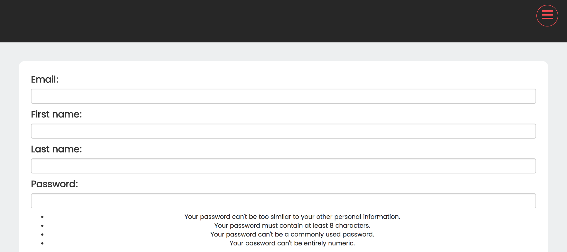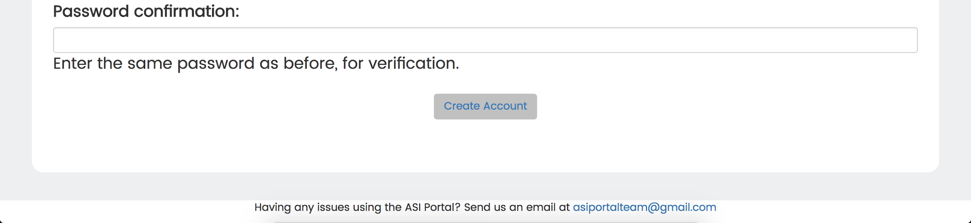

Before

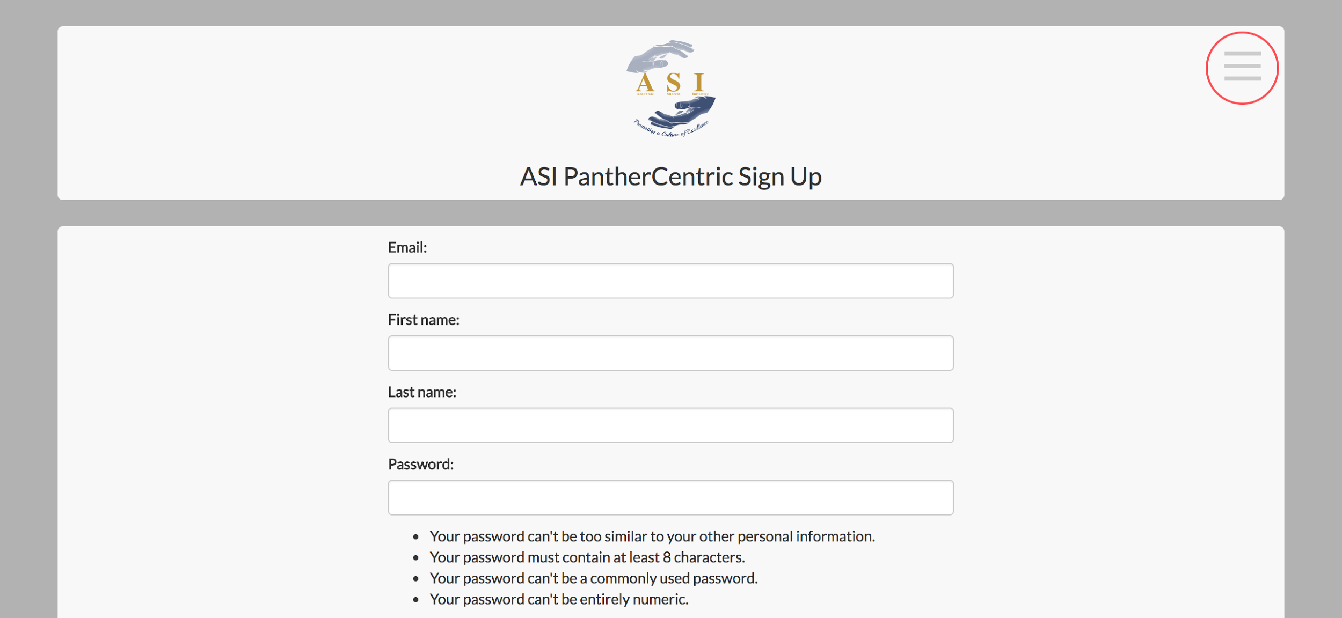

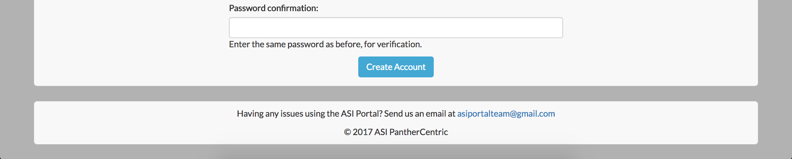

After

## User Story # 779 Change Administrator UI

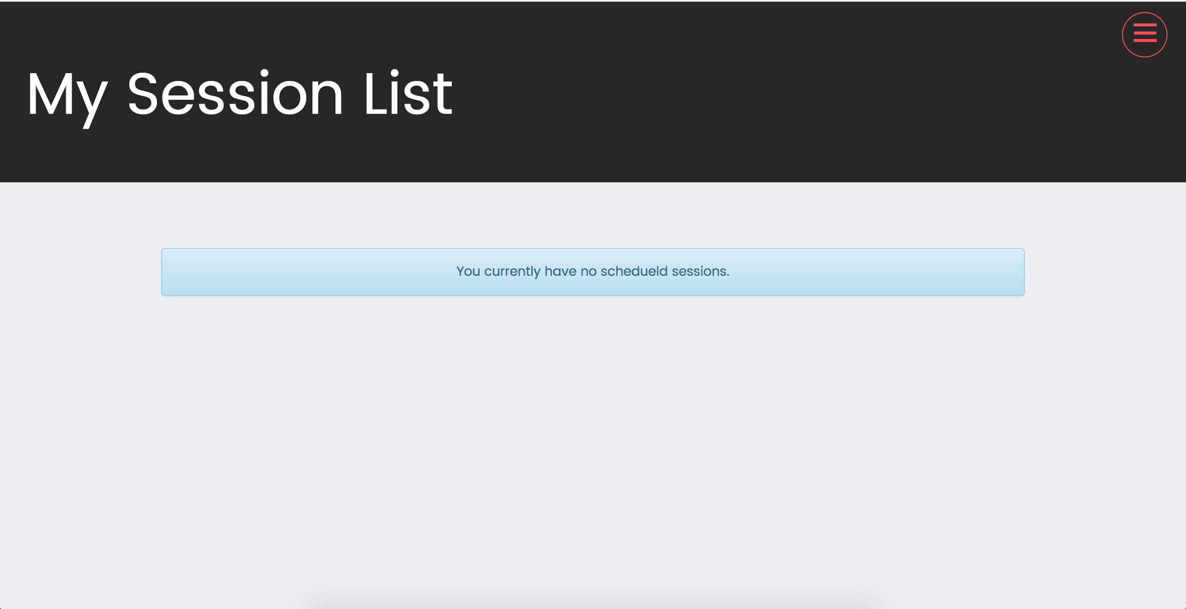

Before

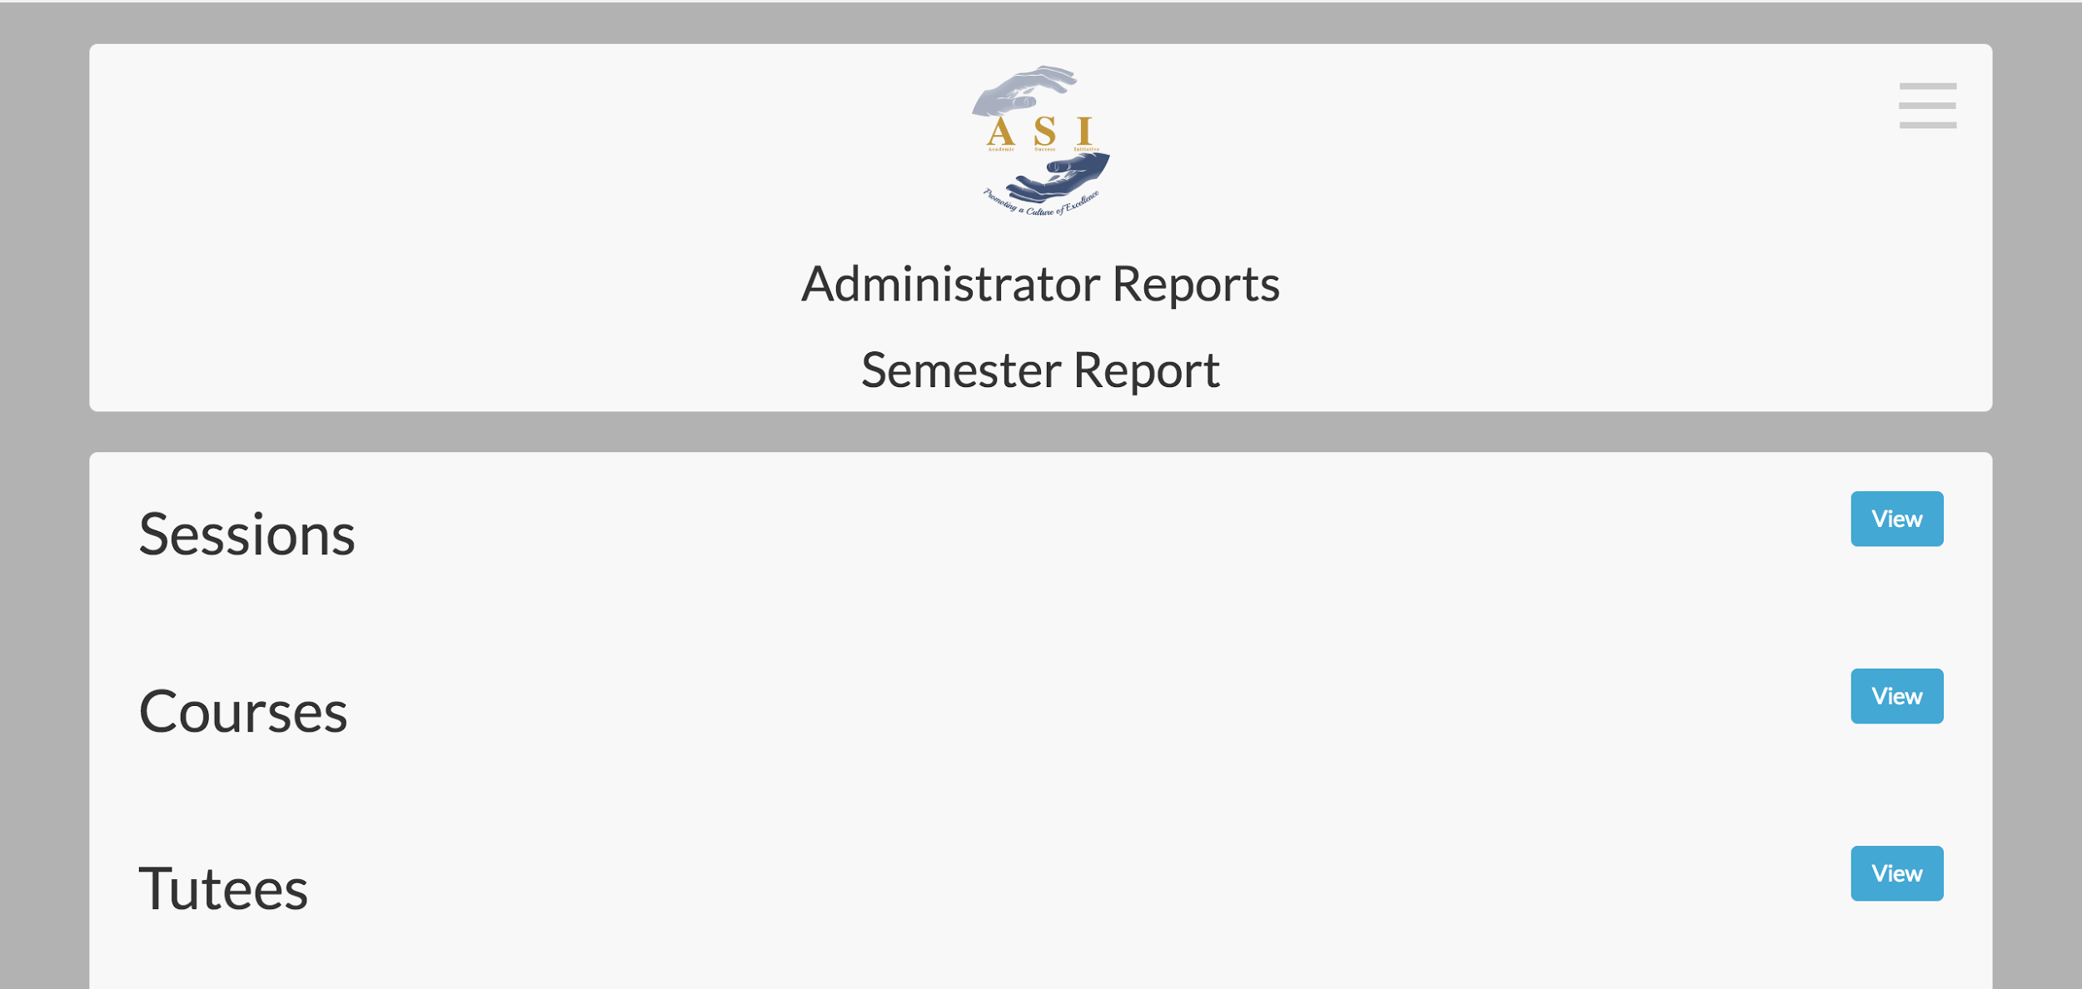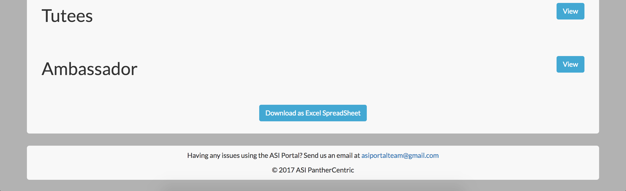

After

## User Story # 779 Change Administrator Header UI



Figure n. Header before changes. Note no difference between user and administrator view



Figure n. Clearly Labeled and distinguished as administrator view with menu on upper right hand corner.

## User Story # 781 Change Administrator Footer UI



Figure n. Before changes to Administrator Footer

Figure n. After changes to Administrator Footer

## 

## 

## Appendix C - Sprint Review Reports

## Sprint 1 Review Meeting Minutes

Attendees: Myriam Herle, Alberto Santoyo, Rolando Moreno, Priscila Cordova, Jake Lopez

Start time: 14:00

End time: 15:00

After a show and tell presentation, the implementation of the following user stories were accepted by the product owners: All.

* User Story #666 - View of current tutees
* User Story #667 - View detailed student information
* User Story #668 - Sort list of students by name
* User Story #669 - Sort list of students by course
* User Story #670 - Filter list of students by name
* User Story #678 - Extend user model

The following ones were rejected and moved back to the product backlog to be assigned to a future sprint at a future Spring Planning meeting.

* None

## 

## Sprint 2 Review Meeting Minutes

Attendees: Myriam Herlle, Alfredo Santoyo, Rolando Moreno, Priscila Cordova, Jake Lopez

Start time: 14:00

End time: 15:00

After a show and tell presentation, the implementation of the following user stories were accepted by the product owners: All.

* User Story #711 - View overall statistics of students
* User Story #712 - View detailed survey by clicking on survey located in surveys by course view
* User Story #717 - View average rating of tutee and ambassador per session in surveys by course
* User Story #718 - View the drop down menu for survey by course in the student view

The following ones were rejected and moved back to the product backlog to be assigned to a future sprint at a future Spring Planning meeting.

* None

## Sprint 3 Review Meeting Minutes

Attendees: Myriam Herlle, Alfredo Santoyo, Rolando Moreno, Priscila Cordova, Jake Lopez

Start time: 14:00

End time: 15:00

After a show and tell presentation, the implementation of the following user stories were accepted by the product owners: All.

* User Story #731 - System should allow the administrator to write notes on the student profile
* User Story #732 - Show number of actual tutoring sessions vs scheduled sessions
* User Story #733 - Show information about courses for the semester
* User Story #734 - Show information for tutees from the semester
* User Story #735 - Show information about ambassadors from the semester
* User Story #736 - Record the status of students that have been reviewed
* User Story #739 - Download an excel file of the report

The following ones were rejected and moved back to the product backlog to be assigned to a future sprint at a future Spring Planning meeting.

* None

## Sprint 4 Review Meeting Minutes

Attendees: Myriam Herlle, Alfredo Santoyo, Rolando Moreno, Priscila Cordova, Jake Lopez

Start time: 15:00

End time: 16:00

After a show and tell presentation, the implementation of the following user stories were accepted by the product owners: All.

* User Story #730 - System should to allow to see calendar from Google calendar api tied into account (FIU)
* User Story #737 - Change Login Page UI
* User Story #740 - System should notify tutee of upcoming sessions
* User Story #741 - System should should notify of upcoming sessions
* User Story #777 - Change signup page
* User Story #778- Change registering for courses UI and accompanying pages
* User Story #779 - Change administrator UI
* User Story # 780 - Change header for admin UI
* User Story # 781 - Change footer UI for admin
* User Story # 782 - Change header for user UI
* User Story # 783 - Change for for user UI

The following ones were rejected and moved back to the product backlog to be assigned to a future sprint at a future Spring Planning meeting.

* None

## Appendix D - User Manuals, Installation/Maintenance Document, Shortcomings/Wishlist Document and other documents

# User Manuals

### View List of Students Being Tutored

As an administrator logs into the portal, click on the button for Current Students. Next you will see the current list of students being tutored.



While looking at this list you can sort it by student name, major, or even search for a student at the top right corner of the table.

### View Specific Student Details

To view the specific details, you can click on the name of any student on the list.



Next you will see the profile view of said student. You are able to their name, courses they are getting tutored, major, sex, phone number, and email.



### Write Notes About Student

You also have the option to write notes about a student on the profile view. You will see a notes panel in this page. You may type on the space provided and click on “add a comment”.



### View Course Data Table

# 

# 

# Admin Manual

To login, enter user name and password and press login.

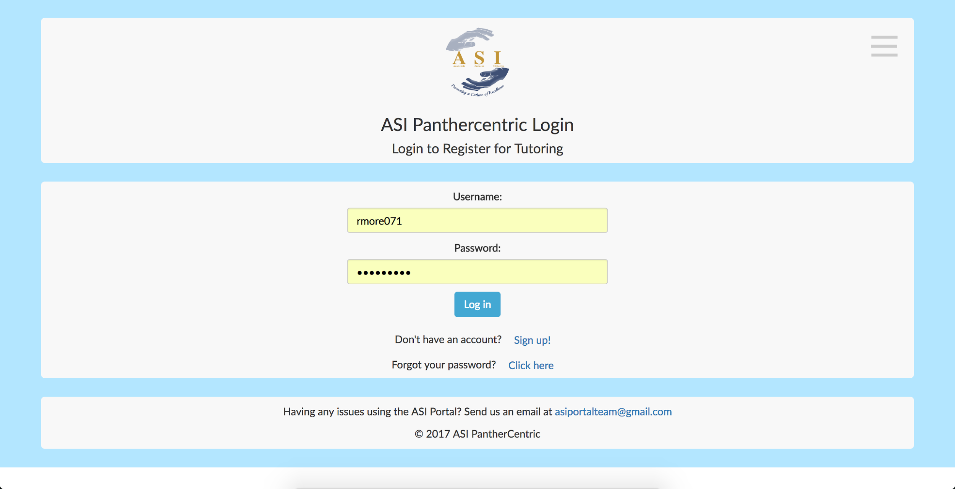

You will be in the administrator menu page.

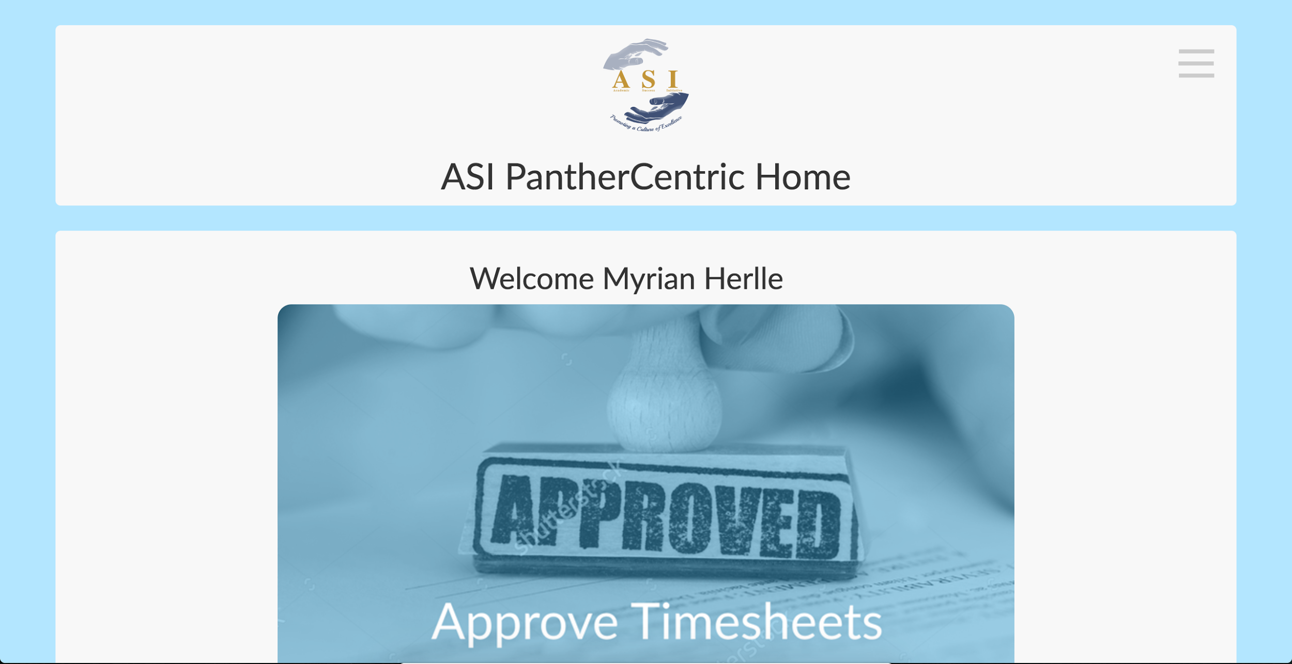

You can then select from three tasks:

Approve Timesheets - Approve ambassador timesheets

Admin Dashboard - View individual student details and progress.

Semester Report - View report of overall progress on semester.



If you click on Approve Timesheets you will be able to approve ambassador timesheets.

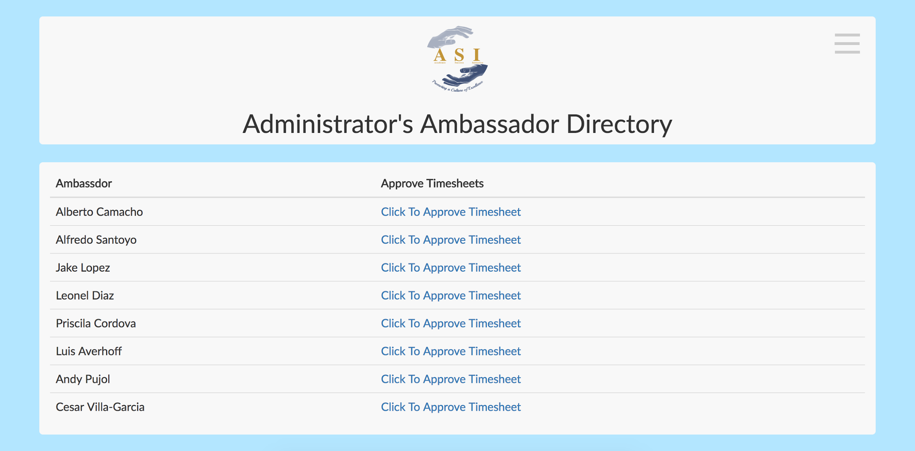

List of ambassador timesheets to approve. Clicking on one will go to the individuals timesheet.

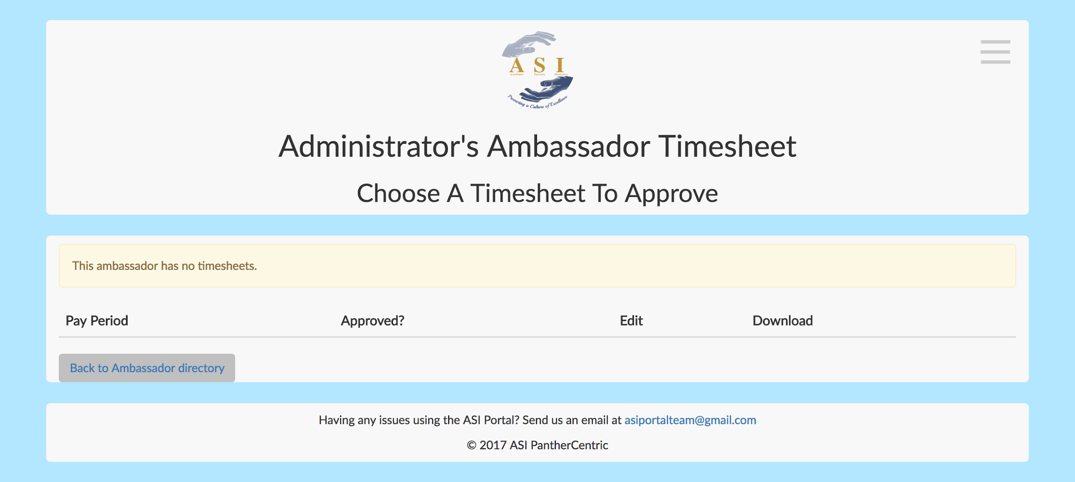

If you click on Admin Dashboard, you will be sent to view student profiles.

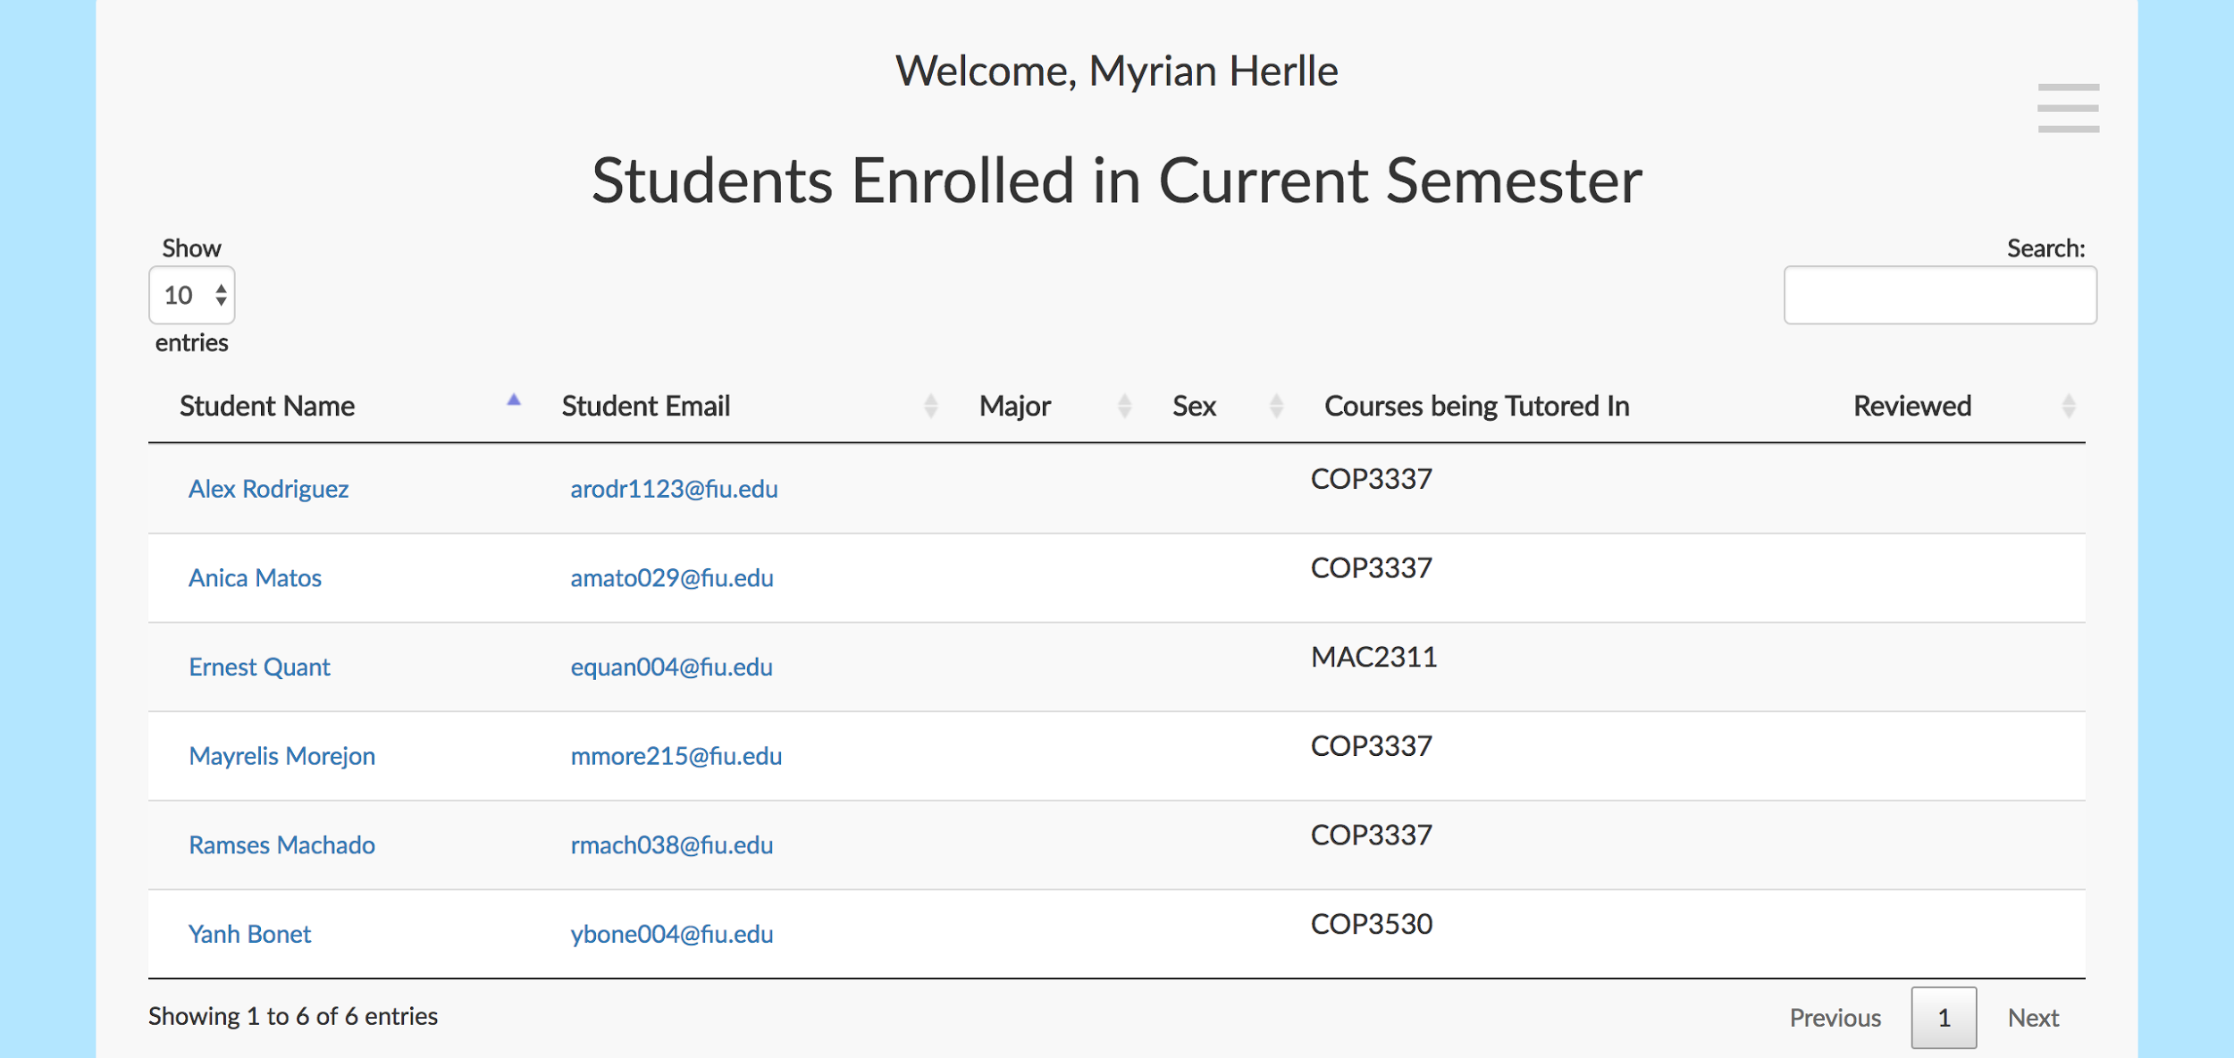

Click on student name to go to individual student profile.

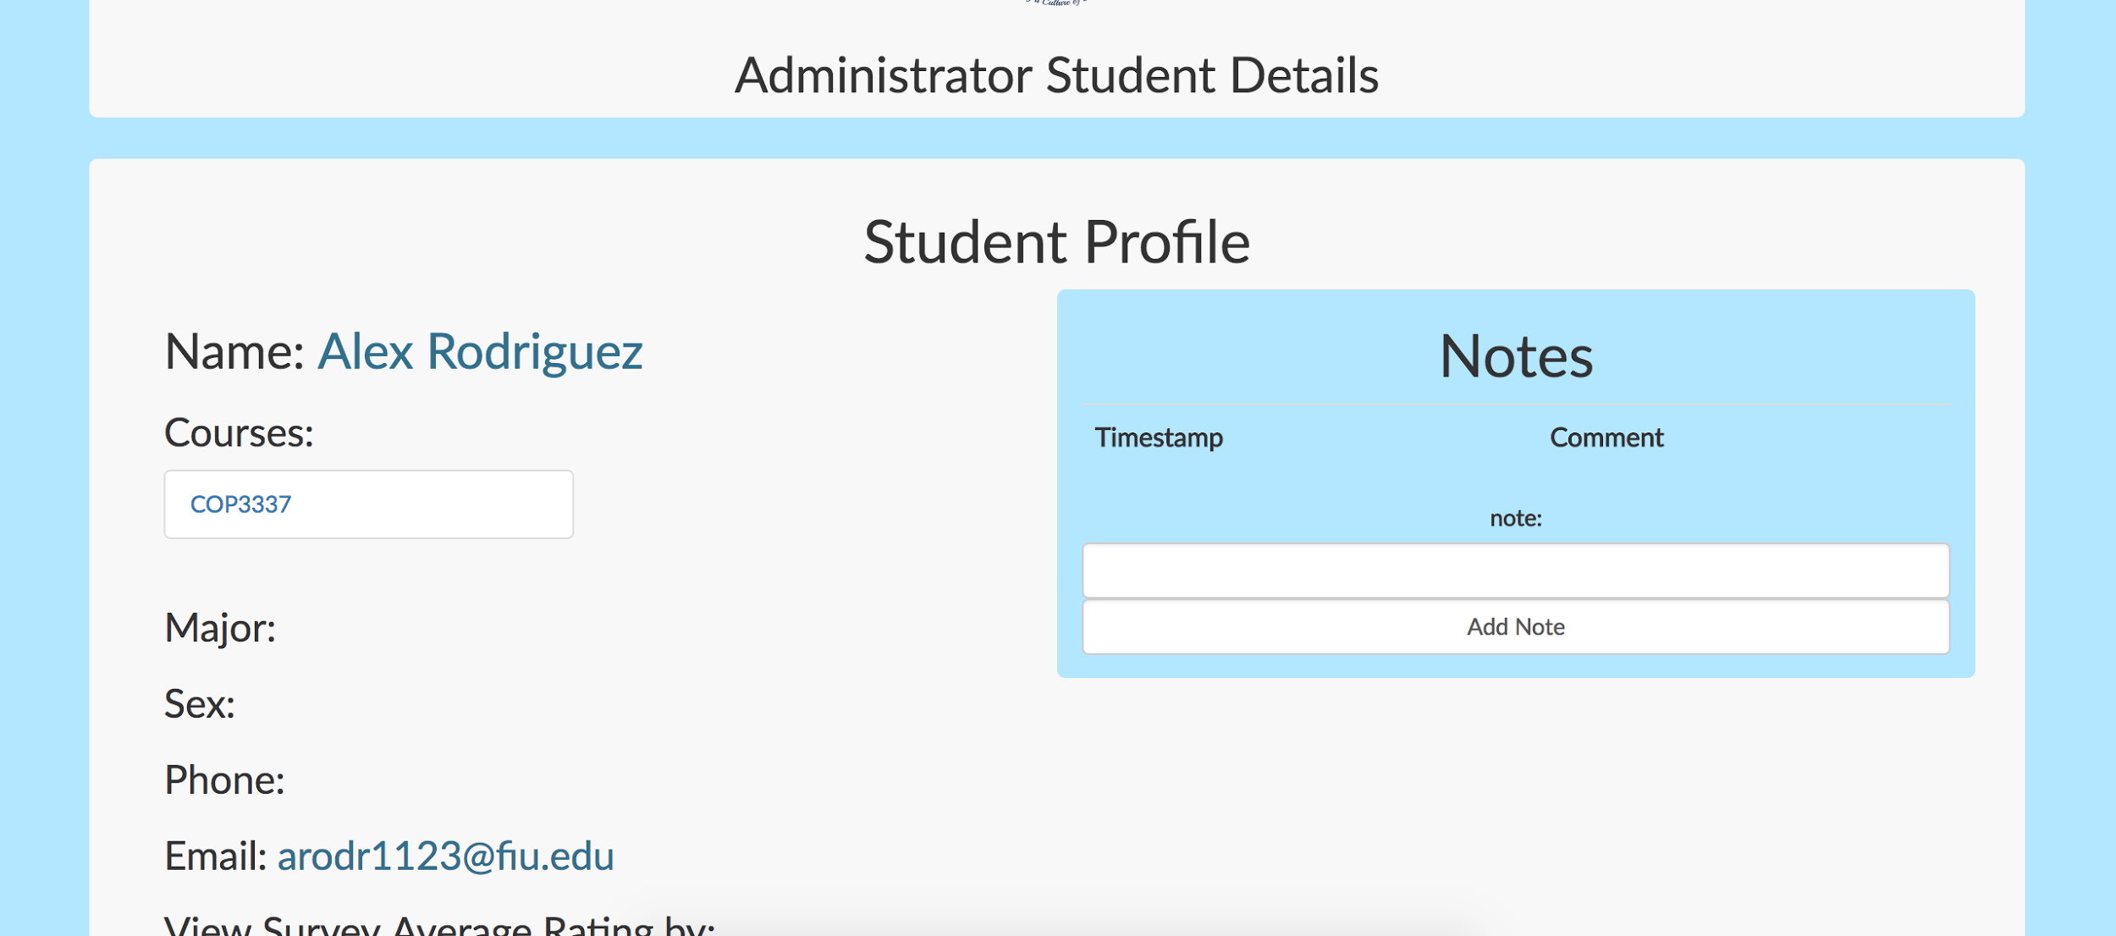

Here you can click to add notes about student or click to view surveys completed for each tutoring session.

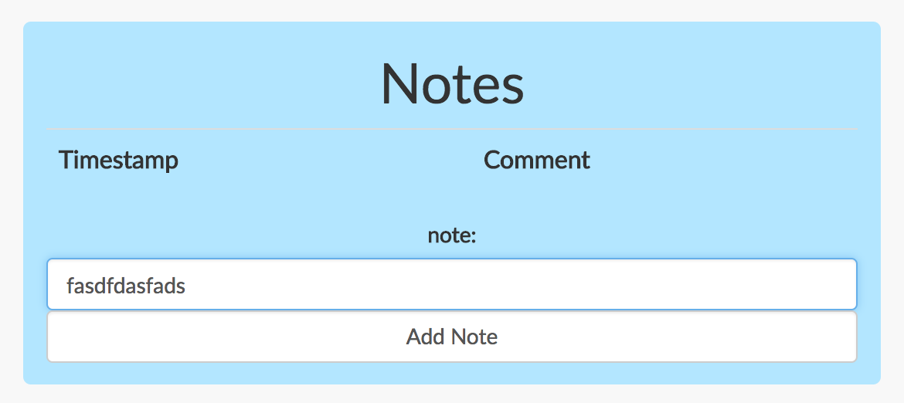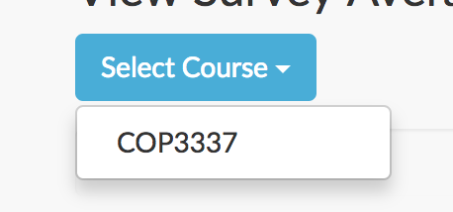

In this screen you can view individual sessions by clicking on the numbers which represent the ratings.

# Screen Shot 2017-07-28 at 3.12.07 PM.png

A modal will pop up with all the details.

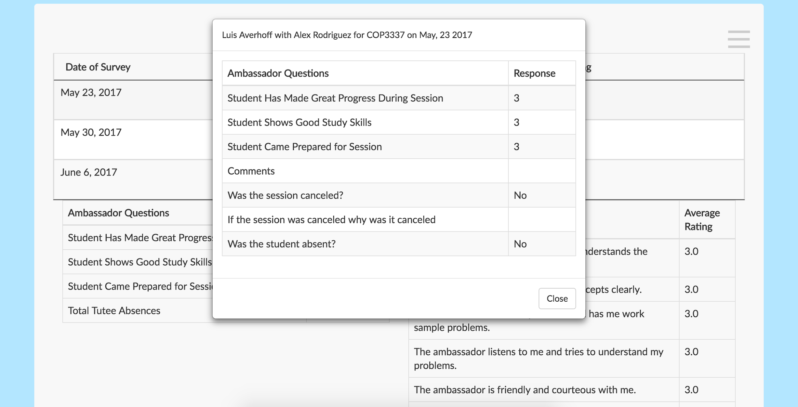

Finally, as an admin you can click on the semester report button to view the semester report. Here you can click on the individual details or download the whole report into an excel file.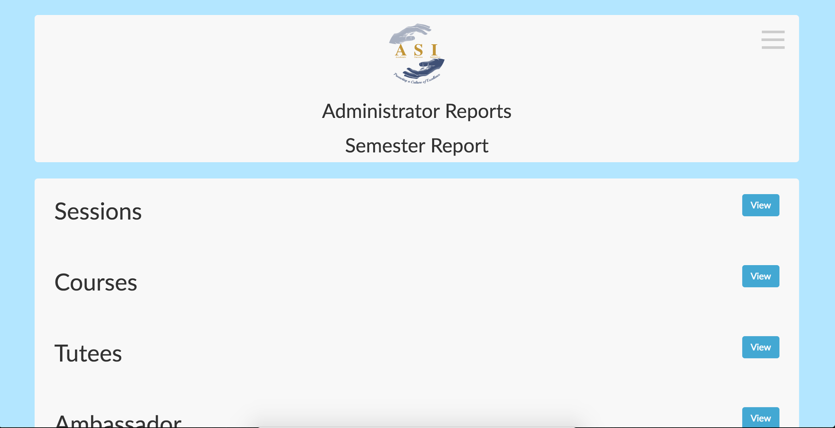

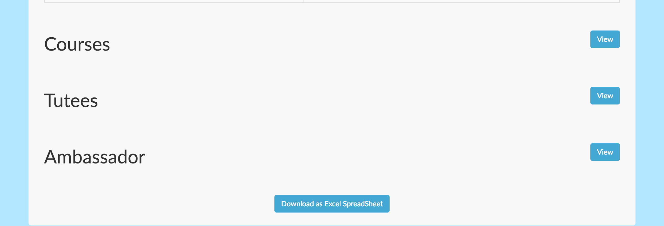

# Installation/Maintenance

# *Installation Guide for Development & Running with Docker*

# To help facilitate development, some members have found it useful to use Docker to run the services necessary to operate the application. The following sections will be a step-by-step guide on how to setup Docker to both host and continue development on the project.

# All the following steps are meant to be executed in your system's command line interface of choice. If you are using a Windows based operating system, please use either PowerShell or Git Bash which is included with the GitHub Windows tools.

# *Pre-requisites*

# First, install docker from the docker website located at [https://www.docker.com](https://www.docker.com/)

# *Docker set-up*

# Checkout the latest version of the project from the GitHub repository. The latest version is maintained by the Academic Success Initiative (ASI), so you should request access from their internal development team.

# Once you have the copy of the latest repository, make sure to check out the Docker compatible version by executing “git checkout docker” in the directory where you have the git repository stored. Your command line output should resemble that of Figure 1.

# Next, you must build the necessary Docker images. The first step is to build the initial container which will host the Python code. To do this execute “docker build -t asiportal .” in your command line in the root directory of the repository. This command may take up to 10 minutes to complete running. Once completed, your command line output should be like Figure 2.

# The next and last step is to build the other necessary images to run the application. To do this, execute “docker-compose up” in the root directory of the repository. This command may also take upwards of 10 minutes to complete running. Once completed, the output should look like Figure 3.

# Note that if you see some output like Figure 4 The application will not finish setting up. You must enter “Control-C” to stop the message, then run “docker-compose up” again.

# Once you see successful build output like that in Figure 3, you may now connect to the application by visiting the localhost:8000 in your web browser. You should be greeted by a screen like that in Figure 5.

# For the ease of development all passwords have been set to “password”. So, to login as any user simply enter their username and “password” for password.

# Figure 1. Result of executing “git checkout docker” in the command line.

# Figure 2. Result of successful completion of the “docker build -t asiportal .” command

# 

# Figure 3. Successful completion of “docker-compose up” command.

# Figure 4. Common issue when first running “docker-compose up”. The process will hang and not complete the set-up of other images. To finish simply enter “Control-C” and run the “docker-compose up” command again.

# Figure 5. The homepage of the ASI PantherCentric 1.0 project.

# 

# *Installation Without Docker*In the case that you are unable to install Docker, or simply do not wish to install Docker, you are still able to get up and running with the installation of a few services. It is highly recommended that you do any development using either Linux or OS X if you choose this route of installation.

# There are a few warnings that should be issued prior to going this route while working with Windows. The main warning is that Redis, a necessary service for the application, has no Windows installer. To install it you must compile Redis from source. While not impossible, it is a bit of an inconvenience. If you do not feel comfortable with this process then please consider either using Docker or a Linux virtual machine.

# *Pre-requisites*

# Install Redis for your platform by visiting:<https://ww.redis.io>

# If on a Linux distribution it is recommended to install this service using your distribution's package manager.

# Install PostgreSQL for your platform by visiting:<https://www.postgresql.org>

# If on a Linux distribution it is recommended to install this service using your distribution's package manager.

* + When you create your database for the project, make sure to initialize it with the SQL file located in the repository root titled “init.sql”.
* Install Python (version 3.6 or higher) by visiting:<https://www.python.org>

# If on a Linux distribution it is recommended to install this service using your distribution's package manager.

# *Setting Up*

# Checkout the latest version of the project from the GitHub repository. The latest version is maintained by the Academic Success Initiative (ASI), so you should request access from their internal development team.

# It is always recommended that you start a new branch for development. If you are working in a team and other members are using Docker, then checkout the docker branch.

# Next, you will want to configure a settings file. A good example file to copy and adjust is located at: repository_root/asiportal/asiapp/settings/local.py

# For the most minimal amount of change to get the project running, please edit the HOST, PORT, USER, and NAME variables as shown in Figure 6.

# Once you have made your changes, ensure that both PostgreSQL and Redis are running.

# Next, you will need to install the Python packages necessary for this project. It is recommended to create a Python virtual environment to ensure there are no conflicts between any global packages you may have already installed. To learn more about how to accomplish this, visit<http://python-guide-pt-br.readthedocs.io/en/latest/dev/virtualenvs/>.

# Navigate to the folder located at: repository_root/asiportal

# From here, execute the command “pip install -r requirements.txt”

# This will install all necessary packages to run the application.

# Once you have installed all packages, simply execute “python manage.py runserver –settings=asiapp.settings.YOUR_SETTINGS_FILE_NAME” to run the application. This should be run from the repository_root/asiportal directory. Correct output is shown in Figure 7.

# You should now be able to navigate to [http://localhost:8000](http://localhost:8000/) and view the application in your web browser. Figure 5 should resemble the page you see when you visit localhost:8000.

# Figure 6. The settings file which should be manipulated to fit your Postgres configuration.

# Figure 7. Successful output of running python manage.py runserver –setings=asiapp.settings.YOUR_FILE_NAME

# 

# Shortcomings/Wishlist

### Notifications

It is to notify the administrator of new registered students of the system  
This would help the administrator identify which student has been able to successfully register and to follow up with them if needed.

### Room Booking

It is to be able to synchronize with the Google calendars for room booking. There is a system already in place in which rooms are booked through the Google calendar. So we simply wish to integrate this to our PantherCentric software. This way sessions would be booked much faster without needing to take extra steps for verifying a space available.   
  
***ADA Compliant***  
We wish to make our system ADA compliant. This would help any students with disabilities use our system with ease. This would include allowing for adjustments in color and font size.  
  
***Reminders***  
These reminders would be set for survey completion for tutees and ambassadors. This way all surveys that are due weekly would be completed.

Another type of reminder we would like to add is timesheet completion. This would help ambassadors complete their forms on time.

# References

[1] Bootstrap Documentation. (n.d.). Retrieved July 17, 2017, from <https://getbootstrap.com/css/>

[2] Django Documentation. (n.d.). Retrieved July 17, 2017, from <https://docs.djangoproject.com/en/1.11/>

[3] Docker Documentation. (n.d.). Retrieved July 17, 2017, from <https://www.docker.com/>

[4] Javascript Documentation. (n.d.). Retrieved July 17, 2017, from <https://developer.mozilla.org/en-US/docs/Web/JavaScript/Reference>

[5] Postgres SQL Documentation. (n.d.). Retrieved July 17, 2017, from Redis Documentation. (n.d.). Retrieved July 17, 2017, from <https://redis.io/documentation>

[6] Python Documentation. (n.d.). Retrieved July 17, 2017, from <https://docs.python.org/3/>

[7] Redis Documentation. (n.d.). Retrieved July 17, 2017, from <https://redis.io/documentation>

[8] Selenium Documentation. (n.d.). Retrieved July 17, 2017, from <http://www.seleniumhq.org/docs/>

[9] "Active Record." P of EAA: Active Record. N.p., n.d. Web. 28 July 2017, from <https://www.martinfowler.com/eaaCatalog/activeRecord.html>.